Abstract

Society has reached technology to create autonomous vehicles and to connect different devices and machinery to each other to exchange data and optimize production efficiency. With this technology, soon it will be possible to achieve better methods to guide blind and visually impaired (BVI) users in their daily activities. The products currently available in the market have several limitations and do not satisfy BVI users. We believe that one of the reasons behind this problem is that they are not members of the development team or are not consulted by these.

The lack of an efficient solution for BVI users’ navigation became even larger with the SARS-CoV2 pandemic, in which people had to avoid contact with each other and not touch other surfaces.

The purpose of this paper is to use Virtual Reality (VR) to test and evaluate different designs of BVI products and to verify if non-BVI users have the same mental demand and situation awareness as BVI users when using assistive products. The idea is to use VR as a testing ground where a BVI user can try different assistive solutions in different scenarios. By doing so, the user becomes part of the product design and evaluation, resulting in better and more user-friendly products. The proposed method includes not only the setup of the virtual environment but also the use of physiological sensors and subjective tests to assess the mental workload and situational awareness in different situations.

To illustrate the proposed method, we use as a case study the BVI navigation in a medical clinic submitted to COVID-19 protocols. This case study is chosen due to the current undergoing SARS-CoV-2 pandemic and the impact on BVI people.

The scenes were made using Unity3D, a widely used development platform for virtual reality applications. The VR device was the Tobii Eye Tracking VR, a head-mounted display for virtual reality developed using the HTC VIVE. The VR device is used for defining the position and orientation of the user in a virtual environment in Unity. Based on the current situation in the virtual environment, inputs are provided to the user using aural commands and haptics devices. To assess the mental workload, physiological sensors, from TEA Captiv T-Sens, are used. Among them, are an electrocardiogram sensor (ECG), to gather heart-rate and heart-rate variance data using, and a galvanic skin reaction sensor (GSR) to collect skin conductance. Besides these sensors, the users are also expected to answer mental workload assessment tests and situation awareness questionnaires.

Among the expected benefits of the proposed method is the flexibility and agility to create different scenarios, as well as the possibility to test all of them in the same physical room. This could not only speed the design of new solutions but also improve the overall quality of the products and verify the need of a BVI user in the development team of an assistive product.

Contents

1 Introduction 8

1.1 Motivation 8

1.2 Objectives 9

1.3 Resources and methods 9

1.4 Research boundaries 10

1.5 Structure 10

2 Theoretical Foundation 12

2.1 Human Factor or Ergonomics 12

2.2 Mental Workload (MWL) 14

2.2.1 Task Performance 15

2.2.2 Physiological measures 16

2.2.3 Subjective measures 17

2.3 Situation Awareness (SA) 18

2.3.1 SAGAT 19

2.4 Extended Reality (XR) 20

2.4.1 Augmented Reality (AR) 20

2.4.2 Augmented Virtuality (AV) 21

2.4.3 Mixed Reality (MR) 21

2.4.4 Virtual Reality (VR) 21

2.5 Co-Design 22

3 Literature review 24

3.1 Virtual Reality Without Vision 24

3.2 Effects of Emotion and Agency on Presence in Virtual Reality 26

3.3 Bradley and Dunlop research about BVI navigation 28

3.3.1 The 2002 investigation 28

3.3.2 The 2005 experiment 30

3.4 Evaluation of spatial display for navigation without sight 32

3.5 Use of VR in the aircraft cabin design process 33

3.6 Interviews’ phase 34

3.6.1 Interview with the hospital 34

3.6.2 Interview with the BVI consultants 34

3.7 Experiment idealization’s phase 35

3.7.1 Experiment’s virtual world definition 35

3.7.2 Assessed human factors definition 35

3.7.3 Guidance methods definition 35

3.8 Development and creation’s phase 36

3.8.1 Virtual world creation 36

3.8.2 Tools and methods definition 37

3.8.3 Guidance methods development 38

3.9 Tryouts and tests’ phase 38

3.10 Experiment 39

4 Proposal description 40

4.1 Interviews’ phase 40

4.1.1 Interview with the hospital 40

4.1.2 Interview with the BVI consultants 41

4.2 Experiment idealization’s phase 41

4.2.1 Experiment’s virtual world definition 41

4.2.2 Assessed human factors definition 41

4.2.3 Guidance methods definition 42

4.3 Development and creation’s phase 42

4.3.1 Virtual world creation 42

4.3.2 Tools and methods definition 44

4.3.3 Guidance methods development 44

4.4 Tryouts and tests’ phase 45

4.5 Experiment 45

5 Virtual environment development 47

5.1 Procedures 47

5.2 City Hospital 49

5.3 Medical Clinic 49

5.3.1 Interior 49

5.3.2 Exterior 50

5.4 Adjustments 51

5.5 Final Clinic 51

6 Haptic belt development 52

7 Results’ analysis and discussion 55

7.1 Data from the simulation 55

7.1.1 Time elapsed on each scene 56

7.2 Data from questionnaires 60

7.2.1 NASA-TLX 61

7.2.2 Adapted SAGAT 72

7.2.3 Guidance method’s questionnaire 77

7.3 Data from physiological sensors 80

7.3.1 Electrocardiogram (ECG) data 80

7.3.2 Galvanic skin reaction and temperature data; 90

8 Conclusion 94

8.1 Do BVI users feel present in the VE as if they were in the real world? 94

8.1.1 Answers based on the simulation data 94

8.1.2 Answers based on the subjective data 94

8.1.3 Answers based on the physiological data 94

8.1.4 Final conclusions 95

8.2 Does BVI users rely more on one type of information than the other? 95

8.2.1 Answers based on the simulation data 95

8.2.2 Answers based on the subjective data 95

8.2.3 Answers based on the physiological data 95

8.2.4 Final conclusions and comentaries 96

8.3 Do non-BVI users have the same demands and skills as BVI users whendesigning assistive products? 96

8.3.1 Answers based on the simulation data 96

8.3.2 Answers based on the subjective data 97

8.3.3 Answers based on the physiological data 97

8.3.4 Final conclusions and comentaries 97

8.4 Future works and suggestions 97

Bibliography 98

Appendix A – Questionnaires 103

A.1 BVI condition 103

A.2 NASA-TLX 104

A.3 SAGAT (adapted) 106

A.4 Guidance method evaluation 111

Appendix B – Virtual Cane 117

B.1 Virtual Cane algorithm 117

Appendix C – Haptic Belt 118

C.1 Printed circuit board used on the haptic belt 118

C.2 Vibration unit 119

C.3 Algorithm running in the ESP32 120

C.4 Algorithm running in the Unity 121

Appendix D – ECG processing algorithm 122

Appendix E – GSR processing algorithm 123

Annex A – DOIT Esp32 DevKit v1 datasheet 124

A.1 Especifications 124

A.2 Pinnout 125

Annex B – Kubius 126

B.1 Kubius software 126

# Introduction

## Motivation

According to the World Health Organisation (WHO), there are at least 2.2 billion people with some visual impairment degree (WORLD HEALTH ORGANIZATION AND OTHERS, 2019), hence there is a demand for assistive products in the world. This demand is driven by dissatisfaction with the current products since they are not practical, not portable, invasive or demandful to learn (LOZANO *et al.*, 2009).

This difficulty to use or to learn could be avoided if concepts from human factors, or ergonomics, were analyzed during the product’s development, and these could be done using the proper methods. The early application of these methods and tests could be a game-changer for the success of the product’s user experience (WOLF *et al.*, 2019).

Another tool that helps training and user efficiency is Virtual Reality (VR). VR can be used to create specific, immersive and interactive situations that could help the user to learn and train (FARRELL, 2018) and the developers to create more efficient products.

Another strategy to improve the user experience is to bring the user closer to the development team *Adicionar mais coisa*.

At the beginning of February 2022, about 400 million people had been diagnosed with COVID-19 around the world (RITCHIE *et al.*, 2020). Purposing to try to slow the rate at which the virus spread, WHO recommended strategies like wearing face masks, washing hands regularly, social distancing, avoiding touching surfaces and staying at home

(WORLD HEALTH ORGANIZATION, 2020).

Besides not having a desirable or easily adaptable guidance method, now BVI users’ must avoid touching surfaces, an action that they depend on to perceive the environment, and keep distance from other people, a task that, besides being difficult to maintain, a BVI user is not used to since he/she depends on others to do their daily activities, like to cross the street (JONDANI, 2021).

## Objectives

The objectives of this master’s thesis are to assess BVI users’ using different guidance methods inside a Virtual Environment (VE) and to verify if non-BVI users have the same mental demand and situation awareness as BVI users when using assistive products to improve the development of new assistive solutions for BVI users.

To reach this goal, the following questions must be answered:

1. Do BVI users feel present in the VE as if they were in the real world?
2. BVI users rely on audio cues and haptic feedback to guide. But does it rely more on one type of information than the other?
3. Do non-BVI users have the same demands and skills as BVI users when designing assistive products?

## Resources and methods

To answer all the questions and reach the goal mentioned above, the following resources were allocated:

• To answer about the feeling of presence from BVI users in VE:

* HTC VIVE VR Head Mounted Device (HMD), as show in Figure 1.1; – A guidance method evaluation questionnaires (See Appendix A.4) . • To answer if BVI users rely more on one type of information than the other and if non-BVI users can undergo the same situations as BVI users when using assistive products:
* Mental workload assessment, using:

∗ Physiological sensors (as show in Figure 1.2); ∗ NASA-TLX questionnaire (See Appendix A.2).

* Situation awareness assessment, using:

∗ SAGAT questionnaire (Adapted for this experiment. See Appendix A.3).

10

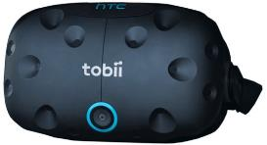

FIGURE1.1–VIVEHTCTOBIIVirtualRe-

alityHeadset.

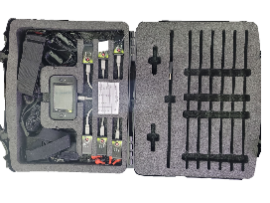

FIGURE1.2–CaptiveT-Senssensors.

## Research boundaries

This experiment is not testing the usability of the guidance tools developed for it. These tools are only used here to help users and researchers compare the different feelings provoked by the information transmitted by it.

## Structure

This master’s thesis is organized in 8 different chapters and they the following:

• Introduction

It’s the current chapter of this master’s thesis

#### • Theoretical Foundation

This chapter explores the mains concepts that are needed to fully understand this experiment. These concepts are:

* Human Factor or Ergonomics;
* Mental Workload (MWL);
* Task Performance;
* Physiological measures; – Subjective measures.
* Situation Awareness (SA);
* Extended Reality (XR);
* Virtual Reality (VR);

*Draft Version: June 1, 2022*

* Co-Design.

#### • Literature review

During this chapter, related articles, i.e articles that involve applications of:

* VR; – BVI users;
* Human factors.

All these articles have some relevance to the current experiment.

#### • Proposal description

Within this chapter, the method used to reach the goals presented above will be explained.

#### • Virtual environment development

This chapter is dedicated to explaining the steps that were taken to design the scene used during the experiment

• Haptic belt development

In this chapter, the process of coding and assembly of the haptic belt is explained.

#### • Results’ analysis and discussion

One of the main chapters of this work. Here are presented and discussed all the gathered results and data

• Conclusion

Finally, which goals were reached and which were not and why they were not.

# Theoretical Foundation

This work uses concepts from Human Factors and Co-design and is supported by tools such as Extended Reality (XR), more precisely VR, and some specific assessment methods using task performance, physiological measures and subjective measures. This chapter introduces the need-to-know of each of these to help to better understand this Master’s thesis. Each subject is introduced in the following 5 sections

## Human Factor or Ergonomics

Studies started during the Second World War because of the performance shortfalls and failures noted in manned equipment. These studies showed that these problems could diminish when engineering, psychology and physiology were gathered when designing a system that was to be handled by a human being (SANDOM; HARVEY, 2004).

This area of study was named ”Human Factors”in the United States and ”Ergonomics” in Europe. Despite this difference in the names, today they are considered the same field of study. The International Ergonomics Association (IEA) defines Human Factors, and Ergonomics, as the following:

Ergonomics (or human factors) is the scientific discipline concerned with the understanding of interactions among humans and other elements of a system, and the profession that applies theory, principles, data and methods to design in order to optimize human well-being and overall system performance. Human Factors professionals contribute to the design and evaluation of tasks, jobs, products, environments and systems in order to make them compatible with the needs, abilities and limitations of people (KARWOWSKI, 2012).

Besides being synonyms, this definition shows that humans are a variable inside a system and their interactions should be studied and that is the focus of Human Factors (SAN-

DOM; HARVEY, 2004; SANDERS; MCCORMICK, 1998; DUL; WEERDMEESTER,

2003).

Humans handle devices, machines and equipment during their daily activities and all of these manipulations are susceptible to accidents or failures that can happen because of the interaction between operator, equipment and environment. Each interface with the operator can be a factor, for example:

* The operator’s body position during an activity;

The position can impact the comfort felled by the operator and this impacts its concentration throughout the activity, therefore, impacting the success rate or the chance of some accident happening (SANDERS; MCCORMICK, 1998).

* The environment’s lighting;

The illumination can make details easier to be noted without provoking discomfort or distraction to the user and even increase productivity (SANDERS; MCCORMICK, 1998).

* The information displayed and manipulation of the device.

The way information is displayed on a screen, figure or text impacts how efficiently it will be understood by the operator. If this takes too long it can draw the operator’s attention for too long and compromise his/her reaction time.

Taking humans into account when designing a product or a system is one of the principles for human factors (SANDOM; HARVEY, 2004) and the results of this humancentred design are already an ISO Standard (BS EN ISO 13407 ”Human-centred design processes for interactive systems”). This standard was originally written for computerbased-systems, but is easily applicable in other scenarios and areas (SANDOM; HARVEY, 2004).

It is important to say that when it is said ”User”, it doesn’t mean that one needs to design a product specifically for an individual. The design has to be suited to everyone (DUL; WEERDMEESTER, 2003).

”Human-Machine systems” (on this thesis, for now on, called simply ”Systems”), are interactions between humans and machines. These systems are designed to have an input, or demand, and an output, or product. Here, ”machine” can be any manipulated object, from a simple screwdriver to a car, or some machine operated by more than one human, like a cargo ship for example. The Figure 2.1 represent a general human-system machine interaction.



Information

processing

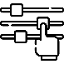

Controlling



Controls



Operation



Display



Senses

Human

Machine

WorkEnvironment

Input

Output

FIGURE 2.1 – Human-Machine system representation (SANDERS; MCCORMICK, 1998).

## Mental Workload (MWL)

Mental workload (MWL) is one of the main concepts studied in Human Factors and is not a familiar concept to most people (STANTON *et al.*, 2004). A good way to explain it is with an analogy with physical workload (STANTON *et al.*, 2004). When an athlete must lift a dumbbell (one of those gym weights bars). The strength demand from the athlete will be proportional to the dumbbell’s mass he/she is lifting. If the dumbbell is lighter than the athlete’s capability, then it will be easy enough for him/her to lift it. So if the athlete is strong enough to carry the dumbbell, he/she will not feel a physical demand bigger than his/her capabilities. So the physical workload of this activity is properly fitted for this athlete.

If the dumbbell is heavier than the athlete can lift then two things can happen:

* Or the athlete adapts to lift that dumbbell using tools (adjust the strategy)
* Or the athlete will not be able to lift completely the dumbbell (performance degrades)

This is a scenario that represents a user, or operator, executing a task that is not fitted for their capabilities.

It is the same with MWL. Each human being has a finite mental capacity and can only use it with a limited number of tasks at the same time. If the sum of these mental demands is higher than the user’s capacity, the user will need to adapt to finish those tasks, otherwise, he/she will compromise the overall performance of those tasks.

Although, if the workload is too low, the same operator may get bored and easily distracted and so could also fail or not process the task’s information.

It’s important to say that MWL is unique within each individual and is influenced by his/her perception of the task‘s workspace but is also impacted by other factors outside the task itself and more related to the operator (like its skill, age, education, training) or the environment (like noise, heat and toxicity) (CAIN, 2007; FALLAHI *et al.*, 2016; CARDOSO; GONTIJO, 2012).

MWL is not a quantitative resource or something that one can directly measure, but it has methods to infer it. The Figure 2.2 has an overview of MWL and its measurement methods.

### Task Performance

If the MWL influences the task performance, then it would be possible to infer it using the performance’s variation of a task. Because there are cases where the user’s mental capacity is too high for only one task, two tasks are designed. In these evaluations, the user is asked to maintain a good performance level and still try to execute both tasks. Both tasks are similar and use the same kind of skill. (STANTON *et al.*, 2004; SANDERS; MCCORMICK, 1998).

For example, an experiment to assess MWL in a flight simulator which uses two tasks:

* Fly a fighter aircraft and maintain a good performance level;
* Mentally sum two random numbers that appear on the screen. If the numbers’ sum is odd, then the pilot should press left on the keyboard else he/she should press right.

If the pilot’s performance at the second task is too low, it means that the demand from the first task was too high for him/her to be able to pay attention to it, then it means that the MWL at the flight was high (MOHANAVELU *et al.*, 2020).



Mental



Task

Demand



Mental

Capacity

workload



Primaryand



Physiological



Subjective

secondary tasks measurements measurements

FIGURE 2.2 – A overview of mental workload and the methods to infer it.

### Physiological measures

There are many physiological reflexes that one can use to assess MWL. These measures are a good, unbiased method to assess MWL (FALLAHI *et al.*, 2016), but, still, it is recommended that they are evaluated alongside another method. It is possible to extract MWL information from the heart and brain activity (CHAKLADAR *et al.*, 2020; ORLANDI; BROOKS, 2018), skin conductance, eye movement, pupillary contraction (STANTON *et al.*, 2004; RODR´IGUEZ *et al.*, 2015) This master’s thesis it is used heart activity and skin conductance.

2.2.2.1 Heart rate and heart variability with electrocardiogram (ECG)

The electrocardiogram is a recording of the heart’s electrical activity. With this recording one can verify the heart’s interval between heartbeats and frequency (heart rate, HR), and other statistical parameters such as the standard deviation and the mean error (heart rate variability, HRV) and these are a good way to assess MWL (CAIN, 2007). This is a simple and non-invasive method used in many human factors’ experiments (MOHANAVELU *et al.*, 2020; MANSIKKA *et al.*, 2016; ZHANG *et al.*, 2014).

The heart activity is controlled by the sympathetic and parasympathetic nervous systems. These systems are responsible to control many of the body’s autonomous activities (STANTON *et al.*, 2004).

During a task that has a mental demand the user’s heart activity changes with MWL. The higher the MWL, the higher the HR and lower the HRV. This happens because of the mechanism that controls our heart activity. These are consequences of two reactions in our system when in a mental demand situation (STANTON *et al.*, 2004).:

* A decreased parasympathetic nervous system activity and;
* An increase in sympathetic nervous system activity.

2.2.2.2 Electrodermal response with galvanic skin reaction (GSR)

One of the electrodermal activities that can happen in our skin is controlled by the sweating and the moisture level and both can be used to reveal changes in our sympathetic system (NOURBAKHSH *et al.*, 2012; SHI *et al.*, 2007). So its origin lies solely in the sympathetic branch of the autonomic nervous system as is MWL (STANTON *et al.*, 2004). EDA is being used to assess stress, emotion, arousal, mental strain and cognitive activity (NOURBAKHSH *et al.*, 2012; STANTON *et al.*, 2004; SHI *et al.*, 2007)m also used to evaluate the usability of HCI systems (SHI *et al.*, 2007) and some are to assess the mental workload (ZHANG *et al.*, 2014; BORGHINI *et al.*, 2014).

### Subjective measures

It is discussed if one should only use subjective measures to measure MWL (SANDERS; MCCORMICK, 1998; STANTON *et al.*, 2004). They are sensitive to perceived difficulty, automation, concurrent activities and demand for multiple resources. These test can be unidimensional, which are simpler but has only a general workload score (STANTON *et al.*, 2004), or multidimensional. Some example of the latter is the Subjective Workload Assessment Technique (SWAT) and the NASA Task Load Index (NASA-TLX), both multidimensional tests. SWAT treats MWL as a load defined by three dimensions: time load; mental effort load; and psychological stress. In this test the user scores each of these dimensions based on a 3-point scale while NASA-TLX uses 6 different dimensions.

2.2.3.1 NASA-TLX

NASA-TLX is a questionnaire created by Hart e Staveland (1988). It is answered by a user who has just completed a task/activity that someone wishes to infer its MWL. This questionnaire will assess the task’s MWL felt by that user with 6 rating scales and each of these is explained, ideally, at the experiment’s briefing. The Table 2.1 presents each scale with a description of it.

TABLE 2.1 – NASA-TLX dimensions and the description of each dimension. (STANTON *et al.*, 2004).

|  |  |
| --- | --- |
| Dimension | Explanation |
| Mental demand (MD) | The mental and perceptive activity demanded by the task (chose, decide, think, calculate, search, etc.). |
| Physical demand (PD) | The physical activity demanded by the task (pull, lift, spin, drag, etc.). |
| Temporal demand (TD) | The time pressure felt by the user. A rating the leverages the time available and the time necessary to completed the task. |
| Performance (PE) | The user’s satisfaction with it’s perfomance or result the task. |
| Effort (EF) | A rating of the effort necessary to achieve that perfomance felt by the user. |
| Frustration (FR) | A rating of stress, annoy or irritation felt by the user throughout the task. |

These questionnaires evaluate only one task/activity. So if the user executed two tasks (like a primary and secondary task), he/she should be oriented to answer about the primary task only, not a combination of both of them (SANDERS; MCCORMICK, 1998).

To measure mental workload, it is recommended not to choose only one measuring method, but more. MWL is multidimensional and can reflect partially or differently in each of the methods (SANDERS; MCCORMICK, 1998).

## Situation Awareness (SA)

Situation awareness (SA) can be defined as ”the perception of the elements within a volume of time and space (Level 1), the comprehension of their meaning (Level 2), and the projection of their status in the near future (Level 3)”. The term was first written in the aeronautic sector. Today is a key factor when designing complex and dynamic systems, i.e the aeronautic and automotive, medical and nuclear power plant systems (ENDSLEY, 1995). It is an important factor to make sure that the user will be capable to take important decisions correctly and achieve high-performance (ENDSLEY, 1988a; ENDSLEY, 2018).

For example, when an air traffic controller looks at a radar display, he/she seeks to understand the aircraft’s position and speed and then predict its position in the near future (5, 10 or 15 minutes after) (SANDERS; MCCORMICK, 1998), or when a pilot reads the cockpit panel, understands their data then he/she can predict the next reading of that same instrument or some other status of the aircraft after a couple of minutes.

As is with MWL, SA is not a quantitative subject. The most common way to measure SA is by subjective methods, for example the Situation Awareness Rating Technique, but is not reliable since it can distort the participant’s answer (STANTON *et al.*, 2004), and the Situation Awareness Global Assessment Technique (SAGAT). The Figure 2.3 represents an overview of SA.



Information



1

stLevel

Perception



2

ndLevel

Comprehension



3

rdLevel

Projection



Decision

making

FIGURE 2.3 – A overview of situation awareness and the SAGAT.

### SAGAT

The Situation Awareness Global Assessment Technique is a method developed by ENDSLEY in 1988b. It is based on how the information is processed inside the user’s mind. The test application is made by stopping the operator activity, usually made in a simulation, then asking the user some questions that were previously created based on the user’s activity. These questions should be as similar as possible to how the person thinks when thinking about that information to avoid extra effort in understanding it (STANTON *et al.*, 2004).

Although the stopping during the activity may sound troublesome for the testing, empirical work has shown that that doesn’t interfere with the user performance and the user memory can withstand a break as long as 5 to 6 min ENDSLEY

## Extended Reality (XR)

Extended reality refers to the interaction of a Human-Machine system with a real and virtual interface together. It has four different forms:

* Augmented Reality;
* Augmented Virtuality;
* Mixed Reality;
* Virtual Reality.

These forms differ from one another based on the leverage of reality and virtuality involved in the system. To help to visualise these differences, Milgram e Kishino (1994) created the concept of ”virtuality continuum” and is presented on Figure 2.4.



Real

Environment

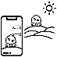

Augmented

Reality



Augmented

Virtuality



Virtual

Reality

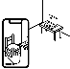

Mixed

Reality

FIGURE 2.4 – The Virtuality Continuum concept (MILGRAM; KISHINO, 1994)

The extreme left means full reality, where the stimuli does not come, or is not produced by any computer or any other digital system. Along the path to the right, the environment starts to have some digital elements until it reaches the far right, where all the elements in the environment have a digital origin (NIJHOLT; TRAUM, 2005; DOOLANI *et al.*, 2020). The first step from the Real Environment to Virtual Reality is the Augmented

Reality.

### Augmented Reality (AR)

In augmented reality, the user can see some digital elements, that could be text, images, video, etc, that are laid in a real environment without the user losing the sense of presence in the real world. Some uses for AR are to assist workers in the manufacturing, assembly tasks and training (DOOLANI *et al.*, 2020; FARRELL, 2018; MA; CHOI, 2007).

### Augmented Virtuality (AV)

While AR brings digital elements inside a real environment, Augmented Virtuality creates an environment that could only exist with a digital origin, like a fantasy world from games or movies. This scenario is the background of some other activity that is being done in a real environment. An example could be using a virtual environment during a pilot or driver training or an engineer visualizing a real-time model of an aircraft in flight (FARSHID *et al.*, 2018). Other examples could be playing sports while using equipment to play it, like tennis, golf or baseball but the arena is completely digital. The user can use the real equipment with a tracker, but, besides that, the rest would be all digital.

### Mixed Reality (MR)

Mixed Reality stays in between Real and Virtual Environments. But what is the difference between MR and AR or AV? In MR the user can manipulate digital elements as if they were inside the real world (DOOLANI *et al.*, 2020). For example, a client from a furniture store could use MR to see what product fit inside his/her room. He/she can move the furniture inside the room and see if the colors, size and shape fit before buying or even going to the shop.

### Virtual Reality (VR)

Resting in the far right of the virtuality continuum, the Virtual Reality has its user as the only element that hasn’t a digital origin, making he/she immersed in a virtual environment, but, of course, inside the physical limits of a real environment (MA; CHOI, 2007). If the feeling of presence of that environment is well done, the user can momentarily forget about the real environment and act and react accordingly to the virtual environment (FARRELL, 2018).

VR is a powerful tool that allows a user to be transported to a tridimensional environment that could be out of reach or that doesn’t exist but is perfect to test or train some situation. Inside this virtual environment, the user can walk and look around and interact with the many elements as if they were real (MUJBER *et al.*, 2004) and this technique becomes more effective and valuable when one can simulate a real situation and use it for training (SALAH *et al.*, 2019).

The Figure 2.5 shows the representations of each of these Extended Reality subsections.

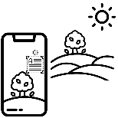

Augmented

Reality

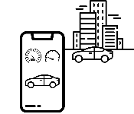

Augmented

Virtuality

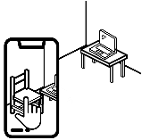

Mixed

Reality

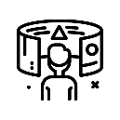

Virtual

Reality

FIGURE 2.5 – A represantion of the differences between AR, AV, MR and VR

## Co-Design

Collaborative design is a way to design in which each element inside a development team has a different experience, resources, ideas or formation which can be important for the product effectiveness. It is based on good communication and information sharing (CHIU, 2002). Still, it is common to say ”collaboration”interchangeably with ”interaction” and ”cooperation”. Some authors define those words differently. ”Interaction” is a more formal relationship between the elements (KAHN, 1996) and ”cooperation” focus more on the coordination and the mutual gain or benefit between the elements (SMITH *et al.*, 1996).

For collaborations, the shared vision and the process to be followed are important (KLEINSMANN, 2006).

Collaborative design is the process in which actors from different disciplines share their knowledge about both the design process and the design content. They do that to create a shared understanding of both aspects, to be able to integrate and explore their knowledge and to achieve the larger common objective: the new product to be designed (KLEINSMANN, 2006).

According to Kleinsmann (2006) two aspects are important for Collaborative Design:

Information is a data after the receiver’s understanding, or translating, process. Knowledge is the data in a state that is possible to record or register to remember later inside the individual’s memory. These can be ideas, facts or concepts. During the collaborative design, these ideas, facts or concepts are exchanged between the actors. This exchange is a fundamental part of this method since it is responsible for the growth of each individual’s knowledge and this is used to perform their tasks. This brings us to the second aspect, the knowledge integration (KLEINSMANN, 2006).

With both of these aspects in mind, Kleinsmann (2006) defines Collaborative design as ”the process in which actors from different disciplines share their knowledge about both the design process and the design content”. This happens to increase the team’s understanding to help them to design a new product based on all of their knowledge and experience.

# Literature review

For the literature review of this work the following steps were taken to filter out the articles read.

• Search through the Scopus and Web of Science platforms;

* Search the Scopus plaform:

∗ Filter articles using the keywords ”Human Factors”, ”Virtual Reality”; ∗ Filter articles from 2019 until 2022 and related to engineering or social science;

∗ Read the title and abstract and select the more relevant of them; ∗ Read the selected articles.

* Search the Web of Science:

∗ Filter articles using the keywords ”Human Factors”, ”Virtual Reality”, ”Covid-19” and ”Blindness”;

∗ Read the title and abstract and select the more relevant of them; ∗ Read the selected articles.

After following these steps, 344 abstracts were read and from these the following articles were selected as the most relevant for the research.

## Virtual Reality Without Vision

SIU *et al.*, also motivated by the popularization of the VR technology, developed a White Cane to be used by BVI users in virtual environments and to make virtual reality applications useful for these users as well. The traditional white cane transmits three sources of information to the user: Detection of obstacles, surface topography and footplacement preview. These information are transmitted through sounds or haptics (SIU *et al.*, 2020) and the developed cane would simulate that in the virtual environment.

For obstacle detection, the new cane ws built with a three-degree-of-freedom brake mechanism that would stop the movement when the cane hit an obstacle. It was installed a voice coil actuator which was used to detect surface properties or other information that had a higher frequency than the capacity of the brake mechanism. Lastly, a wave-based acoustic simulation was used to render geometry-aware sound effects in other to enable the user a sense the surroundings using the sounds (Echolocalisation).

The experiment’s participants were meant to play a ”Scavenger Hunt” using an HTC Vive. During the experiment each participant had two tasks:

* Collect targets along the way;

The main task. Five targets appeared, one at a time, once the previous target was collected, and they emitted a sound that acted like an audio beacon for the participant. The experiment was concluded when the participant collected all of them.

* Avoid virtual obstacles and walls.

The secondary task. These obstacles didn’t emit any sound as a beacon, but the participant could detect it by the shape and by the noise it emits when in contact with the cane. All the obstacles had the same geometry and material, a cube-shaped metal. When tapped by the cane, this object emitted a metal clinking sound.

Besides the audio beacon and the metal sound, there was also a sound when a target was collected, when colliding with a wall and with an obstacle. Figure 3.1 shows the targets obstacles and the starting point location.

The experiment was performed with 8 blind users (4 female, 4 male) from 25 to 70 years old. All of them did a training section where it was presented to them the mechanics of the virtual environment and how to detect walls, doors and obstacles. Figure 3.2 shows both the training and the game rooms.

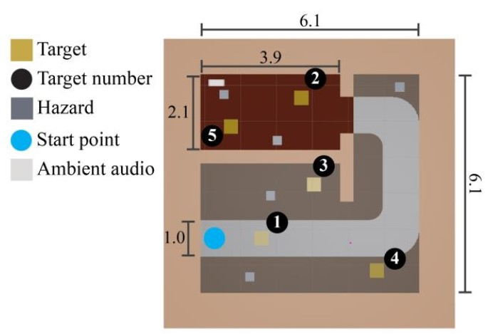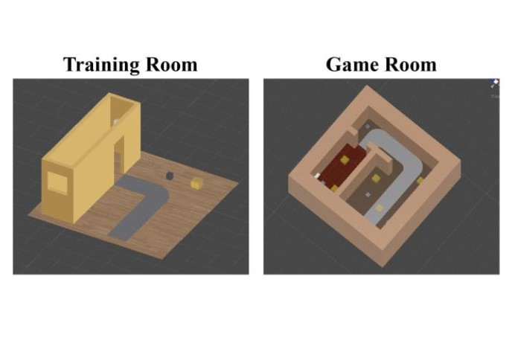

FIGURE 3.1 – Siu et al. key locations. Dis- FIGURE 3.2 – Siu et al. training and game tances are in meters (SIU *et al.*, 2020). rooms layout (SIU *et al.*, 2020).

The researcher found out that the simulated vibration of the cane confused part of the participants, while others were familiar with that vibration of the cane. This has been reflected in the performance of these participants. The ones that were already used with this vibration performed better. This shows that user preferences can impact their performance and experience in the VE.

Another point taken by the researcher was about navigating in tight spaces. It was easier for the participants to navigate in larger areas, similar as it is said in the real world.

The conclusion was about the exploration of the environment. The participants were focused on finding all of the targets and did not explore the environment. This might have caused a bias in the low time and low obstacle hits. So it is not sure that the tool could help a BVI user to freely explore a VE.

The authors noted some limitations. The cane, even though it had a good brake system, it didn’t stop the participant when he/she walked forwards toward a wall. The lack of variation in the cane material and in the feedback possibilities (i.e when the obstacle contacts a point along with the cane, not the tip of it).

The present experiment has similar motivations, to study or improve BVI users’ navigation, but in different environments. While the work from SIU *et al.* was focused on the navigation of BVI users inside a VE, this experiment uses VE to assess BVI navigation in a simulated real environment. SIU *et al.* commented on the importance of the sound in the guidance of the BVI and used spatialized audio to increase the realism and received positive feedback from the participants as this experiment also did.

One big difference between the two works is the cane. SIU *et al.* used a cane controller that represented a virtual cane inside the VE, as was made in this work with the *Virtual Cane*, but the feedback from the *Virtual Cane* interaction on the VE was only a vibration, whilst the cane controller, besides using a high-frequency response that could be said to be similar to vibration, used a brake system to simulate the contact with the wall or obstacle. This experiment couldn’t apply this resource for financial and time reasons.

## Effects of Emotion and Agency on Presence in Virtual Reality

One of the many feelings that flourish during the use of a VR is the feeling of presence. This feeling, inside the virtuality context, is when someone feels drawn into a VE and starts to occupy the VE instead of the real one (CUMMINGS; BAILENSON, 2016).

Jicol *et al.* (2021) explores this feeling in its work. The authors aim to correlate the feeling of presence with one’s agency (which is the self-perception that the user is in control of a situation or some actions (FARRER; FRITH, 2002)) and emotion, both of these in a VE context. Besides assessing this correlation, the author also did a structural equation model (SEM) based on their findings. The author did this by creating two different VE, one that would trigger happy emotions, and another that would trigger fear. For each VE there were two different variations of it, one that the user could interact with its elements and another that it could not. So at the end, four different VE were designed as the Figures 3.3a to 3.4b show.

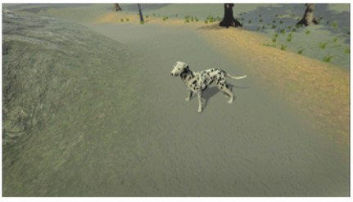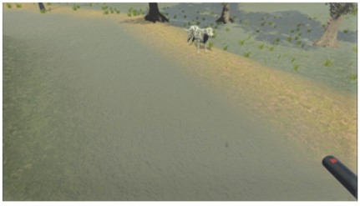

(a) Without agency. (b) With agency.

FIGURE 3.3 – Happy environment (JICOL *et al.*, 2021).

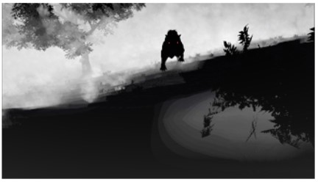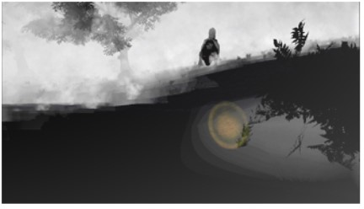

(a) Without agency. (b) With agency.

FIGURE 3.4 – Fear environment (JICOL *et al.*, 2021).

This experiment had 121 participants and they were randomly assigned to one of the four VE. Participants with a neurological disease, fear of dogs, psychological or emotional issues, epilepsy or use of the medical device were excluded.

The authors had three hypotheses about their experiment:

1. The intensity of the dominant emotion in each VE will correlate positively with the presence
2. Presence will be significantly higher in environments where participants have agency
3. Agency will moderate the effect of the emotion on the presence

The first hypothesis was confirmed. No matter if the feeling is positive (happiness) or negative (fear), the users did feel a stronger presence when the positive or negative feelings were more intense.

The second hypothesis was partially correct. In the VE that provoked fear, agency did make a difference and induced a higher feeling of presence, whilst in the VE that provoked happiness, agency did not affect the presence. The same could be said about the third hypothesis.

This is an important work for its findings on the user’s presence feeling. Inside a VE, users that have a direct interaction inside it do find a bigger feeling of presence. This is important for this master’s thesis experiment. It is possible that, if the participant did not feel ”present”inside the VE, the gathered data could be less sensitive to the experiment’s goals.

This experiment did not assess directly the feeling of presence, but the feeling of presence inside a VE with BVI users could be a suggestion for future works or even a base study.

## Bradley and Dunlop research about BVI navigation

Bradley and Dunlop wrote two works about BVI navigation, one in 2002 and the last in 2005.

### The 2002 investigation

In 2002 they studied which information BVI users used throughout their navigation and compared the data collected with other similar data, but instead, it was answered by sighted users. This second data was also collected by the same researchers in a prior investigation, made also in 2002, and both of the data were collected using the same interview structure.

This investigation was made by analyzing the answers from an interview with the participants. In this interview, the participants had to explain how to arrive at two different locations as if they were talking to someone with the same condition. The answer was then classified on 11 different categories:

* Directional (e.g. left/right, north/south)
* Structural (e.g. road, monument, church)
* Environmental (e.g. hill, river, tree)
* Textual-structural (e.g. name of shops, places, restaurants)
* Textual-area/street-based (e.g. name of street, neighborhoods, squares)
* Numerical (e.g. first, second, 100m)
* Descriptive (e.g. steep, tall)
* Temporal/Distance based (e.g. *”walk until you reach...”* or *”before you get to”*)
* Sensory (e.g. sound of engines, the smell of bread from a bakery)
* Motion (e.g. cars passing by, doors opening)
* Social Contact (e.g. asking people or using a guide dog for help)

The motion and the social contact were added in the interview with the BVI users, so the researchers re-analyzed the sighted answers to fill this classification as well. The Figures 3.5 and 3.6 show their findings.

Average nº of utterances used within each contextual category between sighted and visually impaired participants

0

Type of contextual categories

Averagen

º

ofutterance

5

10

15

20

25

30

35

40

45

50

55

60

65

70

75

80

85

90

Direct

Struct

Environ

Text-struct

Text-area/st

Numer

Desc

Sensory

Tem/Dist

Motion

Social

Visualy I

mpaired

Sighted

FIGURE 3.5 – Comparison between sighted participants with BVI participants (BRADLEY; DUNLOP,

2002).

In conclusion the researchers realized that BVI participants use less text-based information than the sighted participants, but BVI participants used more words to describe a path than the sighted participants.

Besides describing the paths to reach the destinations, the researchers also asked the BVI participants their ”opinions on the importance of different types of contextual information for route navigation, design issues relating to usability and their mobile needs/requirements”(BRADLEY; DUNLOP, 2002). Many participants said that white canes and guide dogs had limitations and also commented that sensory information is very important when different types were used together in order to confirm one piece of information.

Average nº of contextual categories used per participant

within sighted and visually impaired groups

0

Groupsusedfor

comparison

1

2

3

4

5

6

7

8

9

10

11

Sighted

VisuallyImpaired

Average nº of categories used for each route description

FIGURE 3.6 – Number of categories used by each group (BRADLEY; DUNLOP, 2002).

### The 2005 experiment

Based on the findings from 2002, Bradley and Dunlop designed an experiment to investigate if there is a difference between the perceived workload of both BVI participants and sighted participants when then navigate using user-tailored information created with the results of both previous experiments.

16 participants, 8 sighted and 8 BVI, were recruited to walk to four pre-determined landmarks at the center of Glasgow. They followed the same orientations that were pre-recorded and given to the participants. For each participant, orientations for 2 of these 4 landmarks, that were made using based on the proportions of the results of the sighted users’ interview, were randomly given. Similar was made with the remaining 2 landmarks, but with orientations made with the findings of the BVI users’ interview. These proportions are presented at the Table 3.1

TABLE 3.1 – Proportion of each type of information used by sighted and BVI participants (BRADLEY; DUNLOP, 2005)

|  |  |  |
| --- | --- | --- |
| Class of contextual information | % Used Sighted | % Used BVI |
| 1. Directional | 37.4 | 30.1 |
| 2. Structural | 11.5 | 20.1 |
| 3. Environmental | 1.6 | 2.9 |
| 4. Textual-structural | 9.9 | 1.2 |
| 5. Textual-area/street | 15.6 | 2.7 |
| 6. Numerical | 5.0 | 7.5 |
| 7. Descriptive | 10.8 | 23.8 |
| 8. Temporal/distance | 8.2 | 5.1 |
| 9. Sensory | 0 | 4.4 |
| 10. Motion | 0 | 0.8 |
| 11. Social contact | 0 | 1.4 |

Their results found that BVI users reached landmarks significantly quicker when given

the information that was made for that group, but still longer than sighted users. This comparison is shown in the Figure 3.7 and 3.8. Condition 1 is the verbal orientation made for sighted users and condition 2 is the verbal orientation made for BVI users

Comparing condition times for Comparing condition times for visually impaired participants sighted participants

0

Averagetime(secs)

50

100

150

200

250

300

Con1

Con2

0

Averagetime(secs)

50

100

150

200

250

300

Con1

Con2

Lan 1 Lan 2 Lan 3 Lan 4 Lan 1 Lan 2 Lan 3 Lan 4

FIGURE 3.7 – Mean times for each land- FIGURE 3.8 – Mean times for each landmark performed by the sighted participants mark performed by the BVI participants

(BRADLEY; DUNLOP, 2005). (BRADLEY; DUNLOP, 2005).

After the experiment a NASA-TLX was completed by each participant. The score for each dimensions is shown in the Figures 3.9 and 3.10. These scores show that BVI participants did have higher workload when guided by the condition 1 as well as the sighted participants did with the condition 2.

Comparing visually impaired

participants’ workload rating for both

conditions

0

Averageweighted

score

50

100

150

200

250

300

350

dition 1

Con

dition 2

Con

Comparing visually impaired

participants’ workload rating for both

conditions

0

Averageweighted

score

20

40

60

80

100

120

140

160

180

Con

dition 1

Con

dition 2

MD PD TD OP EF FR MD PD TD OP EF FR

Type of contextual categories Type of contextual categories

(a) BVI participants. (b) Sighted participants

FIGURE 3.9 – Comparison of the NASA-TLX between the conditions (BRADLEY; DUNLOP, 2005).

Comparing group scores for condition 1

0

Workload dimensions

Averageweightedscore

50

100

150

200

250

300

350

MD

PD

TD

OP

EF

FR

y impaired

Visuall

Sighted

1.

(

a)Condition

Comparing group scores for condition 2

0

Workload dimensions

Averageweightedscore

50

100

150

200

250

300

MD

PD

TD

OP

EF

FR

Visuall

y impaired

Sighted

(

b)Condition

2.

FIGURE 3.10 – Comparison of the NASA-TLX between the participants (BRADLEY; DUNLOP, 2005).

This current experiment used their conclusion in order to create proper navigation commands used in the experiment. Another difference between this experiment and the one written by the duo is the inclusion of haptics information in the scope of studied guidance commands.

## Evaluation of spatial display for navigation without sight

In the work of (MARSTON *et al.*, 2006), the author wanted to test a prototype developed in previous research on the street and in a park with a blind user. This experiment would also compare two different guidance displays, one based on haptics transmission and another based on sounds.

8 BVI participants attended the experiment, which was divided into one training set and two test sites. The first was in a busy block that had a variety of street furniture, parked bicycles and people and the participant needed to pass through 4 waypoints for a total of 244m. The second site was inside a park, with paths made of concrete, crushed gravel and paver blocks, with 7 waypoints for a total of 187m. Each participant did each route with both guidance displays.

The researchers collected the time to collect all waypoints, the errors made, the distance traveled and the percentage of the total time that the users accessed the guidance device. All participants were able to complete all routes and collect all waypoints with both devices. This shows that they were able to be guided by new sound or haptic devices. The mean time to collect all the waypoints using the sound device was lower than with the haptic device, as shown in the Figure 3.11. This Figure shows a standardized time made based on the time that two researchers took to complete the route, both of them blindfolded and with a cane, but already had made the same route many times before and during the experiment.

Another finding from this work is about the use of the haptic device caused some strain

1

Subjects

RelativeAccessMeasure

(

)

RAM

1.5

2.0

2.5

3.0

3.5

4.0

S1

S2

S3

S4

S5

S6

S7

S8

Street HPI

Street Virtual Sound

Park HPI

Park Virtual Sound

FIGURE 3.11 – Standardize mean completion time for each subject with each device in each route (MARSTON *et al.*, 2006).

on the arm and was less acceptable as compared to the sound device, which required no use of the arms.

This study was relevant for current work because it also compares the same types of guidance devices. The participants were asked to score both devices in three questions from 1 = very unacceptable to 5 = very acceptable. These scores are presented in the Table 3.2. As said above, the participants were able to perform the full experiment with both devices, but there seems to be a preference for the sound-based device.

TABLE 3.2 – Scores of the device

|  |  |  |  |  |
| --- | --- | --- | --- | --- |
| Statement | Haptic device’s mean score | SD | Sound device’s mean score | SD |
| Precision of the directiona information | 4.0 | 0 | 4.1 | 0.83 |
| Personal safety while using the device | 4.1 | 0.35 | 4.0 | 0.76 |
| Ease of use | 3.5 | 0.53 | 4.6 | 0.52 |

But what about being able to use both devices? That’s one of the questions that the experiment of this master’s thesis aims to answer.

## Use of VR in the aircraft cabin design process

This chapter is about the proposed methodology of this master thesis experiment. The Figure 4.1 shows the phases and the tasks inside each phase. This chapter will explain each phase and task presented in the Figure 4.1.

Interview’s

phase

Interview

withhospitals

Interview

withBVI

consultants

Scope’sphase

Virtual

environment

definition

Assessed

humanfactors

definition

Guidance

methods

definition

Development’s

phase

Virtualscenes

creation

Toolsand

methods

definition

Guidance

methods

development

Tryout’s

phase

Tryouts

Experiment’s

phase

Experiments

FIGURE 3.12 – Methodology’s diagram

## Interviews’ phase

The first phase of this project was the Interviews’ phase. In this phase, the researchers’ main goal was to gather information, especially those related to the COVID-19 pandemic, about the main procedures that happen inside a hospital and about the daily life of BVI people.

### Interview with the hospital

To understand the procedures that hospitals and medical clinics followed during their day-to-day activities and the COVID-19 pandemic, two hospitals were interviewed. The interview was aimed to find out how a new patient does check-in and the following steps until he/she gets in the proper medic’s office.

At the project’s start, the scenario was supposed to be a reception inside a hospital, but, because of the physical space needed to simulate that virtual environment, the scenario changed throughout the project several times.

### Interview with the BVI consultants

One of the motivations of this master thesis is that the current BVI guidance products are not effective enough and one of the likely reasons is that the BVI users were not consulted during the product development process.

With that thought in mind, BVI users were consulted to design a virtual environment that would be familiar with their reality. Two users with different visual impairments were interviewed, one person that became blind at 13 years old, and another with Usher’s disease. These were critical to understanding how they perceive a medical clinic as they walk in and how they interact with the environment and these notes were used in the next phase.

## Experiment idealization’s phase

At this phase, the proceedings and the interview notes are used to make key decisions about the virtual environment used in the experiment, which human factors are going to be assessed and which guidance methods are going to be used

### Experiment’s virtual world definition

As said before, the original idea was to use a hospital reception as a model for the virtual environment for the experiment, however, the physical space needed to fit the hospital was too big. So instead of a whole hospital reception, it was decided to use it as a medical clinic reception but still with the same proceedings.

### Assessed human factors definition

To reach the experiment’s objective, a set of human factors had to be chosen. The objectives 2 and 3 could be reached if the assessed human factor represented the user’s workload and the developed mental map. Both these could be evaluated using:

* Mental workload
* Situation awareness

The details about each method are explained in the sections 2.2 and 2.3.

### Guidance methods definition

The variety of BVI users is wide, as is the variety of assistive products. All of these products must communicate with the users and they use sound, vibration or both to transmit information. With this thought in mind, it was decided that it would be used at least two methods: one that relies only on audio and another that transmits only vibration. Of course, the interaction between those two methods would be also evaluated.

This interaction became the third method.

Another interesting property that could be evaluated in those products is the effect of information being transmitted with and without the user’s command. This evaluation split the vibration method into two: one that worked *without* the user’s command and another that worked *with* the user’s command.

At the end, the following methods were chosen to be analysed:

* A usual guidance method;
* Audio guidance;
* Vibration guidance without command;
* Vibration guidance with command;
* Mixture of audio and vibration.

## Development and creation’s phase

With the decision of the previous phase it is possible to start the development of the virtual environment, the guidance methods and the tools for the assessment of the human factors.

### Virtual world creation

The virtual reality application was made using the software Unity3D, which is a famous tool for virtual reality applications and game development. It has some built-in tools but is also possible to customize functions for more specific use (WANG *et al.*, 2010). The virtual environments, or scenes (as it is called inside the Unity3D), were made with the dimensions to fit in the CCM entry hall, which has a flat area of 8x4m. Inside the environment, there was some typical furniture or devices found in hospital reception, a reception desk and a waiting area, composed of 2-3 chairs. The participant had 4 tasks at the scene and they are displayed at Figure 4.2. More details ahead at Chapter 5.

1. Clean the hands at the sanitizer totem (COVID-19 procedures);
2. Go to the reception desk to receive a queue number;
3. Go to the waiting area and wait for the number calling;
4. Leave the room when called

Sanitizertotem

Reception



Waitingarea

#### Exit Entry

FIGURE 3.13 – Scheduled task of the experiment and their order.

The goal of these tasks is to engage the user to navigate through the room and see if it can draw a mental map of the scene as well as use the information about the obstacles to avoid them when needed. Besides these main components, there were some minor distractions that are common to hear at a clinical, such as telephone ringing, keyboard typing, people taking and others. These were put to increase the immersion and to be a distraction as well, otherwise, it wouldn’t simulate the reality of these scenarios.

### Tools and methods definition

There were three types of human factors assessment tools that were applied in the experiment:

* Task performance;

Measured using the time and the number of contacts between the user and the furniture throughout the experiment.

* Physiological measures;

Measured using an ECG sensor, a GSR sensor and a temperature sensor. • Subjective measures.

Measured using a NASA-TLX, a SAGAT Adapted questionnaire and a guidance method evaluation questionnaire.

The details about each method are explained in the sections 2.2.1, 2.2.2 and 2.2.3.

### Guidance methods development

As said in the last section, three different guidance methods were established to be used in the experiment besides the White Cane, a haptic belt and a virtual cane.

• A audio guidance method;

The audio-only guidance method will be straight and simple. In the course of the experiment the participant could give two different voice commands:

* ”What is around me?”;

The answer to this command was a quick description of the closest furniture around the user.

* ”Where is (something)?”.

The answer of this command was the direction and distance of something asked by the user.

Each command was answered by a member of the experiment team accordingly. • The haptic belt;

That is a belt that had appended 8 vibration devices that vibrate accordingly to the direction and distance of the closest object around the user. More information on the Haptic Belt ahead at Chapter 6. • The virtual cane.

This was based on the white cane mechanics, that the user ”points”the cane to check near obstacles in the direction of the cane. The virtual cane has a similar function, but instead of connecting the user to the object through the cane, it vibrates when it detects an obstacle in the direction pointed by the user. A VR hand-control was used as canes and the user point it to where he/she wanted. The algorithm used on the Virtual Cane is in the Appendix B

## Tryouts and tests’ phase

At this phase, a few tests were performed to evaluate if the experiment was going as planned and to avoid any unfortunate events or errors during the real experiment. It was expected that changes could be needed to be made before the real experiment and there were a few. It was at this phase that the final dimension of the virtual environment and the physical space were defined.

## Experiment

As the proper section name says, this phase is where the proper experiment was made.

After all these phases were completed, the next step was to analyze all the data and elaborate their conclusions. Instead of going to the results and discussions, the next Chapters 5 and 6 will deepen in the virtual environment development and the haptic belt development in these order. The Figure 4.3 shows a comparison between the virtual environment created in Unity3D and the real environment assembled in the CCM’s entry hall.

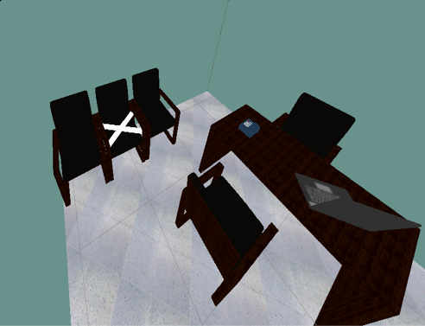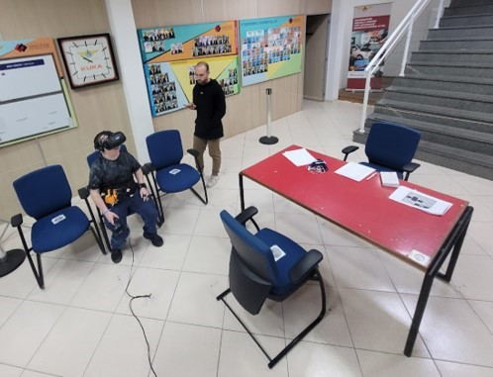

(a) Virtual environment screenshot (b) Real environment photo

FIGURE 3.14 – Environment comparisson

# Proposal description

This chapter is about the proposed methodology of this master thesis experiments. The Figure 4.1 shows the phases and the tasks inside each phase. This chapter will explain each phase and task presented in the Figure 4.1.

Interview’s

phase

Interview

withhospitals

Interview

withBVI

consultants

Scope’sphase

Virtual

environment

definition

Assessed

humanfactors

definition

Guidance

methods

definition

Development’s

phase

Virtualscenes

creation

Toolsand

methods

definition

Guidance

methods

development

Tryout’s

phase

Tryouts

Experiment’s

phase

Experiments

FIGURE 4.1 – Methodology’s diagram

## Interviews’ phase

The first phase of this project was the Interviews’ phase. In these phase, the researchers’ main goal was to gather information, especially those related to the COVID-19 pandemic, about the main procedures that happen inside a hospital and about the daily life of BVI people.

### Interview with the hospital

To understand the procedures that hospital and medical clinics followed during their day to day activities and during the COVID-19 pandemic, two hospitals were interviewed.

The interview was aimed to find out how a new patient does a check-in and the following steps until he/she get in the proper medic’s office.

At the project start, the scenario was supposed to be a reception inside a hospital, but, because of the physical space needed to simulate that virtual environment, the scenario changed along the project several times.

### Interview with the BVI consultants

One of the motivations of this master thesis is that the current BVI guidance products are not effective enough and one of the likely reasons is that the BVI users were not consulted during the products development process.

With that though in mind, BVI users were consulted in order to design a virtual environment that would be familiar to their reality. Two users with different visual impairments were interviewed, one person that became blind with 13 years old, and other that with Usher’s disease. These were critical to understand how they perceive a medical clinic as they walk in and how they interact with the environment and these notes were used in the next phase.

## Experiment idealization’s phase

At this phase, the proceedings and the interview notes are used to take key decisions about the virtual environment used in the experiment, about which human factors are going to be assessed and which guidance methods are going to be used

### Experiment’s virtual world definition

As said before, the original idea was to use a hospital reception as model to the virtual environment for the experiment, however the physical space needed to fit the hospital was to big. So instead of a whole hospital reception, it was decided to use it a medical clinic reception but still with the same proceedings.

### Assessed human factors definition

In order to reach the experiment’s objective, a set of human factors had to be choose. The objectives 2 and 3 could be reach if the assessed human factor represented the user’s workload and the developed mental map. Both these could be evaluated using:

* Mental workload
* Situation awareness

The details about each method are explained in the sections 2.2 and 2.3.

### Guidance methods definition

The variety of BVI users is wide, as is the variety of assistive products. All of these products must communicate with the users and they use sound, vibration or both to transmit these information. With this though in mind, it was decided that that would be used at least two methods: one that rely only in audio and another that transmits only vibration. Of course, the interaction between those two methods would be also evaluated. This interaction became the third method.

Another interesting property that could be evaluated in those products is the effect of a information being transmitted with and without the user’s command. This evaluation split the vibration method in two: one that worked *without* the user’s command and another the worked *with* the user’s command.

At the end, the following methods were chosen to be analysed:

* A usual guidance method;
* Audio guidance;
* Vibration guidance without command;
* Vibration guidance with command;
* Mixture of audio and vibration.

## Development and creation’s phase

With the decision of the previous phase it is possible to start the development of the virtual environment, the guidance methods and the tools for the assessment of the human factors.

### Virtual world creation

The virtual reality application was made using the software Unity3D, which is a famous tool for virtual reality applications and game development. It has some built-in tools but is also possible to customize functions for more specific use (WANG *et al.*, 2010). The virtual environments, or scenes (as it is called inside the Unity3D), were made with the dimensions to fit in the CCM entry hall, that has a flat area of 8x4m. Inside the environment there was some typical furniture or devices found in hospital reception, a reception desk and a waiting area, composed of 2-3 chairs. The participant had 4 tasks at the scene and they are displayed at Figure 4.2. More details ahead at Chapter 5.

1. Clean the hands at the sanitizer totem (COVID-19 procedures);
2. Go to the reception desk to receive a queue number;
3. Go to the waiting area and wait for the number calling;
4. Leave the room when called

Sanitizertotem

Reception



Waitingarea

#### Exit Entry

FIGURE 4.2 – Scheduled task of the experiment and their order.

The goal of these tasks is to engage the user to navigate through the room and see if it is able to draw a mental map of the scene as well as use the information of the obstacles in order to avoid them when needed. Beside theses mains components, there are also some minor distractions that is common to hear at a clinical, such as telephone ringing, keyboard typing, people taking and others. These were put to increase the immersion and to be a distraction as well, otherwise it wouldn’t simulate the reality of these scenarios.

### Tools and methods definition

There were three types of human factors’ assessment tools that were applied at the experiment:

• Task performance;

Measured using the time and the number contacts between the user and the furniture throughout the experiment. • Physiological measures;

Measured using and ECG sensor, a GSR sensor and a temperature sensor. • Subjective measures.

Measured using a NASA-TLX, a SAGAT Adapted questionnaire and a guidance method evaluation questionnaire.

The details about each method are explained in the sections 2.2.1, 2.2.2 and 2.2.3.

### Guidance methods development

As said in the last section, three different guidance methods were established to be used in the experiment besides the White Cane:, a haptic belt and a virtual cane.

* A audio guidance method;

The audio only guidance method will be straight simple. In the course of the experiment the participant could give two different voice commands:

* + ”What is around me?”;

The answer of this command was a quickly description of the closest furniture around the user.

* + ”Where is (something)?”.

The answer of this command was the direction and distance of something asked by the user.

Each command was answered by a member of the experiment team accordingly. • The haptic belt;

That is a belt that had appended 8 vibration devices that vibrate accordingly to the direction and distance of the closest object around the user. More information on the Haptic Belt ahead at Chapter 6.

* The virtual cane.

This was based on the white cane mechanics, that the user ”points”the cane to check near obstacles in the direction of the cane. The virtual cane has a similar function, but instead of connecting the user to the object through the cane, it vibrates when it detects an obstacle in the direction pointed by the user. A VR hand-control was used as canes and the user point’s it to where he/she wanted. The algorithm used on the Virtual Cane is in the Appendix B

## Tryouts and tests’ phase

At this phase a few tests were performed to evaluate if the experiment was going as planned and to avoid any unfortunate events or errors during the real experiment. It was expected that changes could be needed to be made before the real experiment and there were a few. It was at this phase that the final dimension of the virtual environment and the physical space were defined.

## Experiment

As the proper section name says, this phase is were the proper experiment was made.

After all these phases were completed, the next step was to analyze all the data and elaborate their conclusions. Instead of going to the results and discussions, the next Chapters 5 and 6 will deepen in the virtual environment development and in the haptic belt development in these order. The Figure 4.3 show a comparisson between the virtual environment created in Unity3D and the real environment assembled in the CCM’s entry hall.



(a) Virtual environment screenshot (b) Real environment photo

FIGURE 4.3 – Environment comparisson

# Virtual environment development

The main background and the source of the sensorial input was the virtual environment. Its development can be divided in 5 steps. The whole procedure is represented in the Figure 5.1.

1. Procedures
2. City Hospital
3. Medical Clinic
4. Adjustments
5. Final clinic

## Procedures

The first step of the research was to learn how hospitals operate, especially throughout the COVID-19 pandemic. Two hospitals from the city of S˜ao Jos´e dos Campos - S˜ao Paulo were interviewed on how does the reception procedure worked and both of them had a similar operation:

1. Patient enters the hospital
2. Uses the sanitizer to clean their hands
3. Take a queue number and wait for the call of the receptionist
4. Go to the receptionist and does his/her check-in
5. Sits on the waiting area and wait until it’s name is called

Hospital

procedures

Cityhospital

1

stidea

Medical

ClinicV1

Toobig

Chairs

anddesk

Telephone

ringing

Keyboard

typing

1

stpresentation

TV

playing

People

chatting

Queue

machine

Medical

ClinicV2

Medical

ClinicV3

Medical

ClinicV4

Auditoriumcomplexity

Exterior

sounds

1

sttest

Medical

ClinicV5

FIGURE 5.1 – Virtual environment development process

The tasks in the experiment were to be similar to these procedures. The only exception was the name-calling, step 5, because of the complexity of creating a routine inside the virtual environment that could call the participant’s name. One possible solution was to use an actor, but because of the COVID-19 procedures that limit the number of people inside a room, this solution was discarded.

Since the procedures were from hospitals, the first idea of a virtual environment was to build a virtual hospital reception.

## City Hospital

If the virtual environment was a hospital reception, it would be possible to include a lot of artifacts that could increase the participant’s sense of presence, such as people walking and the sound of elevators, and that was very appealing.

One problem with that idea was the physical space needed to simulate that. It would be needed a closed-quarters space with enough area to allow the participant to walk through the whole reception. The original space was approximately 15x20m and the laboratory, or the university, didn’t have somewhere like that.

So the solution for that was to shrink down the area to fit inside the laboratory, so it was decided not to simulate a hospital reception, but a medical clinic reception

## Medical Clinic

The laboratory didn’t have a room that could fit a hospital reception, but it did have plenty of space that could fit a medical clinic reception, especially in the laboratory’s auditorium. The laboratory has 7x10m and that was the dimension of the first version of the virtual medical clinic. At the first moment, it was decided that this would be the setting for the experiment and its development went towards the definition of the interior details (blue path on the Figure 5.1), but other problems appeared along with the development that the room dimensions needed to be redefined (red path on the Figure 5.1). Both of these modification are going to be detailed in the following Interior and Exterior subsections.

### Interior

The goal of the interior was to increase the presence and feeling of the participant inside the virtual environment. The inspiration was from the typical objects and furniture that a patient notices when waiting in reception. The first objects positioned inside the reception were the desk, chairs (both normal and some with ”X”in the seats to represent a COVID-19 procedure), a telephone and a laptop. The last two also emitted sounds to increase the feeling of presence and to point to the BVI participant where the reception desk was located. The telephone and the laptop had a C# script to play their sounds randomly.

This virtual environment was presented to two BVI members of the research team and they pointed out that it needed to have more noise, to increase even more the feeling of presence. They felt the lack of people chattering and the noise that came from a TV show, both were included in the virtual environment. To simulate the people chattering, dialogues from video or series between two people were used. The TV noise was made similarly, but with audio from famous Brazilian tv programs. Another missing artifact noticed by the team was the queue machine that was also included. All these added objects also had a script that played a specific dialogue/program/queue order for each created scene, never repeating once, to increase the sensation of a different day [1]. After all of these objects were included, the interior was ready for a trial.

### Exterior

The first version of the clinic had 7x10m, which was the exact dimension of the *Audit´orio Romi*, the room that was selected to be the physical space for the experiment. Since it was the exact dimension, it became the first change, since an extra space is needed to place the two VR Stations, that in the experiment were assembled on a tripod basis. That modification became the second version of the clinic, with 5x7m.

The second modification came from the maximum distance between the VR Stations. According to ”SteamVR” (the software that was the interface between the computer and the VR) the maximum distance was 5m, besides that it could not guarantee the correct operation of the device. Besides that, the auditorium was filled with chairs and without a computer. Every time an experiment was going to be realized, it would be needed to rearrange the entire room, costing almost half an hour to clear the space and another half an hour to return to its place. The solution was to reduce, once more, the virtual environment dimensions to 4x4 and that was the third version of the medical clinic.

The fourth version was reached because, even though smaller, the rearrangement of the auditorium was still a nuisance. The answer to that was to experiment in the entry hall. This was a space, just in front of the room where the computer with all the files was stationed. The only problem was that people passed by until 17h, but since the chosen auditorium was the physical space, it was scheduled that the experiment was going to be performed only during non-working hours.

With these Exterior and Interior modification, the environment was ready to receive its first BVI participant.

## Adjustments

The first BVI participant was the blind member of the research team and he enjoyed the final result, but still found a thing that could help to increase the feeling of presence. He pointed out that BVI people normally find the exit of a room by searching the following sounds in sequence and repeatedly:

1. Sound of a door opening;
2. Noise from an exterior space (like people walking, cars passing by, horns, etc.);
3. Sound of a door closing.

After that note, a sound-emitting point was added to each environment. This point played this sequence of sounds, but in a random interval.

## Final Clinic

After that last addition, the clinic reached its final version.

# Haptic belt development

Since haptic is one of the types of information that a BVI user can rely on, it was a good idea to test haptic devices in the experiment. These haptic devices would not detect the real object per se, but would receive the information from Unity3D based on the position of the user inside the virtual environment.

The virtual cane was a simple development, since the controller already had a vibration motor inside of it. Knowing that, was only a matter to find the right commands and write an algorithm that worked. A pseudo-code is presented at Appendix B. The two differences between the virtual cane and the haptic belt are the command to check the distance and the fact that with the cane the user must point to the direction where he/she wants to investigate if there is an obstacle whilst the belt indicates to the user the direction of the closest object.

The idea to design a haptic belt came as a suggestion from one of the research members. It was possible to buy one directly from the internet but the cost was too high, so it was decided to assemble one from scratch. The project was based on a haptic compass (KYLECORRY31, 2020), but instead of having the input being made by a magnetometer, it was made by the Unity3D.

The first prototype was made using a Arduino Mega 2560, LEDs and a protoboard. If Unity3D could send a command to turn the LED on, then the software would be able to do the same with a coin vibrator. After checking the communication between Unity3D and Arduino, it was time to build the proper belt.

The materials used were:

* DOIT ESP32 DevKit v1. (Datasheet in the Annex A);
* A printed circuit board (PCB)
* A leather belt;
* 8 Coin Vibrator 1027;
* 16 female P2 jacks or PJ-320B;

CHAPTER 6. HAPTIC BELT DEVELOPMENT 53

* 16 P2 male or PJ cable connectors;
* 8 straps;
* Duct tape;
* A 3D printed case.

The first step was to correct and adapt the algorithm used on the Arduino to be used on ESP32 also using the LEDs. After it was made sure that it would also work with an ESP32, the system was designed on the EasyEDA website (EASY..., ) them a PCB was ordered with the schematic presented in the Appendix C. While the PCB didn’t arrive the coin vibrator and the cables were being soldered. When the PCB arrived, it was time to solder the board P2 jacks and design a case for it, represented in the Figure 6.1. After everything was soldered, printed, and connected it was ready, as is represented in the Figure 6.2.

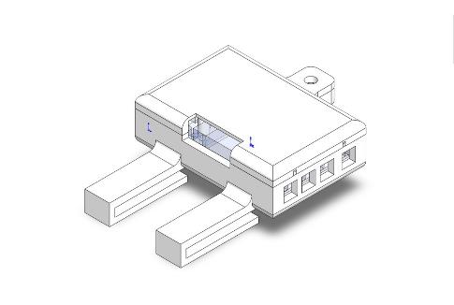

FIGURE 6.1 – CAD model of the designed case

Until this moment the belt was working cabled, but since the participant could walk great distances it was decided that the correct way to connect Unity3D with the ESP32 would be by wireless and it was decided to use a Bluetooth connection. The pseudo-code used in the development are in the Appendix C.

*Draft Version: June 1, 2022*

CHAPTER 6. HAPTIC BELT DEVELOPMENT

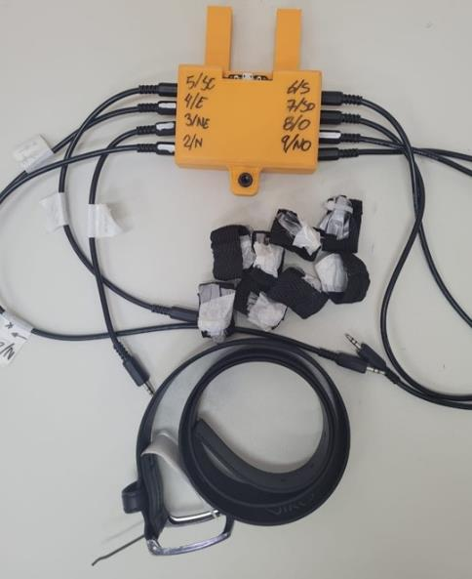

FIGURE 6.2 – Haptic belt

# Results’ analysis and discussion

Throughout the experiment, three data sources were gathered from the participants, and this chapter will show their values, will explain the process to analyze the data and will discuss their results. Each source will have its section, making up to three sessions, and they are:

* Data collected from the simulation;
* Data collected from questionnaires;
* Data collected from physiological sensors.

From this point, the data from the blind participants will be called ”Blind” sample and the data from the sighted participants will be called ”Sight” sample.

The processing of each data collected is rather similar and follows these steps:

1. Separate the Blind sample and the Sight sample;
2. Check if the samples are normally distributed;

If the data is normally distributed then it is possible to use other statistical analyses and verify the results statistically.

1. Check if the ”blind” sample is statistically different then the ”sight” sample; This is one of the goals. To verify that the workload and the situation awareness of the blind participants are different from the sighted participants
2. Calculate the average of of each participant in each method;
3. Calculate the average of the participant group in each method.

## Data from the simulation

Unity3D was programmed to record the time that each user spent in each scene. It is expected that the time analysis will show the following observation:

* The scene made with the white cane would be the fastest and with the less number of impacts;

Since the participant is already used to this method, it is safe to assume that with the others methods the participant would go slower and hit more furniture on the way.

* Comparing both scenes made with the same method, the second one would have the fastest and with less impact;

Not only this is expected but also is the intention on having two scenes with each method.

### Time elapsed on each scene

The data collected from the participants are shown in the Table 7.1.

TABLE 7.1 – Duration grouped by participant and guidance method (in minutes).

|  |  |  |  |  |  |  |  |
| --- | --- | --- | --- | --- | --- | --- | --- |
|  |  |  | Base | Audio | Haptic  Belt | Virtual  Cane | Mixture |
| Participant | Visual  Condition | Round |  |  |  |  |  |
| 001 | Sight | First | 10:18 | 13:05 | 6:42 | 6:52 | 7:54 |
|  |  | Return | 12:38 | 6:25 | 7:41 | 10:28 | 5:21 |
| 001C | Blind | First | 2:11 | 6:00 | 10:41 | 9:02 | 7:42 |
|  |  | Return | 11:21 | 7:41 | 6:06 | 5:36 | 6:10 |
| 002C | Blind | First | 2:02 | 6:17 | 4:32 | 7:34 | 4:08 |
|  |  | Return | 13:32 | 8:06 | 8:02 | 3:35 | 3:57 |
| 003 | Sight | First | 8:06 | 2:14 | 2:51 | 4:21 | 8:11 |
|  |  | Return | 4:11 | 15:25 | 6:50 | 5:25 | 4:18 |
| 003C | Blind | First | 2:40 | 11:16 | 8:04 | 5:20 | 5:42 |
|  |  | Return | 6:38 | 4:59 | 4:00 | 8:52 | 5:32 |
| 004 | Sight | First | 2:40 | 11:16 | 8:04 | 5:20 | 5:42 |
|  |  | Return | 6:38 | 4:59 | 4:00 | 8:52 | 5:32 |
| 004C | Blind | First | 2:30 | 6:26 | 4:23 | 5:04 | 3:54 |
|  |  | Return | 8:29 | 6:14 | 11:25 | 4:29 | 6:24 |
| 005 | Sight | First | 2:33 | 6:58 | 5:34 | 5:09 | 7:52 |
|  |  | Return | 8:16 | 8:46 | 4:25 | 6:45 | 3:00 |

The Table 7.2 show the the average time of each participant on each method and they are plotted in the Figure 7.1 and 7.2. The Figure shows that there is no pattern in the relationship between the difference in the rounds of each method with the visual condition of the users.

The Table 7.7 show the the average time of each participant and Figure 7.3 these data

TABLE 7.2 – Average duration grouped by participant and guidance method (in minutes).

|  |  |  |  |  |  |  |
| --- | --- | --- | --- | --- | --- | --- |
| Participant | Base | Audio | Haptic Belt | Virtual Cane | Mixture | Visual Condition |
| 001 | 11:28 | 9:45 | 7:12 | 8:40 | 6:38 | Sight |
| 001C | 6:46 | 6:50 | 8:23 | 7:19 | 6:56 | Blind |
| 002C | 7:47 | 7:11 | 6:17 | 5:34 | 4:02 | Blind |
| 003 | 6:09 | 8:50 | 4:51 | 4:53 | 6:14 | Sight |
| 003C | 4:39 | 8:08 | 6:02 | 7:06 | 5:37 | Blind |
| 004 | 4:39 | 8:08 | 6:02 | 7:06 | 5:37 | Sight |
| 004C | 5:30 | 6:20 | 7:54 | 4:46 | 5:09 | Blind |
| 005 | 5:25 | 7:52 | 4:59 | 5:57 | 5:26 | Sight |

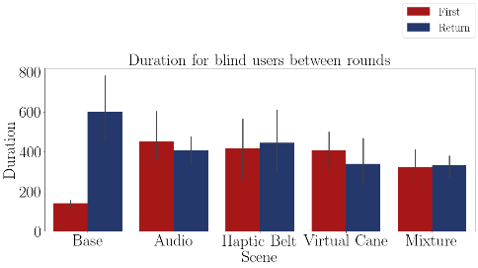

FIGURE 7.1 – Bar plot of the average time of the blind participants on each method.

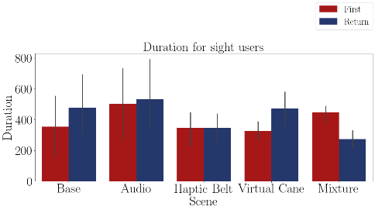

FIGURE 7.2 – Bar plot of the average time of sighted participants on each method.

is plotted. The Figure shows that there could be some difference in the time between the methods, but that would only be assured with a hypothesis test.

TABLE 7.3 – Duration difference grouped by participant and guidance method.

|  |  |  |  |  |  |  |
| --- | --- | --- | --- | --- | --- | --- |
| Participant | Base | Audio | Haptic  Belt | Virtual  Cane | Mixture | Visual  Condition |
| 001 | 22.6% | -50.9% | 14.7% | 52.4% | -32.2% | Sight |
| 001C | 419.6% | 28.2% | -42.9% | -37.9% | -20.0% | Blind |
| 002C | 563.4% | 28.9% | 77.3% | -52.6% | -4.2% | Blind |
| 003 | -48.3% | 587.1% | 139.6% | 24.5% | -47.5% | Sight |
| 003C | 148.9% | -55.8% | -50.3% | 66.3% | -2.8% | Blind |
| 004 | 148.9% | -55.8% | -50.3% | 66.3% | -2.8% | Sight |
| 004C | 237.4% | -3.2% | 160.5% | -11.5% | 63.7% | Blind |
| 005 | 222.8% | 25.9% | -20.6% | 30.9% | -61.9% | Sight |

The Table 7.4 show the the average time grouped by visual condition and Figure 7.4 these data is plotted. The table shows a noticeable difference between the two groups. The Figure 7.4 shows that the global average of the groups in all scenes were almost the same.

TABLE 7.4 – Duration difference grouped by participant and visual Condition.

|  |  |  |  |  |  |
| --- | --- | --- | --- | --- | --- |
| Visual Condition | Base | Audio | Haptic Belt | Virtual Cane | Mixture |
| Blind | 342.3% | -0.5% | 36.1% | -8.9% | 9.2% |
| Sight | 86.5% | 126.6% | 20.8% | 43.5% | -36.1% |

For more correct analysis, one should use statistical methods to analyze. So hypothesis tests were used, but the first step in this analysis is to check if the sample has a normal distribution.

The Table 7.5 shows the Shapiro Wilk test p-value. If this value is higher than 0.05, then the sample is normally distributed. The table 7.5 indicates that the p-values of the time averages are normally distributed hence the steps that follow are allowed to be used.

The Table 7.6 shows the T-test p-value between the time average of the blind sample and the time average of the sight sample. If this value is higher than 0.05, it means that there is no statistical differences between the samples and that both samples had the same time performance. The table 7.6 indicates the time of both the blind and the sighted users are statistically the same, with an exception of the ”Audio” method.

The Table 7.8 shows the Anova test p-value of the blind time averages between the guidance methods presented in the Table 7.7. If this value is higher than 0.05, there is at least one method that has no statistical difference between one from the other methods. The table 7.8 indicates that there is no similar variations between the methods, which means that all of the time differences noticed in the methods are relevant.

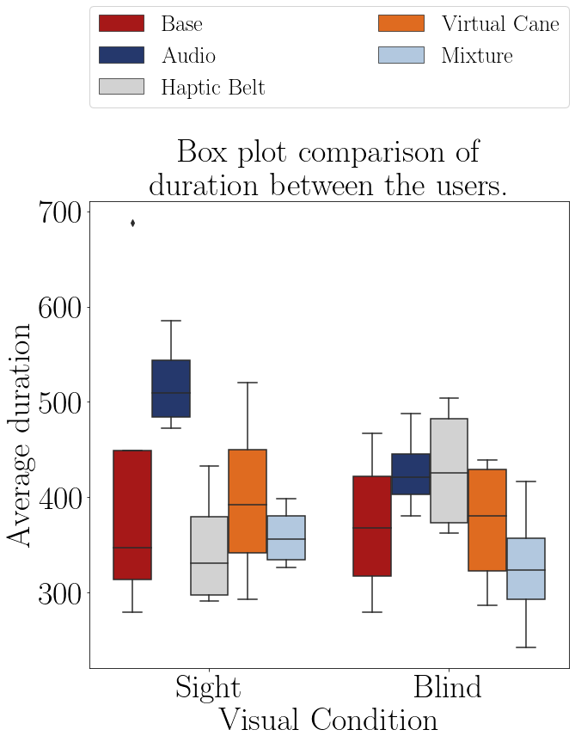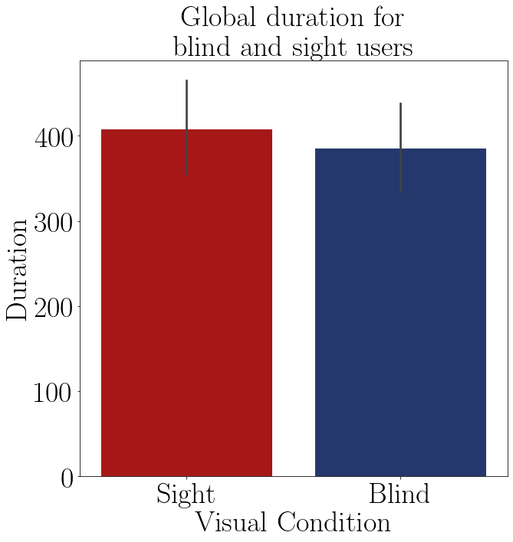

|  |  |  |  |
| --- | --- | --- | --- |
| FIGURE 7.3 – Boxplot of the average time of each group on each method. | | FIGURE 7.4 – Barplot of the average time of each group. | |
| TABLE 7.5 – Shapiro test p-value for the duration of participant in each method. | | TABLE 7.6 – T test p-value for the duration for blinded users versus sighted users. | |
| |  |  | | --- | --- | | Method | Shapiro P-Value | | Audio blind | 0.848 | | Audio sight | 0.623 | | Haptic Belt blind | 0.296 | | Haptic Belt sight | 0.420 | | Virtual Cane blind | 0.402 | | Virtual Cane sight | 0.954 | | Mixture blind | 0.966 | | Mixture sight | 0.619 | | |  |  | | --- | --- | | Method | T-Test P-Value | | Base | 0.675 | | Audio | 0.036 | | Haptic Belt | 0.134 | | Virtual Cane | 0.667 | | Mixture | 0.442 | | |

Considering the on Table 7.6, the duration of the ”sight” sample is similar to the ”blind” sample and considering the conclusion from the ANOVA test and the Figure 7.3, the method that had the better time efficiency was the one mixing all of the methods together, and the least one was the ”Audio” method.

Despite all these results above, it is noticeable some outliers in the data, especially in the first participants, when the most minor procedure errors, such as the one to stop the simulation, hence stopping the timer, had happened.

TABLE 7.7 – Duration difference grouped by participant and guidance method.

|  |  |  |  |  |  |  |
| --- | --- | --- | --- | --- | --- | --- |
| Participant | Base | Audio | Haptic  Belt | Virtual  Cane | Mixture | Visual  Condition |
| 001 | 22.6% | -50.9% | 14.7% | 52.4% | -32.2% | Sight |
| 001C | 419.6% | 28.2% | -42.9% | -37.9% | -20.0% | Blind |
| 002C | 563.4% | 28.9% | 77.3% | -52.6% | -4.2% | Blind |
| 003 | -48.3% | 587.1% | 139.6% | 24.5% | -47.5% | Sight |
| 003C | 148.9% | -55.8% | -50.3% | 66.3% | -2.8% | Blind |
| 004 | 148.9% | -55.8% | -50.3% | 66.3% | -2.8% | Sight |
| 004C | 237.4% | -3.2% | 160.5% | -11.5% | 63.7% | Blind |
| 005 | 222.8% | 25.9% | -20.6% | 30.9% | -61.9% | Sight |

TABLE 7.8 – Anova p-value for the duration of each method for blinded users.

|  |  |  |  |  |  |
| --- | --- | --- | --- | --- | --- |
| Source | Squared sum | DOF | Squared average | F | P-Value  (*F*0 *>F*) |
| Between factors | 360193.228 | 4 | 90048.307 | 8.921 | 0.001 |
| Inside factors | 151418.029 | 15 | 10094.535 |  |  |
| Total | 511611.257 | 19 |  |  |  |

## Data from questionnaires

There were 3 different questionnaires in this experiment. Each of these questionnaires was meant to verify one of the experiment goals:

* NASA-TLX;

Meant to verify the mental workload of the user. Is expected that after each ”First” round, the mental workload would decrease and that one of the methods would have the least mental workload. Also that there is a noticeable difference between the sight sample mental workload and the blind sample mental workload.

* Adapted SAGAT;

Meant to verify the situation awareness and the mental map of the user. Is expected to notice an increase from the ”First” round to the ”Return” round at each method and a difference between the ”blind” sample and the ”sight” sample.

* Guidance method’s questionnaire.

Meant to assess the user experience with each method.

### NASA-TLX

It is possible to analyze the mental workload using NASA-TLX in two different ways. The first is by analyzing only the mental demand scale and the second is by analyzing the NASA-TLX score, which is an average of the scales’ rating.

7.2.1.1 Analysis of the mental demand scale

The Table 7.9 presents the mental demand averages by each participant on each scenes and they are plotted in the Figures 7.5 and 7.6.

TABLE 7.9 – Mental demand felled by the participants.

|  |  |  |  |  |  |  |  |
| --- | --- | --- | --- | --- | --- | --- | --- |
|  |  |  | Base | Audio | Haptic  Belt | Virtual  Cane | Mixture |
| Participant | Visual  Condition | Round |  |  |  |  |  |
| 001 | Sight | First | 6 | 12 | 11 | 5 | 9 |
|  |  | Return | 6 | 13 | 13 | 5 | 10 |
| 001C | Blind | First | 3 | 1 | 14 | 3 | 6 |
|  |  | Return | 1 | 1 | 10 | 2 | 6 |
| 002C | Blind | First | 5 | 1 | 1 | 10 | 12 |
|  |  | Return | 1 | 1 | 1 | 10 | 3 |
| 003 | Sight | First | 2 | 18 | 18 | 16 | 10 |
|  |  | Return | 1 | 12 | 15 | 11 | 8 |
| 003C | Blind | First | 5 | 5 | 5 | 8 | 1 |
|  |  | Return | 3 | 1 | 1 | 2 | 1 |
| 004 | Sight | First | 8 | 17 | 20 | 12 | 20 |
|  |  | Return | 5 | 12 | 15 | 10 | 15 |
| 004C | Blind | First | 9 | 10 | 15 | 10 | 10 |
|  |  | Return | 7 | 10 | 14 | 8 | 10 |
| 005 | Sight | First | 2 | 4 | 12 | 10 | 13 |
|  |  | Return | 2 | 6 | 10 | 6 | 12 |

The Table 7.10 show the the average mental demand between the rounds of each participant and the Figure 7.7 these data is plotted. The figure shows a noticeable difference between the two groups. The Figure 7.7 indicates a visual difference between the mental demand felt by the sighted participants and the mental demand felt by the blind participants. Inside the blind groups is also noticeable a difference between the methods, but the ones that are different do not show a better performance, instead of higher mental demand than the one felt during the ”Base” method.

The Table 7.11 show the the average mental demand grouped by visual condition and these data is plotted in Figure 7.8. Both the table and the figure also show the difference between the mental demand of the ”sight” sample and the ”blind” sample.

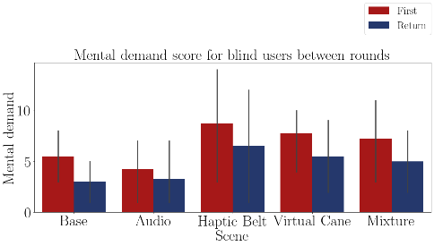

FIGURE 7.5 – Bar plot of the average mental demand of the blind participants on each method.

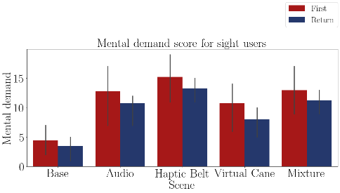

FIGURE 7.6 – Bar plot of the average mental demand of the sighted participants on each method.

TABLE 7.10 – Mental demand average by participant and method.

|  |  |  |  |  |  |  |
| --- | --- | --- | --- | --- | --- | --- |
| Participant | Base | Audio | Haptic  Belt | Virtual  Cane | Mixture | Visual  Condition |
| 001 | 6.00 | 12.50 | 12.00 | 5.00 | 9.50 | Sight |
| 001C | 2.00 | 1.00 | 12.00 | 2.50 | 6.00 | Blind |
| 002C | 3.00 | 1.00 | 1.00 | 10.00 | 7.50 | Blind |
| 003 | 1.50 | 15.00 | 16.50 | 13.50 | 9.00 | Sight |
| 003C | 4.00 | 3.00 | 3.00 | 5.00 | 1.00 | Blind |
| 004 | 6.50 | 14.50 | 17.50 | 11.00 | 17.50 | Sight |
| 004C | 8.00 | 10.00 | 14.50 | 9.00 | 10.00 | Blind |
| 005 | 2.00 | 5.00 | 11.00 | 8.00 | 12.50 | Sight |

TABLE 7.11 – Mental demand average grouped by participant and visual Condition

|  |  |  |  |  |  |
| --- | --- | --- | --- | --- | --- |
| Visual Condition | Base | Audio | Haptic  Belt | Virtual  Cane | Mixture |
| Blind | 4.25 | 3.75 | 7.62 | 6.62 | 6.125 |
| Sight | 4.00 | 11.75 | 14.25 | 9.38 | 12.125 |

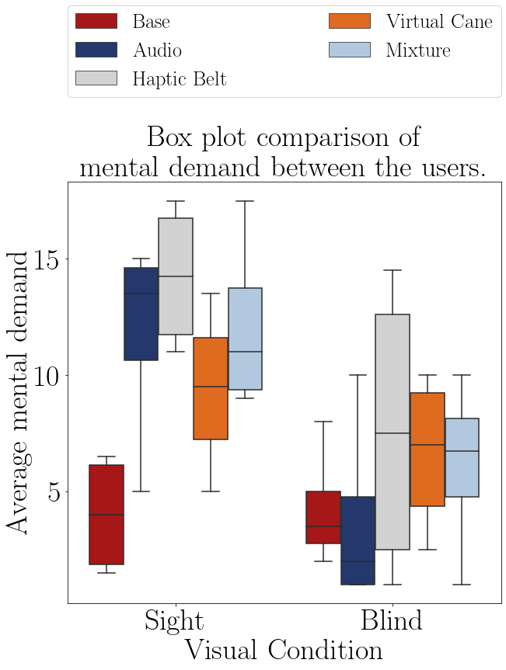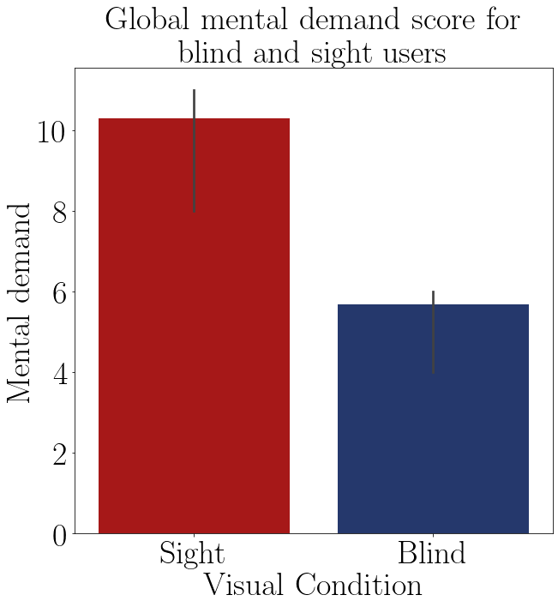

FIGURE 7.7 – Boxplot of the average mental FIGURE 7.8 – Barplot of the average mental demand of participant. demand of each group.

The Shapiro–Wilk normality test on the Table 7.23 shows that these data are normally distributed, with a p-value higher than 0.05, then it is possible to perform a T-Test to guarantee that the ”blind” sample is different than the ”sight” sample.

According to the T-Test presented in the Table 7.13, the only method that showed a difference in the mental demand between the ”sight”sample and the ”blind”sample is the audio method. In the other methods both samples had a similar mental demand.

The Table 7.14 shows the Anova test p-value of the mental demand average of the ”blind” sample between the guidance methods presented on the Table 7.10. The p-value indicates that there is at least one method that is statistically equal to one of the other methods.

The Table 7.15 presents the conclusion of a pairwise Fisher LSD test of the blind mental demand average between all the guidance methods. The results show that only the ”Haptic Belt” caused a different mental demand average than the one noticed on the

TABLE 7.12 – Shapiro test p-value for the mental demand for each method and visual condition.

|  |  |
| --- | --- |
| Method | Shapiro P-Value |
| Base blind | 0.369 |
| Base sight | 0.145 |
| Audio blind | 0.066 |
| Audio sight | 0.117 |
| Haptic Belt blind | 0.346 |
| Haptic Belt sight | 0.300 |
| Virtual Cane blind | 0.555 |
| Virtual Cane sight | 0.948 |
| Mixture blind | 0.771 |
| Mixture sight | 0.339 |

TABLE 7.13 – T test p-value for the mental demand on each method for blinded users versus sighted users.

|  |  |
| --- | --- |
| Method | T-Test P-Value |
| Base | 0.897 |
| Audio | 0.044 |
| Haptic Belt | 0.122 |
| Virtual Cane | 0.320 |
| Mixture | 0.070 |

TABLE 7.14 – Anova p-value for the average mental demand on each method for blinded users.

|  |  |  |  |  |  |
| --- | --- | --- | --- | --- | --- |
| Source | Squared sum | DOF | Squared average | F | P-Value  (*F*0 *>F*) |
| Between factors | 42.575 | 4 | 10.644 | 0.556 | 0.698 |
| Inside factors | 287.062 | 15 | 19.137 |  |  |
| Total | 329.637 | 19 |  |  |  |

”Base” Method.

TABLE 7.15 – Cross validation p-value for the average mental demand on each method for blinded users.

|  |  |  |  |
| --- | --- | --- | --- |
| Method | | | Analysis |
| Base | *X* | Audio | *H*0 : *µBase* = *µAudio* |
| Base | *X* | Haptic Belt | *H*1 : *µBase* ̸= *µHapticBelt* ∗∗ |
| Base | *X* | Virtual Cane | *H*0 : *µBase* = *µV irtualCane* |
| Base | *X* | Mixture | *H*0 : *µBase* = *µMixture* |
| Audio | *X* | Haptic Belt | *H*1 : *µAudio* ̸= *µHapticBelt* ∗∗ |
| Audio | *X* | Virtual Cane | *H*1 : *µAudio* ̸= *µV irtualCane* ∗∗ |
| Audio | *X* | Mixture | *H*0 : *µAudio* = *µMixture* |
| Haptic Belt | *X* | Virtual Cane | *H*0 : *µHapticBelt* = *µV irtualCane* |
| Haptic Belt | *X* | Mixture | *H*0 : *µHapticBelt* = *µMixture* |
| Virtual Cane | *X* | Mixture | *H*0 : *µV irtualCane* = *µMixture* |

The Table 7.17 shows the Anova test p-value of the mental demand variation of the ”blind” sample between the guidance methods presented on the Table 7.16. The p-value indicates that there is at least one method that is statistically equal to one of the other methods so it’s recommended to do a pairwise analysis between all the methods.

The Table 7.18 presents the conclusion of a pairwise Fisher LSD test of the blind mental demand variation between all the guidance methods. The results show that the

TABLE 7.16 – Mental demand variation by participant and method.

|  |  |  |  |  |  |  |
| --- | --- | --- | --- | --- | --- | --- |
| Participant | Base | Audio | Haptic  Belt | Virtual  Cane | Mixture | Visual  Condition |
| 001 | 0.0% | 8.3% | 18.2% | 0.0% | 11.1% | Sight |
| 001C | -66.7% | 0.0% | -28.6% | -33.3% | 0.0% | Blind |
| 002C | -80.0% | 0.0% | 0.0% | 0.0% | -75.0% | Blind |
| 003 | -50.0% | -33.3% | -16.7% | -31.2% | -20.0% | Sight |
| 003C | -40.0% | -80.0% | -80.0% | -75.0% | 0.0% | Blind |
| 004 | -37.5% | -29.4% | -25.0% | -16.7% | -25.0% | Sight |
| 004C | -22.2% | 0.0% | -6.7% | -20.0% | 0.0% | Blind |
| 005 | 0.0% | 50.0% | -16.7% | -40.0% | -7.7% | Sight |

TABLE 7.17 – Anova p-value for the mental demand variation on each method for blinded users.

|  |  |  |  |  |  |
| --- | --- | --- | --- | --- | --- |
| Source | Squared sum | DOF | Squared average | F | P-Value  (*F*0 *>F*) |
| Between factors | 2901.806 | 4 | 725.451 | 0.604 | 0.666 |
| Inside factors | 18007.946 | 15 | 1200.530 |  |  |
| Total | 20909.752 | 19 |  |  |  |

”Virtual Cane”method has a similar mental demand variation to the ”Base”method. All other methods have a different variation. This can be seen at the Table 7.19 and in the Figure 7.9 compiles the mental demand average of the methods observed on all of the participants.

TABLE 7.18 – Cross validation p-value for the mental demand variation on each method for blinded users.

|  |  |  |  |
| --- | --- | --- | --- |
| Method | | | Analysis |
| Base | *X* | Audio | *H*1 : *µBase* ̸= *µAudio* ∗∗ |
| Base | *X* | Haptic Belt | *H*1 : *µBase* ̸= *µHapticBelt* ∗∗ |
| Base | *X* | Virtual Cane | *H*0 : *µBase* = *µV irtualCane* |
| Base | *X* | Mixture | *H*1 : *µBase* ̸= *µMixture* ∗∗ |
| Audio | *X* | Haptic Belt | *H*0 : *µAudio* = *µHapticBelt* |
| Audio | *X* | Virtual Cane | *H*0 : *µAudio* = *µV irtualCane* |
| Audio | *X* | Mixture | *H*0 : *µAudio* = *µMixture* |
| Haptic Belt | *X* | Virtual Cane | *H*0 : *µHapticBelt* = *µV irtualCane* |
| Haptic Belt | *X* | Mixture | *H*0 : *µHapticBelt* = *µMixture* |
| Virtual Cane | *X* | Mixture | *H*0 : *µV irtualCane* = *µMixture* |

According to T-Test on Table 7.13, the mental demand of the ”sight”sample is similar to the ”blind” sample, excluding only the ”Audio” method.

According to both Anova test at Table 7.14 and 7.17, Tables 7.10 and 7.16 and Figure

TABLE 7.19 – Mental demand variation grouped by participant and visual Condition

|  |  |  |  |  |  |
| --- | --- | --- | --- | --- | --- |
| Visual Condition | Base | Audio | Haptic  Belt | Virtual  Cane | Mixture |
| Blind | -52.2% | -20.0% | -28.8% | -32.1% | -18.750 |
| Sight | -21.9% | -1.1% | -10.0% | -22.0% | -10.395 |

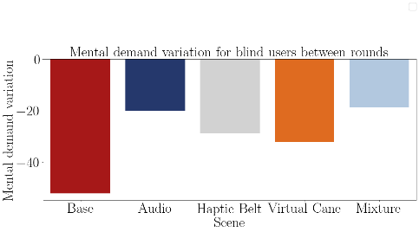

FIGURE 7.9 – Barplot of the average mental demand variation from the blind participants of each method.

7.9, none of the methods did provoke a higher mental demand variation than the one notice on the ”Base” method on the participants and the only different mental demand average was noticed on the ”Haptic Belt”method, and is higher mental demand than the ”Base” method.

7.2.1.2 Analysis of the NASA-TLX score

The Table 7.20 presents the Nasa score averages by each participant on each scenes and they are plotted in the Figures 7.10 and 7.11. It is notible that after each ”First” round the Nasa score diminishes for both ”sight” and ”blind” participants.

The Table 7.21 shows the average Nasa score between the rounds of each participant and in the Figure 7.12 this data is plotted. The table and the figure also show a noticeable difference between the two groups, meaning that probably the Nasa score from the ”sight” sample is higher than the one of the ”blind” sample.

The Table 7.22 show the the average Nasa score grouped by visual condition and these data is plotted in Figure 7.13. Both the table and the figure also show the difference between the mental demand of the ”sight” sample and the ”blind” sample.

TABLE 7.20 – NASA score felled by the participants.

|  |  |  |  |  |  |  |  |
| --- | --- | --- | --- | --- | --- | --- | --- |
|  |  |  | Base | Audio | Haptic  Belt | Virtual  Cane | Mixture |
| Participant | Visual  Condition | Round |  |  |  |  |  |
| 001 | Sight | First | 7.83 | 10.17 | 9.83 | 7.00 | 9.000 |
|  |  | Return | 8.00 | 11.00 | 10.83 | 6.17 | 9.333 |
| 001C | Blind | First | 4.83 | 4.00 | 8.83 | 5.17 | 6.333 |
|  |  | Return | 4.17 | 4.00 | 6.67 | 4.50 | 6.167 |
| 002C | Blind | First | 6.33 | 4.83 | 4.83 | 9.00 | 7.000 |
|  |  | Return | 4.50 | 4.83 | 4.83 | 7.00 | 5.167 |
| 003 | Sight | First | 4.83 | 9.83 | 10.17 | 9.50 | 6.500 |
|  |  | Return | 4.33 | 6.67 | 9.67 | 7.83 | 4.833 |
| 003C | Blind | First | 4.00 | 4.00 | 5.33 | 6.67 | 3.500 |
|  |  | Return | 4.00 | 3.83 | 3.67 | 3.50 | 3.500 |
| 004 | Sight | First | 6.67 | 14.83 | 13.67 | 11.50 | 15.833 |
|  |  | Return | 6.83 | 11.83 | 11.83 | 10.83 | 12.167 |
| 004C | Blind | First | 9.83 | 10.00 | 12.67 | 9.67 | 11.000 |
|  |  | Return | 8.67 | 9.17 | 11.67 | 9.33 | 10.833 |
| 005 | Sight | First | 5.00 | 7.67 | 9.00 | 8.00 | 9.667 |
|  |  | Return | 5.00 | 7.67 | 8.67 | 7.67 | 6.000 |

TABLE 7.21 – NASA-TLX score grouped by participant and method.

|  |  |  |  |  |  |  |
| --- | --- | --- | --- | --- | --- | --- |
| Participant | Base | Audio | Haptic  Belt | Virtual  Cane | Mixture | Visual  Condition |
| 001 | 7.9% | 10.6% | 10.3% | 6.6% | 9.2% | Sight |
| 001C | 4.5% | 4.0% | 7.8% | 4.8% | 6.2% | Blind |
| 002C | 5.4% | 4.8% | 4.8% | 8.0% | 6.1% | Blind |
| 003 | 4.6% | 8.2% | 9.9% | 8.7% | 5.7% | Sight |
| 003C | 4.0% | 3.9% | 4.5% | 5.1% | 3.5% | Blind |
| 004 | 6.8% | 13.3% | 12.8% | 11.2% | 14.0% | Sight |
| 004C | 9.2% | 9.6% | 12.2% | 9.5% | 10.9% | Blind |
| 005 | 5.0% | 7.7% | 8.8% | 7.8% | 7.8% | Sight |

TABLE 7.22 – NASA-TLX score grouped by participant and visual Condition

|  |  |  |  |  |  |
| --- | --- | --- | --- | --- | --- |
| Visual Condition | Base | Audio | Haptic  Belt | Virtual  Cane | Mixture |
| Blind | 5.79 | 5.58 | 7.31 | 6.85 | 6.688 |
| Sight | 6.06 | 9.96 | 10.46 | 8.56 | 9.167 |

The Shapiro–Wilk normality test on the Table ?? shows that these data are normally distributed, with an exception of the ”Audio”Nasa score. This means that further analysis

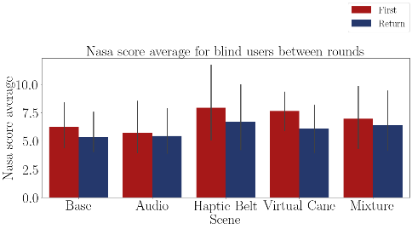

FIGURE 7.10 – Bar plot of the average Nasa-TLX score of the blind participants on each method.

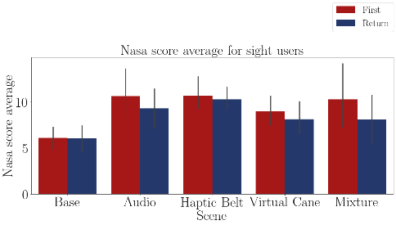

FIGURE 7.11 – Bar plot of the average Nasa-TLX score of the sighted participants on each method.

cannot be applied to this method.

According to the T-Test presented in the Table 7.24 it cannot be verified that the average Nasa score is different between the ”sight” and the ”blind” samples.

The Table 7.25 shows the Anova test p-value of the average Nasa score, presented in the Table 7.21, of the ”blind” sample between the guidance methods. The p-value indicates that there is at least one method that is statistically equal to one of the other methods so it’s recommended to do a pairwise analysis between all the methods.

The Table 7.18 presents the results of a pairwise Fisher LSD test of the blind Nasa score average between all the guidance methods. The results show that all of the averages are statistically the same. That means that there is no difference in the Nasa score felt by the ”blind” sample between the methods.

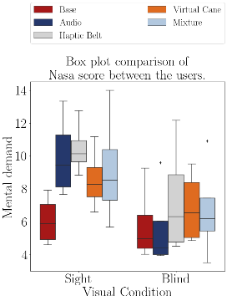

FIGURE 7.12 – Boxplot of the average NasaTLX score of the participants.

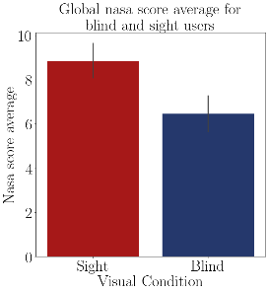

FIGURE 7.13 – Barplot of the average nasa score of each group.

TABLE 7.23 – Shapiro test p-value for the mental demand for each method and visual condition.

|  |  |
| --- | --- |
| Method | Shapiro P-Value |
| Base blind | 0.369 |
| Base sight | 0.145 |
| Audio blind | 0.066 |
| Audio sight | 0.117 |
| Haptic Belt blind | 0.346 |
| Haptic Belt sight | 0.300 |
| Virtual Cane blind | 0.555 |
| Virtual Cane sight | 0.948 |
| Mixture blind | 0.771 |
| Mixture sight | 0.339 |

TABLE 7.24 – T test p-value for the NASA score on each method for blinded users versus sighted users.

|  |  |
| --- | --- |
| Method | T-Test P-Value |
| Base | 0.855 |
| Audio | 0.058 |
| Haptic Belt | 0.159 |
| Virtual Cane | 0.296 |
| Mixture | 0.331 |

TABLE 7.25 – Anova p-value for the average Nasa score on each method for blinded users.

|  |  |  |  |  |  |
| --- | --- | --- | --- | --- | --- |
| Source | Squared sum | DOF | Squared average | F | P-Value  (*F*0 *>F*) |
| Between factors | 8.592 | 4 | 2.148 | 0.267 | 0.895 |
| Inside factors | 120.773 | 15 | 8.052 |  |  |
| Total | 129.365 | 19 |  |  |  |

TABLE 7.26 – Cross validation p-value for the average Nasa score on each method for blinded users.

|  |  |  |  |
| --- | --- | --- | --- |
| Method | | | Analysis |
| Base | *X* | Audio | *H*0 : *µBase* = *µAudio* |
| Base | *X* | Haptic Belt | *H*0 : *µBase* = *µHapticBelt* |
| Base | *X* | Virtual Cane | *H*0 : *µBase* = *µV irtualCane* |
| Base | *X* | Mixture | *H*0 : *µBase* = *µMixture* |
| Audio | *X* | Haptic Belt | *H*0 : *µAudio* = *µHapticBelt* |
| Audio | *X* | Virtual Cane | *H*0 : *µAudio* = *µV irtualCane* |
| Audio | *X* | Mixture | *H*0 : *µAudio* = *µMixture* |
| Haptic Belt | *X* | Virtual Cane | *H*0 : *µHapticBelt* = *µV irtualCane* |
| Haptic Belt | *X* | Mixture | *H*0 : *µHapticBelt* = *µMixture* |
| Virtual Cane | *X* | Mixture | *H*0 : *µV irtualCane* = *µMixture* |

The Table 7.27 shows the Anova test p-value of the mental demand average of the ”blind” sample between the guidance methods presented in the Table 7.30. The p-value indicates that there is at least one method that is statistically equal to one of the other methods.

TABLE 7.27 – Anova p-value for the variation Nasa score on each method for blinded users.

|  |  |  |  |  |  |
| --- | --- | --- | --- | --- | --- |
| Source | Squared sum | DOF | Squared average | F | P-Value  (*F*0 *>F*) |
| Between factors | 825.191 | 4 | 206.298 | 1.172 | 0.362 |
| Inside factors | 2639.612 | 15 | 175.974 |  |  |
| Total | 3464.803 | 19 |  |  |  |

TABLE 7.28 – NASA-TLX score variation grouped by participant and method.

|  |  |  |  |  |  |  |
| --- | --- | --- | --- | --- | --- | --- |
| Participant | Base | Audio | Haptic  Belt | Virtual  Cane | Mixture | Visual  Condition |
| 001 | 2.1% | 8.2% | 10.2% | -11.9% | 3.7% | Sight |
| 001C | -13.8% | 0.0% | -24.5% | -12.9% | -2.6% | Blind |
| 002C | -28.9% | 0.0% | 0.0% | -22.2% | -26.2% | Blind |
| 003 | -10.3% | -32.2% | -4.9% | -17.5% | -25.6% | Sight |
| 003C | 0.0% | -4.2% | -31.2% | -47.5% | 0.0% | Blind |
| 004 | 2.5% | -20.2% | -13.4% | -5.8% | -23.2% | Sight |
| 004C | -11.9% | -8.3% | -7.9% | -3.4% | -1.5% | Blind |
| 005 | 0.0% | 0.0% | -3.7% | -4.2% | -37.9% | Sight |

The Table 7.29 presents the conclusion of a pairwise Fisher LSD test of the blind Nasa score variation between all the guidance methods. The results show that only the ”Audio” method caused a different variation than the one noticed in the ”Base” Method. The Figure 7.14 shows the variation of the Nasa score and one can notice that the variation provoked on the ”Audio” method” is a lot lesser than the other ones.

TABLE 7.29 – Cross validation p-value for the variation Nasa score on each method for blinded users.

|  |  |  |  |
| --- | --- | --- | --- |
| Method | | | Analysis |
| Base | *X* | Audio | *H*1 : *µBase* ̸= *µAudio* ∗∗ |
| Base | *X* | Haptic Belt | *H*0 : *µBase* = *µHapticBelt* |
| Base | *X* | Virtual Cane | *H*0 : *µBase* = *µV irtualCane* |
| Base | *X* | Mixture | *H*0 : *µBase* = *µMixture* |
| Audio | *X* | Haptic Belt | *H*1 : *µAudio* ̸= *µHapticBelt* ∗∗ |
| Audio | *X* | Virtual Cane | *H*1 : *µAudio* ̸= *µV irtualCane* ∗∗ |
| Audio | *X* | Mixture | *H*0 : *µAudio* = *µMixture* |
| Haptic Belt | *X* | Virtual Cane | *H*0 : *µHapticBelt* = *µV irtualCane* |
| Haptic Belt | *X* | Mixture | *H*1 : *µHapticBelt* ̸= *µMixture* ∗∗ |
| Virtual Cane | *X* | Mixture | *H*1 : *µV irtualCane* ̸= *µMixture* ∗∗ |

TABLE 7.30 – NASA-TLX score variation grouped by participant and method.

|  |  |  |  |  |  |  |
| --- | --- | --- | --- | --- | --- | --- |
| Participant | Base | Audio | Haptic  Belt | Virtual  Cane | Mixture | Visual  Condition |
| 001 | 2.1% | 8.2% | 10.2% | -11.9% | 3.7% | Sight |
| 001C | -13.8% | 0.0% | -24.5% | -12.9% | -2.6% | Blind |
| 002C | -28.9% | 0.0% | 0.0% | -22.2% | -26.2% | Blind |
| 003 | -10.3% | -32.2% | -4.9% | -17.5% | -25.6% | Sight |
| 003C | 0.0% | -4.2% | -31.2% | -47.5% | 0.0% | Blind |
| 004 | 2.5% | -20.2% | -13.4% | -5.8% | -23.2% | Sight |
| 004C | -11.9% | -8.3% | -7.9% | -3.4% | -1.5% | Blind |
| 005 | 0.0% | 0.0% | -3.7% | -4.2% | -37.9% | Sight |

According to T-Test on Table 7.24 all of the Nasa scores are similar between both groups.

According to both Anova test at Table 7.25 and 7.25, Table 7.30 7.21 and Figure 7.14, all of the methods have a similar Nasa score average, and the only different variation is provoked by the ”Audio” method, and is a smaller variation.

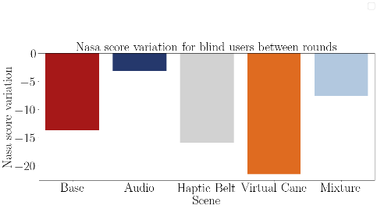

FIGURE 7.14 – Barplot of the Nasa score variation from the blind participants of each method.

### Adapted SAGAT

In this subsection, the Sagat questionnaire is analyzed. Its result may give an idea of the mental map the participant is drawing. For each question a participant could score 1 point or a fraction of it. The total score of each participant is presented on the Table 7.31 and they are plotted in the Figures 7.15 and 7.16. It is visually noticeable that both of the groups perform better the second time they visit the room.

TABLE 7.31 – Adapted Sagat global score by participant and guidance method.

|  |  |  |  |  |  |  |  |
| --- | --- | --- | --- | --- | --- | --- | --- |
|  |  |  | Base | Audio | Haptic  Belt | Virtual  Cane | Mixture |
| Participant | Visual  Condition | Round |  |  |  |  |  |
| 001 | Sight | First | 1.00 | 0.45 | 0.43 | 0.27 | 0.650 |
|  |  | Return | 1.00 | 0.60 | 0.50 | 0.50 | 0.450 |
| 001C | Blind | First | 0.62 | 0.55 | 0.53 | 0.58 | 0.350 |
|  |  | Return | 0.62 | 0.65 | 0.85 | 0.55 | 0.550 |
| 002C | Blind | First | 0.68 | 0.45 | 0.40 | 0.45 | 0.625 |
|  |  | Return | 0.53 | 0.50 | 0.40 | 0.65 | 0.850 |
| 003 | Sight | First | 1.00 | 0.68 | 0.60 | 0.40 | 0.675 |
|  |  | Return | 1.00 | 0.60 | 0.72 | 0.62 | 0.750 |
| 003C | Blind | First | 0.72 | 0.75 | 0.75 | 0.47 | 0.900 |
|  |  | Return | 1.00 | 1.00 | 0.85 | 0.90 | 0.900 |
| 004 | Sight | First | 1.00 | 0.72 | 0.80 | 0.60 | 0.825 |
|  |  | Return | 1.00 | 0.78 | 0.95 | 0.82 | 0.700 |
| 004C | Blind | First | 0.75 | 0.60 | 0.77 | 0.50 | 0.650 |
|  |  | Return | 0.90 | 0.60 | 0.93 | 0.72 | 0.900 |
| 005 | Sight | First | 1.00 | 0.30 | 0.32 | 0.40 | 0.400 |
|  |  | Return | 1.00 | 0.38 | 0.30 | 0.20 | 0.600 |

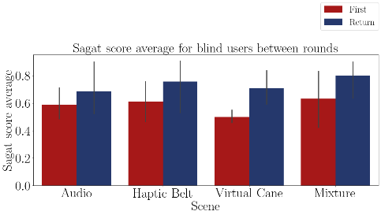

FIGURE 7.15 – Bar plot of the average Sagat score of the blind participants on each method.

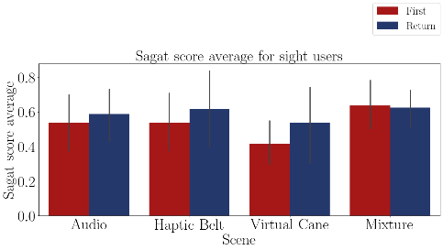

FIGURE 7.16 – Bar plot of the average Sagat score of the sighted participants on each method.

The Table 7.32 shows the average Sagat score between the rounds of each participant and the Figure 7.17 this data is plotted. It is possible only to assume that some methods cause different Sagat scores than others, but both groups performed rather similarly.

The Table 7.33 shows the average Sagat score grouped by visual condition and these data, without considering the ”Base”method, is plotted in Figure 7.18. Both the table and the figure also show a slight difference between the score in favor of the ”blind” sample.

The Shapiro–Wilk normality test on the Table 7.34 shows that these data are normally distributed, with a p-value higher than 0.05, then it is possible to perform a T-Test to guarantee that the ”blind” sample is different than the ”sight” sample.

According to the T-Test presented in the Table 7.35, the only method that showed a difference in the Sagat score between the ”sight” sample and the ”blind” sample is the

TABLE 7.32 – Adapted Sagat average global score grouped by participant and guidance method.

|  |  |  |  |  |  |  |
| --- | --- | --- | --- | --- | --- | --- |
| Participant | Base | Audio | Haptic  Belt | Virtual  Cane | Mixture | Visual  Condition |
| 001 | 1.00 | 0.53 | 0.47 | 0.38 | 0.55 | Sight |
| 001C | 0.62 | 0.60 | 0.69 | 0.57 | 0.45 | Blind |
| 002C | 0.60 | 0.47 | 0.40 | 0.55 | 0.74 | Blind |
| 003 | 1.00 | 0.64 | 0.66 | 0.51 | 0.71 | Sight |
| 003C | 0.86 | 0.88 | 0.80 | 0.68 | 0.90 | Blind |
| 004 | 1.00 | 0.75 | 0.87 | 0.71 | 0.76 | Sight |
| 004C | 0.82 | 0.60 | 0.85 | 0.61 | 0.78 | Blind |
| 005 | 1.00 | 0.34 | 0.31 | 0.30 | 0.50 | Sight |

TABLE 7.33 – Adapted Sagat average global score grouped by participant and visual Condition.

|  |  |  |  |  |  |
| --- | --- | --- | --- | --- | --- |
| Visual Condition | Base | Audio | Haptic  Belt | Virtual  Cane | Mixture |
| Blind | 0.73 | 0.64 | 0.68 | 0.60 | 0.716 |
| Sight | 1.00 | 0.56 | 0.58 | 0.48 | 0.631 |

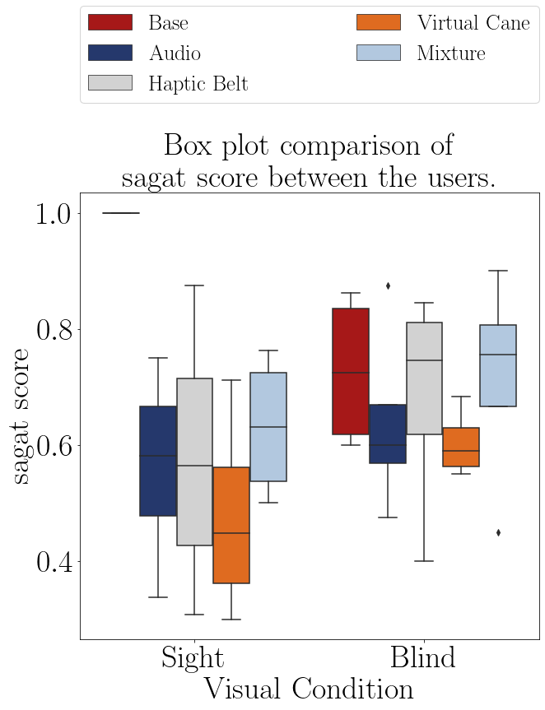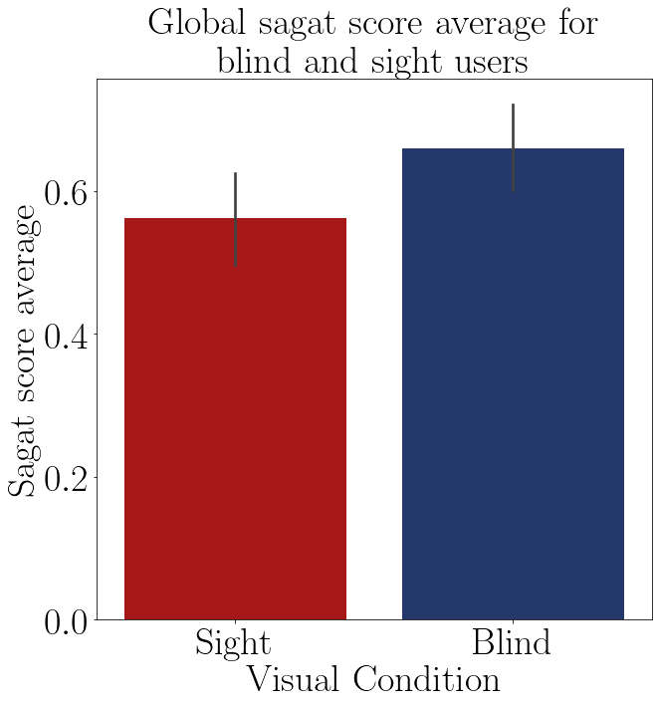

FIGURE 7.17 – Boxplot of the average Sagat score of participant.

|  |
| --- |
| ”Base” method. In the other methods both samples had a similar Sagat score.  The Table 7.36 shows the Anova test p-value of the Sagat score average of the ”blind” |

FIGURE 7.18 – Barplot of the average Sagat score of each group.

TABLE 7.34 – Shapiro test p-value for the Sagat score for each method and visual condition

|  |  |
| --- | --- |
| Method | Shapiro P-Value |
| Base blind | 0.189 |
| Base sight | 1.000 |
| Audio blind | 0.350 |
| Audio sight | 0.925 |
| Haptic Belt blind | 0.315 |
| Haptic Belt sight | 0.942 |
| Virtual Cane blind | 0.549 |
| Virtual Cane sight | 0.784 |
| Mixture blind | 0.520 |
| Mixture sight | 0.446 |

TABLE 7.35 – T test p-value for the Sagat score on each method for blinded users versus sighted users.

|  |  |
| --- | --- |
| Method | T-Test P-Value |
| Base | 0.007 |
| Audio | 0.561 |
| Haptic Belt | 0.527 |
| Virtual Cane | 0.230 |
| Mixture | 0.488 |

sample between the guidance methods presented in the Table 7.32. The p-value indicates that there is at least one method that is statistically equal to one of the other methods.

TABLE 7.36 – Anova p-value for the Sagat score on each method for blinded users.

|  |  |  |  |  |  |
| --- | --- | --- | --- | --- | --- |
| Source | Squared sum | DOF | Squared average | F | P-Value  (*F*0 *>F*) |
| Between factors | 0.045 | 4 | 0.011 | 0.441 | 0.777 |
| Inside factors | 0.380 | 15 | 0.025 |  |  |
| Total | 0.424 | 19 |  |  |  |

The Table 7.37 presents the analysis of a pairwise Fisher LSD test of the blind average Sagat score between all the guidance methods. The results show that only ”Virtual Cane” caused a different average score than the one noticed on the ”Base” Method. The rest of the methods did not significantly change it.

TABLE 7.37 – Cross validation p-value for the Sagat score on each method for blinded users.

|  |  |  |  |
| --- | --- | --- | --- |
| Method | | | Analysis |
| Base | *X* | Audio | *H*0 : *µBase* = *µAudio* |
| Base | *X* | Haptic Belt | *H*0 : *µBase* = *µHapticBelt* |
| Base | *X* | Virtual Cane | *H*1 : *µBase* ̸= *µV irtualCane* ∗∗ |
| Base | *X* | Mixture | *H*0 : *µBase* = *µMixture* |
| Audio | *X* | Haptic Belt | *H*0 : *µAudio* = *µHapticBelt* |
| Audio | *X* | Virtual Cane | *H*0 : *µAudio* = *µV irtualCane* |
| Audio | *X* | Mixture | *H*0 : *µAudio* = *µMixture* |
| Haptic Belt | *X* | Virtual Cane | *H*0 : *µHapticBelt* = *µV irtualCane* |
| Haptic Belt | *X* | Mixture | *H*0 : *µHapticBelt* = *µMixture* |
| Virtual Cane | *X* | Mixture | *H*1 : *µV irtualCane* ̸= *µMixture* ∗∗ |

The Table 7.39 shows the Anova test p-value of the Sagat score variation of the ”blind” sample between the guidance methods presented in the Table 7.38. The p-value indicates that there is at least one method that is statistically equal to one of the other methods so it’s recommended to do a pairwise analysis between all the methods.

TABLE 7.38 – Adapted Sagat global score variation grouped by participant and guidance method.

|  |  |  |  |  |  |  |
| --- | --- | --- | --- | --- | --- | --- |
| Participant | Base | Audio | Haptic  Belt | Virtual  Cane | Mixture | Visual  Condition |
| 001 | 0.0% | 33.3% | 15.5% | 88.0% | -30.8% | Sight |
| 001C | 0.0% | 18.2% | 59.5% | -5.7% | 57.1% | Blind |
| 002C | -22.2% | 11.1% | 0.3% | 44.4% | 36.0% | Blind |
| 003 | 0.0% | -11.1% | 21.0% | 56.6% | 11.1% | Sight |
| 003C | 37.9% | 33.3% | 13.5% | 93.1% | 0.0% | Blind |
| 004 | 0.0% | 6.9% | 18.9% | 37.7% | -15.2% | Sight |
| 004C | 20.0% | 0.0% | 20.8% | 45.3% | 38.5% | Blind |
| 005 | 0.0% | 25.0% | -5.1% | -49.9% | 50.0% | Sight |

TABLE 7.39 – Anova p-value for the variation Sagat score on each method for blinded users.

|  |  |  |  |  |  |
| --- | --- | --- | --- | --- | --- |
| Source | Squared sum | DOF | Squared average | F | P-Value  (*F*0 *>F*) |
| Between factors | 3131.542 | 4 | 782.885 | 1.055 | 0.412 |
| Inside factors | 11133.360 | 15 | 742.224 |  |  |
| Total | 14264.902 | 19 |  |  |  |

The Table 7.40 presents the conclusion of a pairwise Fisher LSD test of the blind Sagat score variation between all the guidance methods. The results show that the ”Haptic Belt” and the ”Mixture”method have different variations than the ”Base”method and they are also different from each other. This can be seen in the Table 7.41 and in the Figure 7.19 compiles the Sagat score average of the methods observed on all of the participants.

According to T-Test on Table 7.35, there is no difference in Sagat score between the ”sight” and the ”blind” sample.

According to both Anova test at Table 7.36 and LSD test at Table 7.37 only the ”Virtual Cane” method has a different Sagat score average and according to the Anova test at Table 7.39 and the LSD test at Table 7.40 the ”Virtual Cane” also has a different variation than the ”Base”method, with the ”Virtual Cane”having a higher, and positive, variation.

Finally, also according with Anova test at Anova test at Table 7.36 and LSD test at Table 7.37 the ”Mixture” method also has a significant increase, different the the ”Base” method. This increase is also bigger and higher.

TABLE 7.40 – Cross validation p-value for the variation Sagat score on each method for blinded users.

|  |  |  |  |
| --- | --- | --- | --- |
| Method | | | Analysis |
| Base | *X* | Audio | *H*0 : *µBase* = *µAudio* |
| Base | *X* | Haptic Belt | *H*0 : *µBase* = *µHapticBelt* |
| Base | *X* | Virtual Cane | *H*1 : *µBase* ̸= *µV irtualCane* ∗∗ |
| Base | *X* | Mixture | *H*1 : *µBase* ̸= *µMixture* ∗∗ |
| Audio | *X* | Haptic Belt | *H*0 : *µAudio* = *µHapticBelt* |
| Audio | *X* | Virtual Cane | *H*1 : *µAudio* ̸= *µV irtualCane* ∗∗ |
| Audio | *X* | Mixture | *H*1 : *µAudio* ̸= *µMixture* ∗∗ |
| Haptic Belt | *X* | Virtual Cane | *H*1 : *µHapticBelt* ̸= *µV irtualCane* ∗∗ |
| Haptic Belt | *X* | Mixture | *H*0 : *µHapticBelt* = *µMixture* |
| Virtual Cane | *X* | Mixture | *H*0 : *µV irtualCane* = *µMixture* |

TABLE 7.41 – Adapted Sagat global score variation grouped by participant and visual Condition

|  |  |  |  |  |  |
| --- | --- | --- | --- | --- | --- |
| Visual Condition | Base | Audio | Haptic  Belt | Virtual  Cane | Mixture |
| Blind | 8.93 | 15.66 | 23.49 | 44.30 | 32.901 |
| Sight | 0.00 | 13.53 | 12.59 | 33.12 | 3.798 |

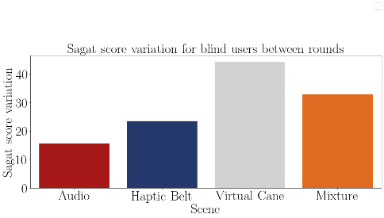

FIGURE 7.19 – Barplot of the average Sagat score variation from the blind participants of each method.

### Guidance method’s questionnaire.

Finally, the Questionnaire is analyzed to give an idea about the impressions of the users with each device. This is an important evaluation to seek their impressions of each method. Each question was evaluated to favor with a higher score the methods that brought more satisfaction to the user. The Table 7.42 shows the average score of each method and they are plotted in the Figures 7.5 and 7.6

TABLE 7.42 – Guidance method questionnaire average score grouped by participant.

|  |  |  |  |  |  |
| --- | --- | --- | --- | --- | --- |
| Participant | Audio | Haptic  Belt | Virtual  Cane | Mixture | Visual Condition |
| 001 | 0.46 | 0.60 | 0.50 | 0.56 | Sight |
| 001C | 0.63 | 0.71 | 0.46 | 0.85 | Blind |
| 002C | 0.86 | 0.91 | 0.49 | 0.72 | Blind |
| 003 | 0.76 | 0.71 | 0.68 | 0.87 | Sight |
| 003C | 0.69 | 0.74 | 0.54 | 0.76 | Blind |
| 004 | 0.86 | 0.77 | 0.57 | 0.64 | Sight |
| 004C | 0.60 | 0.66 | 0.40 | 0.61 | Blind |
| 005 | 0.61 | 0.74 | 0.54 | 0.73 | Sight |

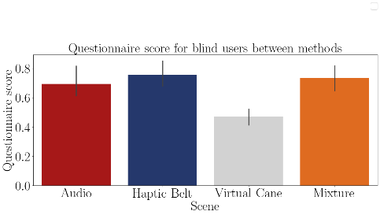

FIGURE 7.20 – Bar plot of the average mental demand of the blind participants on each method.

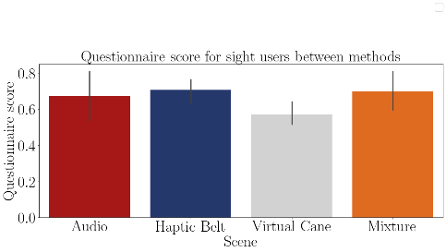

FIGURE 7.21 – Bar plot of the average mental demand of the sighted participants on each method.

The Table 7.43 show the the average questionnaire score of each participant and the Figure 7.22 these data is plotted. It is possible only to assume that some methods cause different Sagat scores than others, but both groups performed rather similarly.

TABLE 7.43 – Guidance method questionnaire average score grouped by visual condition.

|  |  |  |  |  |
| --- | --- | --- | --- | --- |
| Visual Condition | Audio | Haptic Belt | Virtual Cane | Mixture |
| Blind | 0.69 | 0.76 | 0.47 | 0.74 |
| Sight | 0.67 | 0.71 | 0.57 | 0.70 |

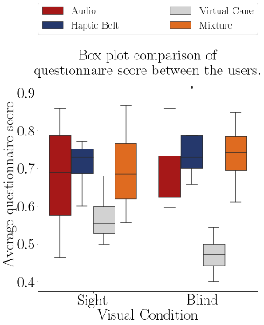

FIGURE 7.22 – Boxplot of the average questionnaire score of each group.

The Shapiro–Wilk normality test on the Table 7.44 shows that these data are normally distributed, with a p-value higher than 0.05, then it is possible to perform the following test to check if there is a significant difference between the methods

The Table 7.45 shows the Anova test p-value of the Sagat score average of the ”blind” sample between the guidance methods presented in the Table 7.42. The p-value indicates that all scores are significantly different from each other. That means that the highest scores shown in Table 7.43, which are the ”Haptic Belt” and the ”Mixture” methods were the most favorite by the participant.

TABLE 7.44 – Shapiro test p-value for the questionnaires score for each method and visual condition.

|  |  |
| --- | --- |
| Method | Shapiro P-Value |
| Audio blind | 0.400 |
| Audio sight | 0.882 |
| Haptic Belt blind | 0.414 |
| Haptic Belt sight | 0.369 |
| Virtual Cane blind | 0.995 |
| Virtual Cane sight | 0.577 |
| Mixture blind | 0.966 |
| Mixture sight | 0.925 |

TABLE 7.45 – Anova p-value for the questionnaire score on each method for blinded users.

|  |  |  |  |  |  |
| --- | --- | --- | --- | --- | --- |
| Source | Squared sum | DOF | Squared average | F | P-Value  (*F*0 *>F*) |
| Between factors | 0.207 | 3 | 0.069 | 7.080 | 0.005 |
| Inside factors | 0.117 | 12 | 0.010 |  |  |
| Total | 0.324 | 15 |  |  |  |

## Data from physiological sensors

There were 3 different sensors in this experiment, 2 that collected physiological data and the one left collected temperature. The last one was used only the eliminate a possible increase in the GSR sensor caused by the increase in the temperature. These were all used to assess Mental Workload.

* Electrocardiogram (ECG) data;

Is expected that the ECG frequency to increase at every ”First” round and then a slight decrease in the next round. Also, the variation is expected to decrease in the ”First” round and a slight increase in the next round.

* Galvanic skin reaction and temperature data;;

Is expected that the GSR average to increase at every ”First” round and then a slight decrease in the next round.

### Electrocardiogram (ECG) data

The ECG analysis is divided into two different types

* Heart rate;

This analysis checks the heartbeat frequency;

* Heart rate variance.

This analysis checks the heartbeat frequency variance and it is done by analyzing the variation of the interval between beats.

At the beginning of each experience, a baseline data was gathered to establish a comparison between the normal state of the user and the state induced state by the scene.

After the data gathering, an algorithm in python was used to read the data and separate it accordingly to each participant, method and round. Since the participants moved during the whole experience a lot of noise was collected by the sensors, so these outliers were removed. The following steps were to normalize the data between -1 and 1 and then a peak detection method was used then, if the results were appropriate, the interval between each peak was calculated and saved to be used in the next software. This judgment was made by analyzing the plotted ECG signal and the detected peaks. If the detected peaks are not aligned with the peaks of the signal, then the method’s parameters were tuned to fit the detected peaks with the signals’ peaks.

The next used software was Kubios HRV Standard. Kubios is a heart rate variability (HRV) analysis software for personal non-commercial use. The Kubios HRV Standard makes it possible to use your HR monitor to examine the health of the cardiovascular system or to evaluate stress and recovery (KUBIUS..., ). At Kubius, the file with the saved intervals was analyzed and the results were saved in a report file to be read in python again. In python the results were plotted, tabled and statistically tested as the other data. In Appendix D there is a diagram with a pseudo-algorithm of this process.

This analysis was made by comparing the baseline values with the values of each round individually and between the round values themselves.

7.3.1.1 Analysis of the heartbeat frequency

The Table 7.46 presents the average heart rate by each participant on each scenes and they are plotted in the Figures 7.23 and 7.24. It is possible to see that there was no heart rate increase by any participant with the exception only of the ”sight”sample in the ”First” round of the ”Base” method.

The Table 7.47 show the the average Sagat score between the rounds of each participant and the Figure 7.17 these data is plotted. It is possible only to assume that some methods cause different Sagat scores than others, but both groups performed rather similarly.

The Figure 7.25 shows a comparison between both groups

The Table 7.48 shows the variation of the heartbeat in each of the rounds of each participant. It is possible to notice that almost all of the variations were negative, meaning

TABLE 7.46 – ECG average BPM felled by the participants.

|  |  |  |  |  |  |  |  |  |
| --- | --- | --- | --- | --- | --- | --- | --- | --- |
|  |  |  | Baseline | Base | Audio | Haptic  Belt | Virtual  Cane | Mixture |
| Participant | Visual  Condition | Round |  |  |  |  |  |  |
| 001 | Sight | First | 81.29 | 76.86 | 71.23 | 63.02 | 64.85 | 58.77 |
|  |  | Return |  | 72.88 | 73.18 | 61.18 | 66.78 | 66.26 |
| 001C | Blind | First | 78.33 | 75.75 | 60.71 | 71.17 | 59.07 | 68.24 |
|  |  | Return |  | 71.05 | 58.61 | 66.22 | 64.20 | 70.76 |
| 002C | Blind | First | 67.78 | 48.69 | 38.67 | 48.74 | 46.89 | 52.23 |
|  |  | Return |  | 52.46 | 47.58 | 58.97 | 56.75 | 58.25 |
| 003 | Sight | First | 77.38 | 74.98 | 63.47 | 71.80 | 70.90 | 72.76 |
|  |  | Return |  | 69.29 | 72.75 | 71.23 | 67.49 | 73.01 |
| 003C | Blind | First | 63.45 | 68.37 | 69.89 | 70.95 | 69.41 | 66.94 |
|  |  | Return |  | 67.34 | 67.44 | 69.68 | 68.82 | 67.37 |
| 004 | Sight | First | 65.32 | 72.97 | 66.85 | 62.45 | 65.94 | 67.86 |
|  |  | Return |  | 76.85 | 69.48 | 65.65 | 64.58 | 71.86 |
| 004C | Blind | First | 78.30 | 75.09 | 73.55 | 73.70 | 71.94 | 74.03 |
|  |  | Return |  | 74.74 | 74.79 | 74.02 | 72.69 | 67.34 |
| 005 | Sight | First | 71.25 | 70.18 | 71.34 | 66.93 | 66.46 | 67.06 |
|  |  | Return |  | 67.69 | 69.57 | 65.97 | 67.00 | 65.47 |

TABLE 7.47 – ECG average BPM variation between rounds.

|  |  |  |  |  |  |  |
| --- | --- | --- | --- | --- | --- | --- |
| Participant | Base | Audio | Haptic  Belt | Virtual  Cane | Mixture | Visual  Condition |
| 001 | -5.2% | 2.7% | -2.9% | 3.0% | 12.7% | Sight |
| 001C | -6.2% | -3.5% | -6.9% | 8.7% | 3.7% | Blind |
| 002C | 7.7% | 23.0% | 21.0% | 21.0% | 11.5% | Blind |
| 003 | -7.6% | 14.6% | -0.8% | -4.8% | 0.3% | Sight |
| 003C | -1.5% | -3.5% | -1.8% | -0.8% | 0.6% | Blind |
| 004 | 5.3% | 3.9% | 5.1% | -2.1% | 5.9% | Sight |
| 004C | -0.5% | 1.7% | 0.4% | 1.0% | -9.0% | Blind |
| 005 | -3.6% | -2.5% | -1.4% | 0.8% | -2.4% | Sight |

that the user decreased its workload between the ”Baseline” and each method.

The Shapiro–Wilk normality test on the Table 7.49 shows that these data are normally distributed, with a p-value higher than 0.05, then it is possible to perform a T-Test to guarantee that the ”blind” sample is different than the ”sight” sample.

According to the T-Test presented in the Table 7.50 there is no difference in the heart rate frequency variation between the sample groups.

The Table 7.51 shows the Anova test p-value of the heart rate frequency of the ”blind”

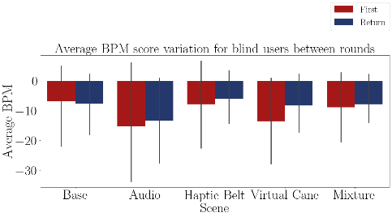

FIGURE 7.23 – Bar plot of the average heart rate of the blind participants on each method.

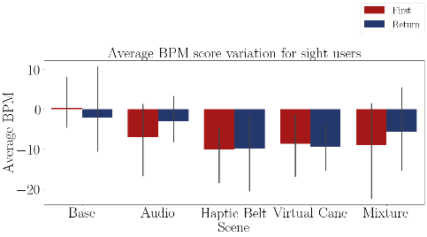

FIGURE 7.24 – Bar plot of the average heart rate of the sighted participants on each method.

sample between the guidance methods presented in the Table 7.48. The p-value indicates that there is at least one method that is statistically equal to one of the other methods.

The Table 7.52 presents the conclusion of a pairwise Fisher LSD test of the blind heart rate frequency variation between all the guidance methods. The results show that only ”Audio” caused a different variation than the one noticed on the ”Base” Method.

According to the Anova test at Table 7.51 and the LSD test at 7.52 only the ”Audio” method provoked a different reaction than the ”Base” method. Besides that, all methods decreased their frequency, going against the original expectations.

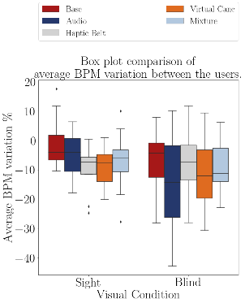

FIGURE 7.25 – Boxplot of the average heart rate of participants on each method. TABLE 7.48 – ECG average BPM variation in relation to the baseline by participant and method.

|  |  |  |  |  |  |  |  |
| --- | --- | --- | --- | --- | --- | --- | --- |
|  |  |  | Base | Audio | Haptic  Belt | Virtual  Cane | Mixture |
| Participant | Visual  Condition | Round |  |  |  |  |  |
| 001 | Sight | First | -5.4% | -12.4% | -22.5% | -20.2% | -27.7% |
|  |  | Return | -10.3% | -10.0% | -24.7% | -17.9% | -18.5% |
| 001C | Blind | First | -3.3% | -22.5% | -9.1% | -24.6% | -12.9% |
|  |  | Return | -9.3% | -25.2% | -15.5% | -18.0% | -9.7% |
| 002C | Blind | First | -28.2% | -42.9% | -28.1% | -30.8% | -22.9% |
|  |  | Return | -22.6% | -29.8% | -13.0% | -16.3% | -14.1% |
| 003 | Sight | First | -3.1% | -18.0% | -7.2% | -8.4% | -6.0% |
|  |  | Return | -10.5% | -6.0% | -8.0% | -12.8% | -5.6% |
| 003C | Blind | First | 7.8% | 10.2% | 11.8% | 9.4% | 5.5% |
|  |  | Return | 6.1% | 6.3% | 9.8% | 8.5% | 6.2% |
| 004 | Sight | First | 11.7% | 2.3% | -4.4% | 0.9% | 3.9% |
|  |  | Return | 17.6% | 6.4% | 0.5% | -1.1% | 10.0% |
| 004C | Blind | First | -4.1% | -6.1% | -5.9% | -8.1% | -5.5% |
|  |  | Return | -4.5% | -4.5% | -5.5% | -7.2% | -14.0% |
| 005 | Sight | First | -1.5% | 0.1% | -6.1% | -6.7% | -5.9% |
|  |  | Return | -5.0% | -2.4% | -7.4% | -6.0% | -8.1% |

TABLE 7.49 – Shapiro test p-value for the ecg average BPM for each method and visual con-

dition

|  |  |
| --- | --- |
| Method | Shapiro P-Value |
| Base blind | 0.377 |
| Base sight | 0.086 |
| Audio blind | 0.721 |
| Audio sight | 0.969 |
| Haptic Belt blind | 0.665 |
| Haptic Belt sight | 0.059 |
| Virtual Cane blind | 0.584 |
| Virtual Cane sight | 0.743 |
| Mixture blind | 0.379 |
| Mixture sight | 0.663 |

TABLE 7.50 – T test p-value for the ecg average BPM each method for blinded users versus sighted users.

|  |  |
| --- | --- |
| Method | T-Test P-Value |
| Base | 0.279 |
| Audio | 0.215 |
| Haptic Belt | 0.594 |
| Virtual Cane | 0.750 |
| Mixture | 0.834 |

TABLE 7.51 – Anova p-value for the average BPM on each method for blinded users.

|  |  |  |  |  |  |
| --- | --- | --- | --- | --- | --- |
| Source | Squared sum | DOF | Squared average | F | P-Value  (*F*0 *>F*) |
| Between factors | 303.579 | 4 | 75.895 | 0.383 | 0.819 |
| Inside factors | 6928.578 | 35 | 197.959 |  |  |
| Total | 7232.157 | 39 |  |  |  |

TABLE 7.52 – Cross validation p-value for the average BPM on each method for blinded users.

|  |  |  |  |
| --- | --- | --- | --- |
| Method | | | Analysis |
| Base | *X* | Audio | *H*1 : *µBase* ̸= *µAudio* ∗∗ |
| Base | *X* | Haptic Belt | *H*0 : *µBase* = *µHapticBelt* |
| Base | *X* | Virtual Cane | *H*0 : *µBase* = *µV irtualCane* |
| Base | *X* | Mixture | *H*0 : *µBase* = *µMixture* |
| Audio | *X* | Haptic Belt | *H*1 : *µAudio* ̸= *µHapticBelt* ∗∗ |
| Audio | *X* | Virtual Cane | *H*0 : *µAudio* = *µV irtualCane* |
| Audio | *X* | Mixture | *H*0 : *µAudio* = *µMixture* |
| Haptic Belt | *X* | Virtual Cane | *H*0 : *µHapticBelt* = *µV irtualCane* |
| Haptic Belt | *X* | Mixture | *H*0 : *µHapticBelt* = *µMixture* |
| Virtual Cane | *X* | Mixture | *H*0 : *µV irtualCane* = *µMixture* |

7.3.1.2 Analysis of the heartbeat frequency

The Table 7.53 presents the standard deviation of the interbeat interval by each participant on each scenes and they are plotted in the Figures 7.26 and 7.27. It is possible to see that there were all of the users felt an increase in the heartbeat variance.

TABLE 7.53 – ECG Average SDNN felled by the participants.

|  |  |  |  |  |  |  |  |  |
| --- | --- | --- | --- | --- | --- | --- | --- | --- |
|  |  |  | Baseline | Base | Audio | Haptic  Belt | Virtual  Cane | Mixture |
| Participant | Visual  Condition | Round |  |  |  |  |  |  |
| 001 | Sight | First | 37.52 | 82.73 | 82.19 | 134.53 | 134.77 | 225.41 |
|  |  | Return |  | 84.96 | 69.48 | 318.75 | 116.00 | 136.51 |
| 001C | Blind | First | 78.55 | 81.29 | 107.06 | 124.74 | 163.97 | 129.05 |
|  |  | Return |  | 120.72 | 130.88 | 131.59 | 157.59 | 124.79 |
| 002C | Blind | First | 93.77 | 73.76 | 98.86 | 81.14 | 33.98 | 79.29 |
|  |  | Return |  | 108.94 | 49.63 | 42.81 | 114.06 | 107.55 |
| 003 | Sight | First | 45.40 | 58.07 | 79.60 | 51.78 | 68.68 | 60.84 |
|  |  | Return |  | 21.30 | 45.71 | 40.93 | 66.32 | 47.82 |
| 003C | Blind | First | 26.14 | 36.87 | 38.32 | 35.10 | 42.39 | 43.69 |
|  |  | Return |  | 52.75 | 41.20 | 44.26 | 42.60 | 46.14 |
| 004 | Sight | First | 91.79 | 120.51 | 121.13 | 154.72 | 128.48 | 125.95 |
|  |  | Return |  | 139.86 | 100.37 | 122.56 | 140.12 | 119.26 |
| 004C | Blind | First | 20.98 | 70.73 | 86.83 | 62.56 | 85.90 | 70.47 |
|  |  | Return |  | 71.95 | 74.89 | 70.02 | 66.09 | 104.04 |
| 005 | Sight | First | 80.61 | 44.50 | 87.69 | 120.52 | 88.59 | 102.80 |
|  |  | Return |  | 59.77 | 93.21 | 122.84 | 141.31 | 96.03 |

The Figure 7.25 shows a comparison between both groups

The Table 7.54 shows the variation of the heartbeat in each round of each participant. In general, all the standard deviations increased, meaning that the mental workload decreased between the ”Baseline” and the method.

The Shapiro–Wilk normality test on the Table 7.55 shows that all of the ”blind”sample data are normally distributed, except the ”Mixture”method. In the ”sight”sample only the ”Base” and the ”Audio” method are normally distributed. That means that the following analyses cannot be made with those exceptions.

According to the T-Test presented in the Table 7.50 there is no difference in the heart rate frequency variation between the sample groups.

The Table 7.51 shows the Anova test p-value of the heart rate frequency of the ”blind” sample between the guidance methods presented in the Table 7.48. The p-value indicates that there is at least one method that is statistically equal to one of the other methods.

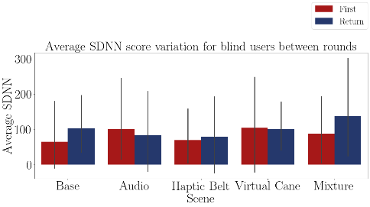

FIGURE 7.26 – Bar plot of the standard deviation of the heart of the blind participants on each method.

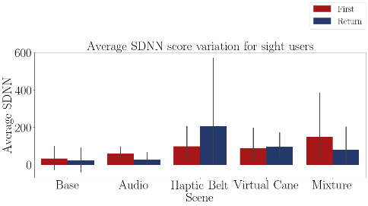

FIGURE 7.27 – Bar plot of the standard deviation of the heart of the sighted participants on each method.

The Table 7.52 presents the conclusion of a pairwise Fisher LSD test of the blind heart rate frequency variation between all the guidance methods. The results show no difference between the methods.

According to the Anova test at Table 7.57 and the LSD test at 7.58 there are no differences between the methods. Besides that, all of them provoked a decrease in the mental workload.

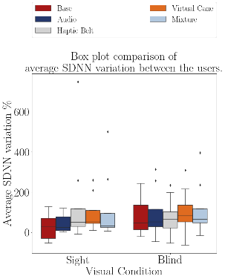

FIGURE 7.28 – Boxplot of the average heart rate of the participants on each method. TABLE 7.54 – ECG Average SDNN variation in relation to the baseline by participant and method.

|  |  |  |  |  |  |  |  |
| --- | --- | --- | --- | --- | --- | --- | --- |
|  |  |  | Base | Audio | Haptic  Belt | Virtual  Cane | Mixture |
| Participant | Visual  Condition | Round |  |  |  |  |  |
| 001 | Sight | First | 120.5% | 119.0% | 258.5% | 259.2% | 500.7% |
|  |  | Return | 126.4% | 85.2% | 749.4% | 209.1% | 263.8% |
| 001C | Blind | First | 3.5% | 36.3% | 58.8% | 108.7% | 64.3% |
|  |  | Return | 53.7% | 66.6% | 67.5% | 100.6% | 58.9% |
| 002C | Blind | First | -21.3% | 5.4% | -13.5% | -63.8% | -15.4% |
|  |  | Return | 16.2% | -47.1% | -54.3% | 21.6% | 14.7% |
| 003 | Sight | First | 27.9% | 75.3% | 14.1% | 51.3% | 34.0% |
|  |  | Return | -53.1% | 0.7% | -9.8% | 46.1% | 5.3% |
| 003C | Blind | First | 41.0% | 46.6% | 34.3% | 62.2% | 67.2% |
|  |  | Return | 101.8% | 57.6% | 69.3% | 63.0% | 76.5% |
| 004 | Sight | First | 31.3% | 32.0% | 68.6% | 40.0% | 37.2% |
|  |  | Return | 52.4% | 9.3% | 33.5% | 52.7% | 29.9% |
| 004C | Blind | First | 237.1% | 313.9% | 198.2% | 309.5% | 235.9% |
|  |  | Return | 243.0% | 257.0% | 233.8% | 215.0% | 395.9% |
| 005 | Sight | First | -44.8% | 8.8% | 49.5% | 9.9% | 27.5% |
|  |  | Return | -25.8% | 15.6% | 52.4% | 75.3% | 19.1% |

TABLE 7.55 – Shapiro test p-value for the ecg average SDNN for each method and visual con-

dition

|  |  |
| --- | --- |
| Method | Shapiro P-Value |
| Base blind | 0.078 |
| Base sight | 0.347 |
| Audio blind | 0.071 |
| Audio sight | 0.130 |
| Haptic Belt blind | 0.414 |
| Haptic Belt sight | 0.001 |
| Virtual Cane blind | 0.723 |
| Virtual Cane sight | 0.015 |
| Mixture blind | 0.027 |
| Mixture sight | 0.001 |

TABLE 7.56 – T test p-value for the ecg average SDNN each method for blinded users versus sighted users.

|  |  |
| --- | --- |
| Method | T-Test P-Value |
| Base | 0.230 |
| Audio | 0.317 |
| Haptic Belt | 0.434 |
| Virtual Cane | 0.862 |
| Mixture | 0.976 |

TABLE 7.57 – Anova p-value for the average SDNN on each method for blinded users.

|  |  |  |  |  |  |
| --- | --- | --- | --- | --- | --- |
| Source | Squared sum | DOF | Squared average | F | P-Value  (*F*0 *>F*) |
| Between factors | 7039.359 | 4 | 1759.840 | 0.130 | 0.970 |
| Inside factors | 474190.070 | 35 | 13548.288 |  |  |
| Total | 481229.429 | 39 |  |  |  |

TABLE 7.58 – Cross validation p-value for the average SDNN on each method for blinded users.

|  |  |  |  |
| --- | --- | --- | --- |
| Method | | | Analysis |
| Base | *X* | Audio | *H*0 : *µBase* = *µAudio* |
| Base | *X* | Haptic Belt | *H*0 : *µBase* = *µHapticBelt* |
| Base | *X* | Virtual Cane | *H*0 : *µBase* = *µV irtualCane* |
| Base | *X* | Mixture | *H*0 : *µBase* = *µMixture* |
| Audio | *X* | Haptic Belt | *H*0 : *µAudio* = *µHapticBelt* |
| Audio | *X* | Virtual Cane | *H*0 : *µAudio* = *µV irtualCane* |
| Audio | *X* | Mixture | *H*0 : *µAudio* = *µMixture* |
| Haptic Belt | *X* | Virtual Cane | *H*0 : *µHapticBelt* = *µV irtualCane* |
| Haptic Belt | *X* | Mixture | *H*0 : *µHapticBelt* = *µMixture* |
| Virtual Cane | *X* | Mixture | *H*0 : *µV irtualCane* = *µMixture* |

### Galvanic skin reaction and temperature data;

The GSR analysis is made by analyzing the average in each round and comparing it with the ”Baseline” average. The temperature was analyzed with the GSR to see if there is some influence and by a graphical analysis there was none.

The Table 7.59 presents the average skin conductance by each participant on each scenes and they are plotted in the Figures 7.29 and 7.30. It is possible to see that in all of the methods there was an increase in the average skin conductance, meaning that the user was aroused and maybe an increase in the mental workload.

TABLE 7.59 – GSR Average felled by the participants.

|  |  |  |  |  |  |  |  |  |
| --- | --- | --- | --- | --- | --- | --- | --- | --- |
|  |  |  | Baseline | Base | Audio | Haptic  Belt | Virtual  Cane | Mixture |
| Participant | Visual  Condition | Round |  |  |  |  |  |  |
| 001 | Sight | First | 4.27 | 8.80 | 15.19 | 15.67 | 15.19 | 14.15 |
|  |  | Return |  | 11.48 | 14.95 | 15.09 | 15.72 | 21.52 |
| 001C | Blind | First | 0.37 | 0.48 | 1.03 | 3.14 | 3.79 | 3.90 |
|  |  | Return |  | 0.83 | 1.58 | 2.81 | 4.04 | 4.57 |
| 002C | Blind | First | 0.17 | 0.91 | 0.23 | 0.17 | 0.17 | 0.17 |
|  |  | Return |  | 0.43 | 0.17 | 0.16 | 0.17 | 0.17 |
| 003 | Sight | First | 0.19 | 0.19 | 0.17 | 0.17 | 0.17 | 0.17 |
|  |  | Return |  | 0.17 | 0.17 | 0.17 | 0.17 | 0.17 |
| 003C | Blind | First | 0.30 | 0.56 | 0.56 | 0.62 | 0.85 | 1.09 |
|  |  | Return |  | 0.62 | 0.63 | 0.65 | 0.92 | 1.06 |
| 004 | Sight | First | 0.30 | 0.56 | 0.56 | 0.62 | 0.85 | 1.09 |
|  |  | Return |  | 0.62 | 0.63 | 0.65 | 0.92 | 1.06 |
| 004C | Blind | First | 1.24 | 2.34 | 3.07 | 3.49 | 2.28 | 2.23 |
|  |  | Return |  | 2.57 | 2.95 | 3.20 | 2.21 | 2.24 |
| 005 | Sight | First | 0.47 | 1.88 | 1.58 | 1.44 | 1.37 | 1.33 |
|  |  | Return |  | 1.66 | 1.53 | 1.47 | 1.49 | 1.33 |

The Figure 7.25 shows a comparison between both groups

The Table 7.60 shows the variation of the heartbeat in each round of each participant. It is also possible to notice the same increase noticed before.

The Shapiro–Wilk normality test on the Table 7.61 shows that only the ”Audio” method is normally distributed for the ”blind” sample while for the ”sight” sample only the ”Virtual Cane” is not normally distributed

According to the T-Test presented in the Table 7.62 there is no difference in the heart rate frequency variation between the sample groups.

The Table 7.63 shows the Anova test p-value of the heart rate frequency of the ”blind”

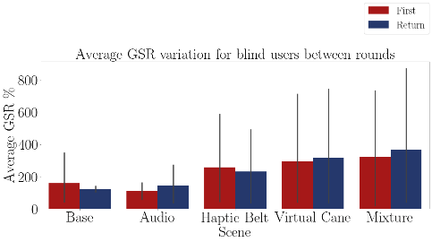

FIGURE 7.29 – Bar plot of the average skin conductance of the blind participants on each method.

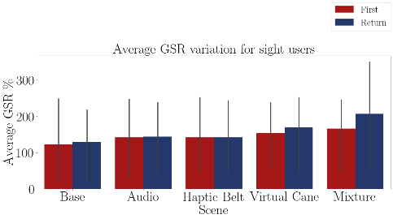

FIGURE 7.30 – Bar plot of the average skin conductance of the sighted participants on each method.

sample between the guidance methods presented in the Table 7.60. The p-value indicates that there is at least one method that is statistically equal to one of the other methods.

The Table 7.64 presents the conclusion of a pairwise Fisher LSD test of the blind heart rate frequency variation between all the guidance methods. The results show that the ”Virtual Cane” and the ”Mixture” have different variations, but since they are not normally distributed this conclusion can not statistically be made.

According to the Anova test at Table 7.63 and the LSD test at 7.64 only the ”Virtual Cane” and the ”Mixture” method provoked a different reaction than the ”Base” method, but since the Shapiro test at the Table 7.61 showed that they are not normally distributed, than this conclusion has no foundation.

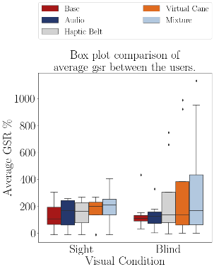

FIGURE 7.31 – Boxplot of the average skin conductace of the participants on each method. TABLE 7.60 – GSR average variation in relation to the baseline by participant and method.

|  |  |  |  |  |  |  |  |
| --- | --- | --- | --- | --- | --- | --- | --- |
|  |  |  | Base | Audio | Haptic  Belt | Virtual  Cane | Mixture |
| Participant | Visual  Condition | Round |  |  |  |  |  |
| 001 | Sight | First | 106.1% | 255.8% | 266.9% | 255.7% | 231.5% |
|  |  | Return | 168.9% | 250.2% | 253.3% | 268.2% | 403.9% |
| 001C | Blind | First | 30.6% | 176.5% | 746.1% | 920.7% | 951.7% |
|  |  | Return | 125.3% | 327.4% | 657.0% | 988.9% | 1132.4% |
| 002C | Blind | First | 432.7% | 32.3% | -0.0% | 0.0% | 0.0% |
|  |  | Return | 151.7% | 1.7% | -5.1% | 0.0% | 0.0% |
| 003 | Sight | First | -3.0% | -12.0% | -12.0% | -12.0% | -11.9% |
|  |  | Return | -12.0% | -12.0% | -11.9% | -12.0% | -11.9% |
| 003C | Blind | First | 85.4% | 84.2% | 104.2% | 182.4% | 258.8% |
|  |  | Return | 105.3% | 109.2% | 113.0% | 202.4% | 249.7% |
| 004 | Sight | First | 85.4% | 84.2% | 104.2% | 182.4% | 258.8% |
|  |  | Return | 105.3% | 109.2% | 113.0% | 202.4% | 249.7% |
| 004C | Blind | First | 89.6% | 148.5% | 182.8% | 84.3% | 80.7% |
|  |  | Return | 108.2% | 138.6% | 159.0% | 78.7% | 81.6% |
| 005 | Sight | First | 302.5% | 239.2% | 207.7% | 193.9% | 184.7% |
|  |  | Return | 255.2% | 227.1% | 214.9% | 219.6% | 185.9% |

TABLE 7.61 – Shapiro test p-value for the gsr average for each method and visual condition

|  |  |
| --- | --- |
| Method | Shapiro P-Value |
| Base blind | 0.002 |
| Base sight | 0.565 |
| Audio blind | 0.544 |
| Audio sight | 0.065 |
| Haptic Belt blind | 0.017 |
| Haptic Belt sight | 0.194 |
| Virtual Cane blind | 0.004 |
| Virtual Cane sight | 0.020 |
| Mixture blind | 0.011 |
| Mixture sight | 0.281 |

TABLE 7.62 – T test p-value for the average GSR on each method for blinded users versus sighted users.

|  |  |
| --- | --- |
| Method | T-Test P-Value |
| Base | 0.802 |
| Audio | 0.780 |
| Haptic Belt | 0.367 |
| Virtual Cane | 0.348 |
| Mixture | 0.354 |

TABLE 7.63 – Anova p-value for the average GSR on each method for blinded users.

|  |  |  |  |  |  |
| --- | --- | --- | --- | --- | --- |
| Source | Squared sum | DOF | Squared average | F | P-Value  (*F*0 *>F*) |
| Between factors | 301240.786 | 4 | 75310.197 | 0.797 | 0.535 |
| Inside factors | 3307916.688 | 35 | 94511.905 |  |  |
| Total | 3609157.475 | 39 |  |  |  |

TABLE 7.64 – Cross validation p-value for the average GSR on each method for blinded users.

|  |  |  |  |
| --- | --- | --- | --- |
| Method | | | Analysis |
| Base | *X* | Audio | *H*0 : *µBase* = *µAudio* |
| Base | *X* | Haptic Belt | *H*0 : *µBase* = *µHapticBelt* |
| Base | *X* | Virtual Cane | *H*1 : *µBase* ̸= *µV irtualCane* ∗∗ |
| Base | *X* | Mixture | *H*1 : *µBase* ̸= *µMixture* ∗∗ |
| Audio | *X* | Haptic Belt | *H*0 : *µAudio* = *µHapticBelt* |
| Audio | *X* | Virtual Cane | *H*1 : *µAudio* ̸= *µV irtualCane* ∗∗ |
| Audio | *X* | Mixture | *H*1 : *µAudio* ̸= *µMixture* ∗∗ |
| Haptic Belt | *X* | Virtual Cane | *H*0 : *µHapticBelt* = *µV irtualCane* |
| Haptic Belt | *X* | Mixture | *H*0 : *µHapticBelt* = *µMixture* |
| Virtual Cane | *X* | Mixture | *H*0 : *µV irtualCane* = *µMixture* |

# Conclusion

In this final chapter, the goals will be revised along with the results collected. It will be divided into four sections, one for each goal and a final one for future works and suggestions, and each section will have four more subsections, one for each data source gathered and one for a conclusion and commentaries for that goal.

## Do BVI users feel present in the VE as if they were in the real world?

### Answers based on the simulation data

Analyzing the time that each user took to complete each scene, it is not possible to infer a conclusion, because this data was not meant to measure this goal.

### Answers based on the subjective data

This data also was not made to assess this goal, because there is no base of comparison with subjective data from before the experiment, hence before the user started to use the virtual reality.

### Answers based on the physiological data

According to the ECG data, there was a decrease in the mental workload during the experiment while the expectation was to be an increase instead. This difference proves that the users were impacted by the experiment in the virtual reality, but does not represent the same situation outside the virtual reality.

The GSR data also showed a change when the users were using virtual reality. The results showed that the users were aroused or had an increased mental workload.

### Final conclusions

The physiological data gathered was the only source of data to assess this goal, and they had opposite conclusions regarding the expected. The ECG showed a decrease in the mental workload, while the GSR showed an increase.

The collected ECG data is less reliable than the collected GSR due to the sensibility of the sensors used. It was noted that the ECG is very sensitive to movements and the position of the sensors in relationship with the data receiver. If something stands in the way between the sensor and receiver, such as a human body, that data is lost, causing the resulting analysis to be noiseless or to be made using corrections such as the one used.

So, this goal was partially achieved.

## Does BVI users rely more on one type of information than the other?

### Answers based on the simulation data

With the regard to the time, and since the Anova test showed that all of the data are different from each other, one can look at the Table 7.4 and notice that the method that the users took the shorter time was the ”Mixture”method, which was along with the expectation that the BVI users rely on both of the information, but the second shortest was the ”Virtual Cane”, so it indicates that the BVI user relies more on a haptic source of information. But this data is not entirely reliable, since there were a couple of mistakes in the first experiment to close each simulation, hence increasing the final time of each user at the round.

### Answers based on the subjective data

Analysing the Figures 7.7, 7.12, 7.17 and 7.22 one can notice that the haptic source of information is preferable for they have the best results in general for each questionnaire, but the Anova test disagree with that conclusion in some cases, but that can a conseguence of the fact that only 4 individuals of each group did the experiment.

### Answers based on the physiological data

Disconsidering that all of the ECG data were against the expected variation, according to the Anova test, only the ”Audio” method can be concluded that is different from the 96

”Base” method and Figure 7.23 shows a similar conclusion.

The skin conductance Anova test resulted that only the ”Virtual Cane”and the ”Mixture” method are different than the ”Base” method, and, also according to the skin data, they aroused more the user or have a higher mental workload. Another conclusion from the Anova test is that the ”Audio” method has a similar workload to the ”Base” method, and ironically this was the only one that could be said that arouses less or has a lesser mental workload.

### Final conclusions and comentaries

The majority of the graphics showed a tendency that haptics sources of data are more favorable for the BVI users, but the conclusion drawn by the hypothesis test did not support that analysis. This may be due to the small sample size.

One observation made during the experiment is that the BVI users during the ”Audio” and ”Mixture”method did not use, or used only a few times, the audio guidance provided by the researcher. This does not discard that they did not rely on sound information, because the simulation has filled with audio cues. This may be because of their previous experience in navigation and mobility alone.

The conclusion for this goal would be that they do rely more on a mixture of haptic and audio data, the first for obstacle detection at and short distance, the latter for guidance and information gathered at bigger distances.

## Do non-BVI users have the same demands and skills as BVI users when designing assistive products?

### Answers based on the simulation data

Results from the simulation data and the T-Test showed that the only time data that was different between the groups is the ”Audio”. Analyzing the rest of the data one can conclude that the results had no difference.

Results from the Figure 7.3 showed a rather similar average duration between the two groups going along with the conclusion from the T-Test, but there is the matter of the unreliability of this data mentioned before.

*Draft Version: June 1, 2022*

### Answers based on the subjective data

The T-Test of each questionnaire showed that there are no differences between the groups, but the Figures 7.7, 7.12 and 7.17 showed a noticeable difference between the groups. These unmatched results may be because of the small sample number.

### Answers based on the physiological data

The Figure 7.28 indicates that there are no visual difference between the groups. The Figure 7.25 indicates a difference on the distribution and a rather similar average. The

Figure 7.31 indicates higher arousal or mental workload by the ”blind” users. All the T-Tests indicate that both groups have the same variation of workload and arouse.

### Final conclusions and comentaries

The T-Test results showed in general that both groups had similar results, while some graphics showed the opposite. This happened maybe because of two reasons. First because of a small sample size. Second because of a tendency of the ”sight” sample. The sighted participant all were used to technology and volunteering for experiments, while the same can not be said for the BVI participants.

To close up, this goal is considered not achieved for lack of a bigger and more diverse sample size.

## Future works and suggestions

For future works related to this one it could be suggested:

* Repeat the experiment in a real situation and compare it with this one to verify the first goal;
* Repeat the experiment with more devices with different proportions of haptic and audio information sources;
* Repeat the experiment with bigger sample size and a more diverse sample to verify if the results of the hypothesis test do remain the same;

# Bibliography

BORGHINI, G.; ASTOLFI, L.; VECCHIATO, G.; MATTIA, D.; BABILONI, F.

Measuring neurophysiological signals in aircraft pilots and car drivers for the assessment of mental workload, fatigue and drowsiness. Neuroscience & Biobehavioral Reviews, Elsevier, v. 44, p. 58–75, 2014. 17

BRADLEY, N. A.; DUNLOP, M. D. Investigating context-aware clues to assist navigation for visually impaired people. In: Proceedings of Workshop on Building Bridges: Interdisciplinary Context-Sensitive Computing, University of Glasgow. [S.l.: s.n.], 2002. 28, 29, 30

BRADLEY, N. A.; DUNLOP, M. D. An experimental investigation into wayfinding directions for visually impaired people. Personal and Ubiquitous Computing, Springer, v. 9, n. 6, p. 395–403, 2005. 28, 30, 31, 32

CAIN, B. A review of the mental workload literature. Defence research and development Toronto (Canada), 2007. 15, 16

CARDOSO, M. d. S.; GONTIJO, L. A. Evaluation of mental workload and performance measurement: Nasa tlx and swat. Gest˜ao &, Produ¸c˜ao, v. 19, p. 873–884, 2012. 15

CHAKLADAR, D. D.; DEY, S.; ROY, P. P.; DOGRA, D. P. Eeg-based mental workload estimation using deep blstm-lstm network and evolutionary algorithm. Biomedical Signal Processing and Control, Elsevier, v. 60, p. 101989, 2020. 16

CHIU, M.-L. An organizational view of design communication in design collaboration.

Design studies, Elsevier, v. 23, n. 2, p. 187–210, 2002. 22

CUMMINGS, J. J.; BAILENSON, J. N. How immersive is enough? a meta-analysis of the effect of immersive technology on user presence. Media psychology, Taylor & Francis, v. 19, n. 2, p. 272–309, 2016. 26

DOOLANI, S.; WESSELS, C.; KANAL, V.; SEVASTOPOULOS, C.; JAISWAL, A.; NAMBIAPPAN, H.; MAKEDON, F. A review of extended reality (xr) technologies for manufacturing training. Technologies, Multidisciplinary Digital Publishing Institute, v. 8, n. 4, p. 77, 2020. 20, 21

DUL, J.; WEERDMEESTER, B. Ergonomics for beginners: a quick reference guide.

[S.l.]: CRC press, 2003. 12, 13

EASY EDA. Dispon´ıvel em: [*<*https://easyeda.com/*>*.](https://easyeda.com/) 53

ENDSLEY, M. R. Design and evaluation for situation awareness enhancement. In:

SAGE PUBLICATIONS SAGE CA: LOS ANGELES, CA. Proceedings of the Human

Factors Society annual meeting. [S.l.], 1988. v. 32, n. 2, p. 97–101. 18

ENDSLEY, M. R. Situation awareness global assessment technique (SAGAT). In: IEEE.

Proceedings of the IEEE 1988 national aerospace and electronics conference. [S.l.],

1988. p. 789–795. 19

ENDSLEY, M. R. Measurement of situation awareness in dynamic systems. Human factors, SAGE Publications Sage CA: Los Angeles, CA, v. 37, n. 1, p. 65–84, 1995. 18, 19

ENDSLEY, M. R. Automation and situation awareness. In: Automation and human performance: Theory and applications. [S.l.]: CRC Press, 2018. p. 163–181. 18

ESPRESSIF SYSTEMS. ESP32-DevKitC V5: Getting sstarted guide. 2022. Dispon´ıvel em: [*<*https://docs.espressif.com/projects/esp-idf/en/latest/esp32/hw-reference/esp32/ get-started-devkitc.html*>*.](https://docs.espressif.com/projects/esp-idf/en/latest/esp32/hw-reference/esp32/get-started-devkitc.html) Acesso em: 18 fev. 2022. 125

FALLAHI, M.; MOTAMEDZADE, M.; HEIDARIMOGHADAM, R.; SOLTANIAN,

A. R.; MIYAKE, S. Effects of mental workload on physiological and subjective responses during traffic density monitoring: A field study. Applied ergonomics, Elsevier, v. 52, p. 95–103, 2016. 15, 16

FARRELL, W. A. Learning becomes doing: Applying augmented and virtual reality to improve performance. Performance Improvement, Wiley Online Library, v. 57, n. 4, p. 19–28, 2018. 8, 20, 21

FARRER, C.; FRITH, C. D. Experiencing oneself vs another person as being the cause of an action: the neural correlates of the experience of agency. Neuroimage, Elsevier, v. 15, n. 3, p. 596–603, 2002. 27

FARSHID, M.; PASCHEN, J.; ERIKSSON, T.; KIETZMANN, J. Go boldly!: Explore augmented reality (ar), virtual reality (vr), and mixed reality (mr) for business. Business Horizons, Elsevier, v. 61, n. 5, p. 657–663, 2018. 21

HART, S. G.; STAVELAND, L. E. Development of nasa-tlx (task load index): Results of empirical and theoretical research. In: Advances in psychology. [S.l.]: Elsevier, 1988. v. 52, p. 139–183. 17

JICOL, C.; WAN, C. H.; DOLING, B.; ILLINGWORTH, C. H.; YOON, J.; HEADEY, C.; LUTTEROTH, C.; PROULX, M. J.; PETRINI, K.; O’NEILL, E. Effects of emotion and agency on presence in virtual reality. In: Proceedings of the 2021 CHI Conference on Human Factors in Computing Systems. [S.l.: s.n.], 2021. p. 1–13. 26, 27

JONDANI, J. A. Strategies for addressing the special needs of people with visual impairments during the covid-19 pandemic. Journal of Visual Impairment & Blindness, SAGE Publications Sage CA: Los Angeles, CA, v. 115, n. 3, p. 263–267, 2021. 8

KAHN, K. B. Interdepartmental integration: a definition with implications for product development performance. Journal of product innovation management, Elsevier, v. 13, n. 2, p. 137–151, 1996. 22

KARWOWSKI, W. The discipline of human factors and ergonomics. Handbook of human factors and ergonomics, Citeseer, v. 4, p. 3–37, 2012. 12 KLEINSMANN, M. S. Understanding collaborative design. 2006. 22, 23

KUBIUS HRV Standard. Dispon´ıvel em:

[*<*https://www.kubios.com/scientific-research/*>*.](https://www.kubios.com/scientific-research/) 81

KYLECORRY31. Haptic compass belt. 2020. Dispon´ıvel em:

[*<*https://www.instructables.com/Haptic-Compass-Belt/*>*.](https://www.instructables.com/Haptic-Compass-Belt/) 52

LOZANO, C. A.; KACZMAREK, K. A.; SANTELLO, M. Electrotactile stimulation on the tongue: Intensity perception, discrimination, and cross-modality estimation. Somatosensory & motor research, Taylor & Francis, v. 26, n. 2-3, p. 50–63, 2009. 8

MA, J. Y.; CHOI, J. S. The virtuality and reality of augmented reality. J. Multim.,

Citeseer, v. 2, n. 1, p. 32–37, 2007. 20, 21

MANSIKKA, H.; SIMOLA, P.; VIRTANEN, K.; HARRIS, D.; OKSAMA, L. Fighter

pilots’ heart rate, heart rate variation and performance during instrument approaches. Ergonomics, Taylor & Francis, v. 59, n. 10, p. 1344–1352, 2016. 16

MARSTON, J. R.; LOOMIS, J. M.; KLATZKY, R. L.; GOLLEDGE, R. G.; SMITH,

E. L. Evaluation of spatial displays for navigation without sight. ACM Transactions on

Applied Perception (TAP), ACM New York, NY, USA, v. 3, n. 2, p. 110–124, 2006. 32, 33

MILGRAM, P.; KISHINO, F. A taxonomy of mixed reality visual displays. IEICE

TRANSACTIONS on Information and Systems, The Institute of Electronics,

Information and Communication Engineers, v. 77, n. 12, p. 1321–1329, 1994. 20

MOHANAVELU, K.; POONGUZHALI, S.; RAVI, D.; SINGH, P. K.; MAHAJABIN, M.; RAMACHANDRAN, K.; SINGH, U. K.; JAYARAMAN, S. Cognitive workload

analysis of fighter aircraft pilots in flight simulator environment. Defence Science Journal, v. 70, n. 2, 2020. 15, 16

MUJBER, T. S.; SZECSI, T.; HASHMI, M. S. Virtual reality applications in manufacturing process simulation. Journal of materials processing technology, Elsevier, v. 155, p. 1834–1838, 2004. 21

NIJHOLT, A.; TRAUM, D. The virtuality continuum revisited. In: CHI’05 Extended

Abstracts on Human Factors in Computing Systems. [S.l.: s.n.], 2005. p. 2132–2133. 20

NOURBAKHSH, N.; WANG, Y.; CHEN, F.; CALVO, R. A. Using galvanic skin response for cognitive load measurement in arithmetic and reading tasks. In: Proceedings of the 24th Australian Computer-Human Interaction Conference. [S.l.: s.n.], 2012. p. 420–423. 17

ORLANDI, L.; BROOKS, B. Measuring mental workload and physiological reactions in marine pilots: Building bridges towards redlines of performance. Applied ergonomics,

Elsevier, v. 69, p. 74–92, 2018. 16

RITCHIE, H.; MATHIEU, E.; ROD´eS-GUIRAO, L.; APPEL, C.; GIATTINO, C.; ORTIZ-OSPINA, E.; HASELL, J.; MACDONALD, B.; DATTANI, S.; ROSER, M.

Coronavirus (COVID-19) cases. 2020. Dispon´ıvel em:

[*<*https://ourworldindata.org/covid-cases*>*.](https://ourworldindata.org/covid-cases) Acesso em: 8 fev. 2022. 8

RODR´IGUEZ, S.; SANCHEZ, L.; L´ OPEZ, P.; CA´ NAS, J. J. Pupillometry to assess air˜ traffic controller workload through the mental workload model. In: Proceedings of the 5th international conference on application and theory of automation in command and control systems. [S.l.: s.n.], 2015. p. 95–104. 16

SALAH, B.; ABIDI, M. H.; MIAN, S. H.; KRID, M.; ALKHALEFAH, H.; ABDO, A.

Virtual reality-based engineering education to enhance manufacturing sustainability in industry 4.0. Sustainability, Multidisciplinary Digital Publishing Institute, v. 11, n. 5, p. 1477, 2019. 21

SANDERS, M. S.; MCCORMICK, E. J. Human factors in engineering and design.

Industrial Robot: An International Journal, Emerald Group Publishing Limited, 1998.

12, 13, 14, 15, 17, 18, 19

SANDOM, C.; HARVEY, R. S. Human factors for engineers. [S.l.]: Iet, 2004. v. 2. 12, 13

SHI, Y.; RUIZ, N.; TAIB, R.; CHOI, E.; CHEN, F. Galvanic skin response (gsr) as an index of cognitive load. In: CHI’07 extended abstracts on Human factors in computing systems. [S.l.: s.n.], 2007. p. 2651–2656. 17

SIU, A. F.; SINCLAIR, M.; KOVACS, R.; OFEK, E.; HOLZ, C.; CUTRELL, E. Virtual reality without vision: A haptic and auditory white cane to navigate complex virtual worlds. In: Proceedings of the 2020 CHI conference on human factors in computing systems. [S.l.: s.n.], 2020. p. 1–13. 24, 25, 26

SMITH, K. G.; SMITH, K. A.; OLIAN, J. D.; JR, H. P. S. *et al.* Top management team demography and process: The role of social integration and communication. Irish

Journal of Management, Irish Academy of Managment, v. 17, n. 1, p. 36, 1996. 22

STANTON, N. A.; HEDGE, A.; BROOKHUIS, K.; SALAS, E.; HENDRICK, H. W.

Handbook of human factors and ergonomics methods. [S.l.]: CRC press, 2004. 14, 15, 16, 17, 18, 19

WANG, S.; MAO, Z.; ZENG, C.; GONG, H.; LI, S.; CHEN, B. A new method of virtual reality based on unity3d. In: IEEE. 2010 18th international conference on Geoinformatics. [S.l.], 2010. p. 1–5. 36, 43

WOLF, A.; BINDER, N.; MIEHLING, J.; WARTZACK, S. Towards virtual assessment of human factors: A concept for data driven prediction and analysis of physical user-product interactions. In: CAMBRIDGE UNIVERSITY PRESS. Proceedings of the Design Society: International Conference on Engineering Design. [S.l.], 2019. v. 1, n. 1, p. 4029–4038. 8

WORLD HEALTH ORGANIZATION. Advice for the public on covid-19. World Health Organization, 2020. Dispon´ıvel em: [*<*https:](https://www.who.int/emergencies/diseases/novel-coronavirus-2019/advice-for-public)

[//www.who.int/emergencies/diseases/novel-coronavirus-2019/advice-for-public*>*.](https://www.who.int/emergencies/diseases/novel-coronavirus-2019/advice-for-public)

Acesso em: 8 fev. 2022. 8

WORLD HEALTH ORGANIZATION AND OTHERS. World report on vision. [S.l.], 2019. 8

ZHANG, H.; ZHU, Y.; MANIYERI, J.; GUAN, C. Detection of variations in cognitive workload using multi-modality physiological sensors and a large margin unbiased regression machine. In: IEEE. 2014 36th Annual International Conference of the IEEE

Engineering in Medicine and Biology Society. [S.l.], 2014. p. 2985–2988. 16, 17

# Appendix A - Questionnaires

## A.1 BVI condition

Co´digo de identifica¸ca˜o do volunt´ario:

*Os dados deste question´ario s˜ao anˆonimos e somente ser˜ao utilizados para fins acadˆemicos e de pesquisa, ficando proibido seu manuseio ou uso sem consentimento do coordenador da pesquisa.*

Parte 1 - Question´ario sobre dados pessoais.

Idade: Sexo: ( ) Masculino ( ) Feminino

Como deficiente visual vocˆe se identifica como:

( ) Cego

( ) Surdo-Cego

( ) Baixa Visa˜o

( ) Monocular

( ) N˜ao sou deficiente visual

USO DO PESQUISADOR

Ordem dos cen´arios:

## A.2 NASA-TLX

Co´digo de identifica¸ca˜o do volunt´ario:

*Os dados deste question´ario s˜ao anˆonimos e somente ser˜ao utilizados para fins acadˆemicos e de pesquisa, ficando proibido seu manuseio ou uso sem consentimento do coordenador da pesquisa.*

Parte 2 - Question´ario sobre carga mental (NASA-TLX).

TESTE ( ) BASE ( ) AUDIO´ ( ) CINTO HAPTICO´ ( ) BENGALA ( ) MISTO

Avalie cada um dos itens abaixo em uma escala de 1 a 20.

Primeira visita

1. Demanda Mental 
2. Demanda F´ısica 
3. Demanda Temporal 
4. Desempenho 
5. Esforc¸o 
6. Frustra¸ca˜o Retorno
7. Demanda Mental 
8. Demanda F´ısica 
9. Demanda Temporal 
10. Desempenho 
11. Esforc¸o 
12. Frustra¸ca˜o 

## A.3 SAGAT (adapted)

Co´digo de identifica¸ca˜o do volunt´ario:

*Os dados deste question´ario s˜ao anˆonimos e somente ser˜ao utilizados para fins acadˆemicos e de pesquisa, ficando proibido seu manuseio ou uso sem consentimento do coordenador da pesquisa.*

Parte 3 - Question´ario sobre consciˆencia situacional (SAGAT).

TESTE ( ) BASE ( ) AUDIO´ ( ) CINTO HAPTICO´ ( ) BENGALA ( ) MISTO

Primeira visita

#### N´ıvel 1 – Percepc¸˜ao

|  |  |
| --- | --- |
| 1) Existe algum objeto pro´ximo de vocˆe? | 2) Sinalize onde o objeto est´a: |

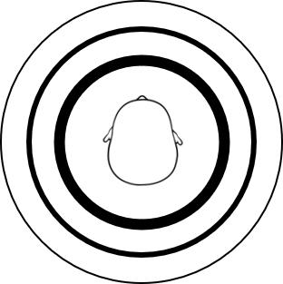

|  |  |
| --- | --- |
| 3) Existe algu´em perto de vocˆe? | 4) Sinalize onde a pessoa esta´: |



|  |  |
| --- | --- |
| 5) Vocˆe percebeu alguma fonte de som caracter´ıstica do lugar onde vocˆe se encontra? | 6) Sinalize de onde vem o som: |



|  |  |
| --- | --- |
| N´ıvel 2 – Compreensa˜o |  |
| 7) Sinalize em que dire¸ca˜o est´a a recepcionista: | 8) Sinalize em que dire¸ca˜o esta´ a sa´ıda: |



|  |  |
| --- | --- |
| N´ıvel 3 – Proje¸ca˜o |  |
| 9) O que vocˆe espera encontrar no caminho ao retornar `a mesa de recep¸ca˜o? | 10) Qual ser´a a sua trajeto´ria para sair? Descreva seus pro´ximos movimentos. |

11) Qual a distaˆncia vocˆe imagina que existe 12) Qual a distaˆncia vocˆe imagina que existe entre vocˆe e a mesa da recepc¸˜ao? entre vocˆe e a sa´ıda?

#### Retorno N´ıvel 1 – Percepc¸˜ao

|  |  |
| --- | --- |
| 1) Existe algum objeto pro´ximo de vocˆe? | 2) Sinalize onde o objeto est´a: |



|  |  |
| --- | --- |
| 3) Existe algu´em perto de vocˆe? | 4) Sinalize onde a pessoa esta´: |



|  |  |
| --- | --- |
| 5) Vocˆe percebeu alguma fonte de som caracter´ıstica do lugar onde vocˆe se encontra? | 6) Sinalize de onde vem o som: |



#### N´ıvel 2 – Compreensa˜o

1. Sinalize em que dire¸ca˜o est´a a recep-
2. Sinalize em que dire¸ca˜o esta´ a sa´ıda:

cionista:



#### N´ıvel 3 – Proje¸ca˜o

9) O que vocˆe espera encontrar no caminho 10) Qual ser´a a sua trajeto´ria para sair? Deao retornar `a mesa de recep¸ca˜o? screva seus pro´ximos movimentos.

11) Qual a distaˆncia vocˆe imagina que existe 12) Qual a distaˆncia vocˆe imagina que existe entre vocˆe e a mesa da recepc¸˜ao? entre vocˆe e a sa´ıda?

## A.4 Guidance method evaluation

Co´digo de identifica¸ca˜o do volunt´ario:

*Os dados deste question´ario s˜ao anˆonimos e somente ser˜ao utilizados para fins acadˆemicos e de pesquisa, ficando proibido seu manuseio ou uso sem consentimento do coordenador da pesquisa.*

Parte 4 - Question´ario sobre o m´etodo de navega¸c˜ao.

#### TESTE 1 - ORIENTAC¸AO VIA˜ AUDIO´

1) Os sons foram de f´acil interpreta¸ca˜o?

|  |  |  |  |  |  |  |  |
| --- | --- | --- | --- | --- | --- | --- | --- |
| 1 | 2 | 3 | 4 | 5 | | 6 | 7 |
| Muito fa´cil |  |  | M´edio |  | |  | Muito d´ıficil |
| 2) Os sons causaram algum incˆomodo durante o uso? | | | | | |  |  |
| 1 | 2 | 3 | 4 |  | 5 | 6 | 7 |
| Nenhum  incoˆmodo |  |  | M´edio |  |  |  | Muito incoˆmodo |
| 3) Os comandos foram claros? | | |  |  |  |  |  |
| 1 | 2 | 3 | 4 |  | 5 | 6 | 7 |
| Na˜o foram claros |  |  | M´edio |  |  |  | Muito claros |
| 4) Como vocˆe avalia a quantidade de comandos? | | | | |  |  |  |
| 1 | 2 | 3 | 4 |  | 5 | 6 | 7 |
| Muito pouca |  |  | M´edio |  |  |  | Muito  excessiva |

1. Os momentos em que os comandos foram reproduzidos foram inadequados?

|  |  |  |  |  |  |  |
| --- | --- | --- | --- | --- | --- | --- |
| 1 | 2 | 3 | 4 | 5 | 6 | 7 |
| Na˜o foram adequados |  |  | M´edio |  |  | Muito adequados |

1. O som ambiente atrapalhou a reprodu¸ca˜o de algum comando

|  |  |  |  |  |  |  |
| --- | --- | --- | --- | --- | --- | --- |
| 1 | 2 | 3 | 4 | 5 | 6 | 7 |
| Na˜o atrapalhou |  |  | M´edio |  |  | Atrapalhou muito |

1. Vocˆe sentiu falta de alguma informa¸ca˜o durante a orienta¸ca˜o via ´audio?

#### TESTE 2 – CINTO HAPTICO´

1) A informa¸ca˜o da vibra¸ca˜o do cinto foi precisa?

|  |  |  |  |  |  |  |  |
| --- | --- | --- | --- | --- | --- | --- | --- |
| 1 | 2 | 3 | 4 | 5 | 6 | | 7 |
| Pouco  precisa |  |  | M´edio |  |  | | Muito  precisa |
| 2) A vibra¸ca˜o do cinto causou algum incoˆmodo durante o uso? | | | | | | |  |
| 1 | 2 | 3 | 4 | 5 | 6 | | 7 |
| Nenhum  incoˆmodo |  |  | M´edio |  |  | | Muito incoˆmodo |
| 3) A vibra¸ca˜o do cinto causou alguma confus˜ao durante a navegac¸˜ao? | | | | | | |  |
| 1 | 2 | 3 | 4 | 5 |  | 6 | 7 |
| Nenhuma confusa˜o |  |  | M´edio |  |  |  | Muita  confusa˜o |
| 4) A vibra¸ca˜o do cinto trouxe alguma seguran¸ca na navega¸ca˜o? | | | | | |  |  |
| 1 | 2 | 3 | 4 | 5 |  | 6 | 7 |
| Nenhuma seguranc¸a |  |  | M´edio |  |  |  | Muita  seguranc¸a |
| 5) O cinto causou algum incˆomodo durante o uso? | | | | | |  |  |
| 1 | 2 | 3 | 4 | 5 |  | 6 | 7 |
| Nenhum  incoˆmodo |  |  | M´edio |  |  |  | Muito incoˆmodo |

6) Vocˆe sentiu falta de alguma informa¸ca˜o durante a orienta¸ca˜o usando o cinto?

#### TESTE 3 - BENGALA VIRTUAL

1. A informa¸ca˜o da vibra¸ca˜o do cinto foi precisa?

|  |  |  |  |  |  |  |
| --- | --- | --- | --- | --- | --- | --- |
| 1 | 2 | 3 | 4 | 5 | 6 | 7 |
| Pouco  precisa |  |  | M´edio |  |  | Muito  precisa |

1. A bengala virtual funcionou semelhantemente `a bengala tradicional?

|  |  |  |  |  |  |  |  |
| --- | --- | --- | --- | --- | --- | --- | --- |
| 1 | 2 | 3 | 4 | 5 |  | 6 | 7 |
| Pouco semelhante |  |  | M´edio |  |  |  | Muito semelhante |
| 3) O uso da bengala foi intuitivo? | | | |  |  |  |  |
| 1 | 2 | 3 | 4 | 5 |  | 6 | 7 |
| Na˜o foi intuitivo |  |  | M´edio |  |  |  | Muito  intuitivo |
| 4) A bengala causou algum incˆomodo durante o uso? | | | | | |  |  |
| 1 | 2 | 3 | 4 | 5 |  | 6 | 7 |
| Nenhum  incoˆmodo |  |  | M´edio |  |  |  | Muito incoˆmodo |
| 5) A bengala causou alguma confusa˜o durante a navega¸ca˜o? | | | | | |  |  |
| 1 | 2 | 3 | 4 | 5 |  | 6 | 7 |
| Nenhuma confusa˜o |  |  | M´edio |  |  |  | Muita  confusa˜o |

1. Vocˆe sentiu falta de alguma informa¸ca˜o durante a orienta¸ca˜o?
2. Vocˆe prefere mais a bengala virtual ou o cinto? Por quˆe?

#### TESTE 4 - MISTURADO (AUDIO E CINTO)´

1) Os sons foram de f´acil interpreta¸ca˜o?

|  |  |  |  |  |  |  |  |
| --- | --- | --- | --- | --- | --- | --- | --- |
| 1 | 2 | 3 | 4 | 5 | | 6 | 7 |
| Muito fa´cil |  |  | M´edio |  | |  | Muito d´ıficil |
| 2) Os sons causaram algum incˆomodo durante o uso? | | | | | |  |  |
| 1 | 2 | 3 | 4 |  | 5 | 6 | 7 |
| Nenhum  incoˆmodo |  |  | M´edio |  |  |  | Muito incoˆmodo |
| 3) Os comandos foram claros? | | |  |  |  |  |  |
| 1 | 2 | 3 | 4 |  | 5 | 6 | 7 |
| Na˜o foram claros |  |  | M´edio |  |  |  | Muito claros |
| 4) Como vocˆe avalia a quantidade de comandos? | | | | |  |  |  |
| 1 | 2 | 3 | 4 |  | 5 | 6 | 7 |
| Muito pouca |  |  | M´edio |  |  |  | Muito  excessiva |

5) Os momentos em que os comandos foram reproduzidos foram inadequados?

|  |  |  |  |  |  |  |
| --- | --- | --- | --- | --- | --- | --- |
| 1 | 2 | 3 | 4 | 5 | 6 | 7 |
| Na˜o foram adequados |  |  | M´edio |  |  | Muito adequados |
| 6) O som ambiente atrapalhou a reprodu¸ca˜o de algum comando | | | | | |  |
| 1 | 2 | 3 | 4 | 5 | 6 | 7 |
| Na˜o atrapalhou |  |  | M´edio |  |  | Atrapalhou muito |

7) A informa¸ca˜o da vibra¸ca˜o do cinto foi precisa?

|  |  |  |  |  |  |  |  |
| --- | --- | --- | --- | --- | --- | --- | --- |
| 1 | 2 | 3 | 4 | 5 | 6 | | 7 |
| Pouco  precisa |  |  | M´edio |  |  | | Muito  precisa |
| 8) A vibra¸ca˜o do cinto causou algum incoˆmodo durante o uso? | | | | | | |  |
| 1 | 2 | 3 | 4 | 5 | 6 | | 7 |
| Nenhum  incoˆmodo |  |  | M´edio |  |  | | Muito incoˆmodo |
| 9) A vibra¸ca˜o do cinto causou alguma confus˜ao durante a navegac¸˜ao? | | | | | | |  |
| 1 | 2 | 3 | 4 | 5 |  | 6 | 7 |
| Nenhuma confusa˜o |  |  | M´edio |  |  |  | Muita  confusa˜o |
| 10) A vibra¸c˜ao do cinto trouxe alguma seguran¸ca na navega¸ca˜o | | | | | |  |  |
| 1 | 2 | 3 | 4 | 5 |  | 6 | 7 |
| Nenhuma seguranc¸a |  |  | M´edio |  |  |  | Muita  seguranc¸a |
| 11) O cinto causou algum incoˆmodo durante o uso? | | | | | |  |  |
| 1 | 2 | 3 | 4 | 5 |  | 6 | 7 |
| Nenhum  incoˆmodo |  |  | M´edio |  |  |  | Muito incoˆmodo |

1. A mistura de comandos de a´udio com vibra¸ca˜o te trouxe mais seguran¸ca?

|  |  |  |  |  |  |  |
| --- | --- | --- | --- | --- | --- | --- |
| 1 | 2 | 3 | 4 | 5 | 6 | 7 |
| Nenhuma seguranc¸a |  |  | M´edio |  |  | Muita  seguranc¸a |

1. De forma geral, como vocˆe avalia a quantidade de informa¸c˜ao recebida?

|  |  |  |  |  |  |  |
| --- | --- | --- | --- | --- | --- | --- |
| 1 | 2 | 3 | 4 | 5 | 6 | 7 |
| Muito pouca |  |  | M´edio |  |  | Muito  excessiva |

1. Vocˆe sentiu falta de alguma informac¸˜ao durante a orienta¸ca˜o?
2. Considerando a emissa˜o de comandos via a´udio e via cinto ha´ptico, vocˆe considera que algum deles ´e desnecessa´rio?

# Appendix B - Virtual Cane

## B.1 Virtual Cane algorithm

Startsimulation

Getnear

obstacles

Checkdistance

)

usingraycasting

(

Impact?

Add1impact

Sendimpactmessage

andresettimer

Identifynearest

obstacle)

Identifydirection

oftheobstacle)

Identifyintensity

basedondistance)

Vibratecane

no

yes

FIGURE B.1 – Virtual cane’s algorithm diagram

# Appendix C - Haptic Belt

## C.1 Printed circuit board used on the haptic belt

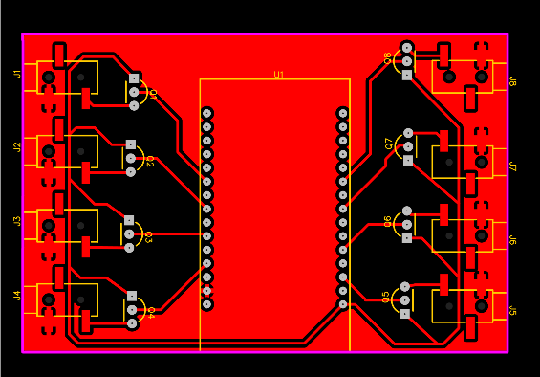

FIGURE C.1 – Printed circuit board wiring

## C.2 Vibration unit

Q9

BPW40

1

2

3

1

2

J9

320B/PJ-001 3.5Jacks

FIGURE C.2 – Vibration Unit

## C.3 Algorithm running in the ESP32

Connected

toUnity

ReadUnity’s

command

Activateor

deactivate?

Identify

Vibrator(s)

Setintensity

Identify

Vibrator(s)

Activate

Vibrator(s)

Deactivate

Vibrator(s)

activate

deactivate

FIGURE C.3 – Unity’s message flowchart inside ESP32

## C.4 Algorithm running in the Unity

Connect

toesp32

Getnear

obstacles

Checkdistance

)

usingclosestpoint

(

Impact?

Add1impact

Sendimpact

message

Identifynearest

obstacle

Identifydirection

oftheobstacle

Identifyintensity

basedondistance

Sendmessage

tovibrator

no

yes

FIGURE C.4 – Unity’s process of identifying obstacle and setting the vibration intensity.

# Appendix D - ECG processing algorithm

Collectthe

ECGData

Python-Read

theECGfile

Python-Remove

theoutliernoise

Python-Nor-

malize(-1and1)

Python-Run

peakfinder

Graphicalanalysis

Python-Tune

thepeakfinder

Python-Calculate

thetimedifference

betweenpeaks

Python-Save

thepeakfile

Kubius-Read

thepeakfile

Kubius-

RunAnalysis

Kubius-Save

areportfile

Python-Read

reportfile

Peaksfit

Peaks

fitnot

FIGURED.1–ECG’sdatatreatmentalgorithim.

# Appendix E - GSR processing algorithm

Collectthe

ECGData

ReadtheGSRfile

Calculate

theaverage

Calculatethe

standarddeviaton

FIGURE E.1 – GSR’s data treatment algorithim.

# Annex A - DOIT Esp32 DevKit v1 datasheet

## A.1 Especifications

|  |  |
| --- | --- |
| CPU: | Xtensa® Dual-Core 32-bit LX6 |
| ROM: | 448 KBytes |
| RAM: | 520 Kbytes |
| Flash | 4 MB |
| Max Clock:  Wireless 802.11 b/g/n  Built-in Antena | 240MHz |
| Conector: | Micro-usb |

Wi-Fi Direct (P2P), P2P Discovery, P2P Group Owner mode e P2P Power Management

Modos de opera¸ca˜o: STA/AP/STA+AP

Bluetooth BLE 4.2

Portas GPIO: 11

GPIO com func¸˜oes de PWM, I2C, SPI, etc

Tens˜ao de opera¸ca˜o: 4,5 9V

Taxa de transferˆencia: 110-460800bps

Suports Firmware remote upgrade

Conversor analo´gico digital (ADC)

Distˆancia entre pinos: 2,54mm

Dimenso˜es: 49 x 25,5 x 7 mm

ANNEX A. DOIT ESP32 DEVKIT V1 DATASHEET 125

## A.2 Pinnout

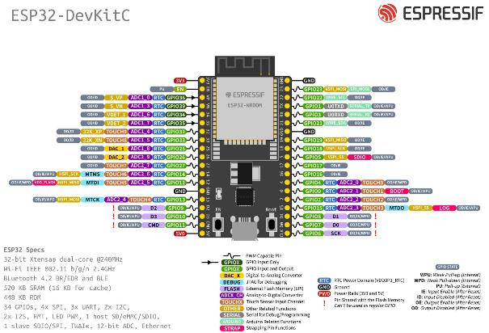

FIGURE A.1 – ESP32 pinnout diagramm (ESPRESSIF SYSTEMS, 2022).

*Draft Version: June 1, 2022*

# Annex B - Kubius

## B.1 Kubius software

Kubios HRV Standard is a heart rate variability (HRV) analysis software for personal non-commercial use. The Kubios HRV Standard makes it possible to use your HR monitor to examine the health of the cardiovascular system or to evaluate stress and recovery.

|  |  |  |  |
| --- | --- | --- | --- |
| FOLHA DE REGISTRO DO DOCUMENTO | | | |
| 1*.* ˜  CLASSIFICAC¸AO/TIPO | 2*.*  DATA | 3*.* º  DOCUMENTO N | 4*.* º DE PAGINAS´ N |
| DM |  | DCTA/ITA/DM-018/2015 | 126 |
| 5*.* ´ITULO E SUBT´ITULO: T  Virtual reality simulation for human factors assessment | | | |
| 6*.*  AUTOR(ES):  Ivan de Souza Rehder | | | |
| 7*.* ˜ OES)/˜ ORG´ AO(S) INTERNO(S)/DIVIS˜ AO(˜ OES):˜ INSTITUIC¸AO(  Instituto Tecnol´ogico de Aeron´autica – ITA | | | |
| 8*.*  PALAVRAS-CHAVE SUGERIDAS PELO AUTOR:  Realidade Virtual; Fatores Humanos; Simulac¸˜ao | | | |
| 9*.* ˜  PALAVRAS-CHAVE RESULTANTES DE INDEXAC¸AO:  Cupim; Dilema; Constru¸c˜ao | | | |
| 10*.* ˜ (X) Nacional ( ) Internacional  APRESENTAC¸AO:  ITA, S˜ao Jos´e dos Campos. Curso de Mestrado. Programa de P´os-Graduac¸˜ao em Engenharia Aeron´autica e Mecˆanica. Area de Sistemas Aeroespaciais e Mecatrˆonica. Orientador: Prof. Dr. Adalberto Santos Dupont.´ Coorientadora: Profa. Dra. Doralice Serra. Defesa em 05/03/2015. Publicada em 25/03/2015. | | | |
| 11*.*  RESUMO:  A sociedade alcan¸cou tecnologia para criar ve´ıculos autˆonomos e conectar diferentes aparelhos e m´aquinas umas `as outras a fim de trocar informa¸c˜oes e otimizar a eficiˆencia de produc¸˜ao. Com essa tecnologia, logo ser´a poss´ıvel obter melhores m´etodos para orientar usu´arios cegos e deficientes visuais (CDV) nas suas atividades di´arias. Os produtos que est˜ao dispon´ıveis no mercado hoje em dia possuem um nu´mero de limita¸c˜oes e n˜ao agradam os usu´arios CDV. Acredita-se que uma das raz˜oes desse problema ´e a ausˆencia do envolvimento de indiv´ıduos CDV no desenvolvimento desses produtos. A falta de uma solu¸c˜ao eficiente para a navegac¸˜ao desse pu´blico tornou-se mais grave com a pandemia da SARS-CoV 2, quando pessoas eram instru´ıdas a praticar isolamento social e evitar contato em superf´ıcies que possam estar contaminadas. O objetivo desse trabalho ´e propor um m´etodo para avaliac¸˜ao de opc¸˜oes de design para produtos assistivos para CDV baseados em Realidade Virtual (RV). A ideia ´e usar o RV como um campo de teste, onde o usu´ario pode experimentar diferentes solu¸c˜oes em diferentes cen´arios. Com isso, ele se torna integrante do design e da avaliac¸˜ao, resultando em um produto melhor e com uma interface mais simples. O m´etodo proposto inclui, al´em da montagem do ambiente virtual, o uso de sensores fisiol´ogicos e testes subjetivos que aferem a carga mental e a consciˆencia situacional nas diferentes situa¸c˜oes e produtos que est˜ao em desenvolvimento. Para ilustrar o m´etodo proposto, ´e estudado a navegac¸˜ao de indiv´ıduos CDV em um hospital que usa protocolos COVID-19. Esse estudo de caso foi escolhido devido a ocorrente pandemia e a situa¸c˜ao cr´ıtica que ela causa `a popula¸c˜ao CDV. O cen´ario virtual foi feito usando Unity3D, uma plataforma de desenvolvimento de aplicac¸˜oes para realidade virtual largamente utilizada. O aparelho RV ´e o Tobbi Eye Tracking VR. S˜ao ´oculos que foram desenvolvidos usando o HTC VIVE. Esses ´oculos s˜ao utilizados para definir a posi¸c˜ao e orienta¸c˜ao do usu´ario no ambiente virtual do Unity. Para inferir a carga mental, foram utilizados os sensores fisiol´ogicos da TEA Capitv T-Sens. Eles s˜ao o eletrocardiograma (ECG), usado para coletar a frequˆencia card´ıaca e a variˆancia card´ıaca, e o GSR (Galvanic skin reaction, rea¸c˜ao galvˆanica da pele), para captar a condutˆancia da pele. Al´em desses sensores, os volunt´arios tamb´em responderam os testes NASA-TLX, tamb´em para verificar a carga mental, e uma vers˜ao adaptada do SAGAT, para determinar a consciˆencia situacional. Entre os benef´ıcios esperados pelo m´etodo ´e a flexibilidade e a agilidade para se criar diferentes cen´arios e tamb´em a possibilidade de testar eles no mesmo espac¸o f´ısico. Isso pode acelerar o design de novas solu¸c˜oes e melhorar a qualidade dos produtos. Outro resultado esperado da pesquisa ´e a identifica¸c˜ao de caracter´ısticas chaves dos produtos que causam o aumento ou diminui¸c˜ao da carga mental ou da consciˆencia situacional nos usu´arios CDV. | | | |
| 12*.*  GRAU DE SIGILO:  (X) OSTENSIVO ( ) RESERVADO ( ) SECRETO | | | |

1. During one of the experiments, a BVI participant commented that he/she felt different day times for each time he/she did the scene